

|  |  |  |
| --- | --- | --- |
|  | | |
|  | (843) 555-1212 | Receiver |
|  | djones69@hgtc.edu | Envelope |
|  | flaresparks.intelligence | World |
|  | 2050 US-501, Conway, SC 29526 | Home |

Table of Contents

Mission Statement and Goals 1

TCTG Documents 5

Request for Proposal Letter 8

Request for Proposal 9

Hardware Requirement Document 13

Software Requirements 14

Mission Statement and Organization Chart 14

Floor 26

Plan 27

Budget 32

Hardware 40

Software 57

Security Polices 65

Installation Guide 91

Work Cited 127

|  |
| --- |
|  |
| Mission Statement and Goals |

# Mission Statement and Goals

Mission Statement

Flare Sparx Intelligence strives to provide our clients with efficient and cutting-edge technology solutions with room for growth that allows their business to thrive in the fast-paced and rapidly growing digital age.

Organizational Chart

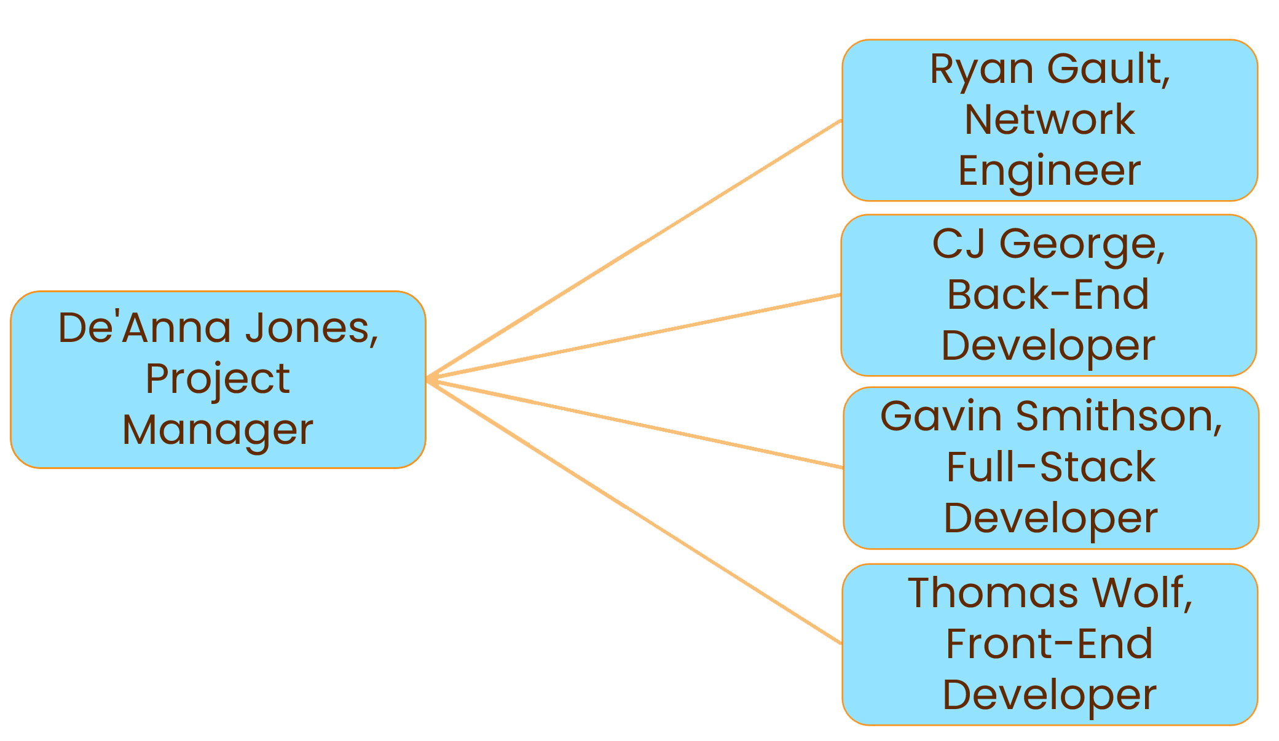

|  |
| --- |
|  |
| TCTG Documents |

# TCTG Documents

TCTG Documents

Below are the documents that TCTG Golf Academy sent Flare Sparx Intelligence.  The documents are Request for Proposal Letter, Request for Proposal, Hardware Requirements, Software Requirements, their Mission Statement, and Organization’s Structure.

# Request for Proposal Letter

January 30, 2024

Ms. DeAnna Jones

Flare Sparx Intelligence

2050 Hwy 501 E

Bldg. 1000C Room 322

Conway, SC 29526

Re: Request for Proposal

Dear Ms. Jones,

It is our great pleasure to welcome you and your team of consultants to prepare a business plan and proposal to bid on the new state-of-the-art golf facility for the TCTG Golf Academy.

My colleagues and I have discussed the many needs for our facility. Attached you will find a Request for Proposal in which we have compiled a list of items to assist you during the design phase and to ensure the needs for our facility, employees and most importantly our clientele are met.

If you should have any questions regarding the attachments, please feel free to contact us either via e-mail at [louann.timmons@hgtc.edu](mailto:louann.timmons@hgtc.edu) or via phone at (843) 349-5367.

We look forward to seeing your business plan and working with you on this project. Thank you for your time.

Sincerely,

LouAnn Timmons

Lou Ann Timmons, CEO

TCTG Golf Academy

Attachments (2)

**2050 Hwy 501 E; Suite 304C; Conway, SC 29526**

**(843) 349-5367**

[**louann.timmons@hgtc.edu**](mailto:louann.timmons@hgtc.edu)

# Request for Proposal

From: TCTG Golf Academy

Request for Proposal (RFP): Analyze, Design, and Develop New System

Reference Number: H01 – 2024 – **02**

Issue Date: January 30, 2024

1) Disclaimer:

This is only a request for a proposal for services and does not express or imply any representation or indicate a commitment to any vendor or consultant’s services or proposal.

2) Background:

The TCTG Golf Academy Department of Information Technology is seeking information and services for the following:

* Network
* Equipment
* Software

This request is being sought for a golf academy in the Horry and Georgetown County Areas.

Information should include but is not limited to: timeline to complete the project; cost of equipment, software, and setup; cost of services; and recommended equipment and software, along with a website, database and security.

Timeline to complete the project will be from the date of this RFP to final submission on April 11, 2024

Final presentation for consideration will be April 30, 2024 with implementation to begin on May 1, 2024.

3) Purpose:

This Request for Proposal is a gathering of information process in which the “TCTG Golf Academy” franchise seeks to collect information and opinions from Systems Analysts to research, budget, setup, and demonstrate/install a new system and software recommendation for the newly built golf course.

4) Contact Information:

Lou Ann Timmons – CEO & Co-Owner – (843) 349-5367

Jason Carman – CFO & Co-Owner – (843) 349-3636

Brian Tessenear – CTO & Co-Owner – (843) 349-5265

Stanton Greenawalt – CISO – (843) 349-5237

E-mail / Dropbox: [louann.timmons@hgtc.edu](mailto:louann.timmons@hgtc.edu)

5) Responses:

Please return Business Plan for consideration no later than: April 11, 2024 by 12:00 (noon) PM

Please submit responses to: Dropbox

Ensure: Your submission is virus checked before submission in Word and PDF format

6) Respondent Details:

Team Name: Flare Sparx Intelligence

Team Lead: DeAnna Jones

Phone: (843) 555-1212

Email: djones69@hgtc.edu



7) Response Schedule:

Weekly Updates until April 30, 2024 with a start date for installation of May 1, 2024

8) TCTG Golf Academy Specifications:

The TCTG Golf Academy facility information is as follows:

* Floor Plan Information
  + Building Size is 600’ x 400’
  + Building includes:
    - 1st floor (refer to floor plan)
    - 2nd floor offices (refer to floor plan)
    - Basement (refer to floor plan)
    - Men’s & Women’s restrooms
    - Storage closets
    - Server Room (recommendation for placement)
    - External Maintenance Shed (refer to floor plan)
* Additional Information
  + Offices
    - All drops for phones, PC’s, laptops, etc. need to be added to the floor plan and explained in detail
    - Offices will currently have 1 employee but future may require up to 2 employees per office
  + **BUDGET: Vendor Dependent**

9) Other Items:

Please see attachment for recommendations requested for hardware and software needs

10) NOTICE:

As this is a newly constructed facility, requirements may need to be adjusted or changed.

Items may be added or removed at the discretion of the owners.

Any changes requested will be written or verbally communicated and contractor/vendor will be responsible for documenting/incorporating those changes



# Hardware Requirement Document

Hardware:

PCs for building as shown on Building Requirements and Floor Plan attached.

Office Printers – shared

Laptops with docking stations, external monitor, external keyboard and external mouse

POS systems as shown on Building Requirements and Floor Plan attached.

Server Rack for the following:

* Server(s): Complete setup with required software
* Switch, Router, Firewall

Punch down Panel (if needed)

Ethernet Cable: CAT5e or CAT6 and RJ45 Connectors

Wi-Fi with Access Points

* Recommendation for number of access points needed for entire building

VoIP Phones as shown on Building Requirements attached.

Uninterruptable Power Supply: 1 for server, 1 for each office, 1 for front desk

* Recommendation needed for this to ensure enough are placed for 99.9% up time.

Keypad Lock and Surveillance Camera for Server Room

Swipe Keypads for server room



# Software Requirements

Software

Server Software:

vmWare with VSphere 7 or greater

vCenter Server

Windows 11

Server 2022 with Active Directory and IIS

Next Generation Firewall

Linux with LAMP stack

Licensing Required for Software

Application Software

Node

React

Microsoft SQL

Recommendations & Costs only (should not be added to vendor budget)

Primary ISP

Secondary ISP

Cloud Backup (Examples: Carbonite, Iron Mountain, OneDrive, etc.)

Recommendation for Choice

# Mission Statement and Organization Chart



TCTG Golf Academy Mission Statement

Our professional care team aims to provide an award-winning facility with a second to none attention to detail for our clients while providing excellent service and products through state-of-the-art technology.

TCTG Golf Academy Organizational Chart



February 12, 2024

Mrs. Lou Ann Timmons

TCTG Golf Academy

2050 Hwy 501 E

Bldg. 1000C Room 304 C

Conway, SC 29526

Re: Response to Proposal

Dear Mrs. Timmons,

Thank you for the opportunity to prepare a business plan and proposal for the state-of-the art facility for the TCTG Golf Academy.

Our team will put our utmost effort into recommendations for your new facility. My colleagues and I will review the Request for Proposal and all documents provided to us, so we can properly advise the best hardware and software for your facility, employees, and clientele. We will provide updates each week to show progress of the development.

We will present the final recommendation for hardware and software with an additional database and website to demonstrate by the requested date of April 11, 2024, to begin implementation on May 1, 2024.

If you should have any questions, please contact us by email at djones69@hgtc.edu or via phone are (843) 555-1212.

Thank you for this opportunity. We look forward to serving your business for this project of recommendations for your new facility.

Sincerely,

De’Anna Jones

De’Anna Jones, Project Manager

2050 US-501, Conway, SC 29526

Request For Services

February 12, 2024

Ms. Madeline Mercer

StealthNet Threat Defense

2050 Hwy. 501 E

Conway, SC 29528

Re: Request for Services

Dear Ms. Mercer,

Our company, Flare Sparx Intelligence, would like to request the services of StealthNet Threat Defense to conduct an analysis of a system we are installing for a new project.

The services we are requesting are as follows:

* White hat penetration testing of a golf course network system and database
* Analysis to begin March 4 and conclude no later than March 15
* Documentation of findings and proposed solutions returned to my attention no later than April 1

If you are able to meet these deadlines and are interested in this contract, please respond to this letter to my attention with the following information no later than February 26, 2024.

* Hourly cost for Infiltration Inc.
* Number of Hours needed to complete the testing

Thank you in advance for your time and assistance in this matter. We look forward to hearing from you.

Sincerely,

De’Anna Jones

DeAnna Jones

Project Manager

2050 Hwy 501 E; Conway, SC 29526

(843) 555-1212

djones69@hgtc.edu

StealthNet Threat Defense

2050 Hwy. 501 E

Conway, SC 29528

mmercer5@hgtc.edu

843-742-4216

February 12, 2024



Flare Sparx Intelligence

2050 Hwy. 501 E

Conway, SC 29528

Subject: Response to Penetration Testing RFP

Dear De’Anna Jones,

We appreciate the opportunity to respond to your Request for Proposal (RFP) for penetration testing services for Flare Sparx Intelligence. StealthNet Threat Defense is a leading cybersecurity firm specializing in comprehensive penetration testing solutions, and we are excited about the prospect of collaborating with your organization to enhance the security of your web assets.

1. Executive Summary:

Our company is committed to delivering high-quality, realistic simulated attacks on your networks, applications, devices, and employees in order to demonstrate the security of your systems and how you can improve them.

2. Company Overview:

Our company has an experienced background in penetration testing networks, applications, and devices, with base certifications being CompTIA Security+ , CCNA, and CEH. Our employees have 10+ years of penetration testing experience and are trusted to protect your systems. Our

specific experience in website security assessment includes protecting in attacks like scripted cross-site scripting, SQL injections, HTML injections, and more.

3. Methodology:

Our comprehensive approach to penetration testing begins with meticulous reconnaissance, where we systematically gather information on devices, services, and open ports. Following this, we conduct in-depth research to identify potential vulnerabilities within the targeted infrastructure. Employing a blend of black box and white box penetration testing methodologies, we rigorously probe for weaknesses. We will do multiple attacks with the vulnerabilities we find, these attacks could be social engineering testing, password cracking, sql injection attacks, XSS attacks, Man-in-the-middle, and many more. Throughout the engagement, meticulous documentation is maintained, capturing every step of our analysis and findings. Finally, we deliver a comprehensive report delineating actionable insights on fortifying your defenses against identified vulnerabilities.

4. Team and Expertise:

Our key team members consist of Brendan Johnson, Amaru Cosme, and Madeline Mercer. Each has earned several key certifications for ethical hacking, including the CCNA, CompTIA Security+, and CEH. They are experts in using several penetration testing tools such as Metasploit, Nmap, and Armitage. They also have sufficient knowledge in website security testing, including experience in gaining and maintaining unauthorized access to websites, and in different injection attacks.

5. Tools and Resources:

Our team will leverage industry-standard tools and resources such as Metasploit, Meterpreter, Armitage, Nmap, Enum4linux, nbtscan, Tcpdump, Wireshark, and Netcat. These are all tools included in Kali Linux, a Linux distribution used specifically for advanced penetration testing. Some industry-standard methodologies that we may use include social engineering, physical penetration testing, web application penetration testing, network penetration testing, vulnerability analysis, intelligence gathering, and exploitation.

6. Timeline:

The testing will begin on March 4th and conclude March 15th. Each day we will focus on a different phase of testing. The first day will consist of reconnaissance in which we will attempt to find your systems’ configurations, logins and passwords, and probing the network. Over the next two days, we will start scanning the network and machines to create a network map, find open ports, and detect any potential vulnerabilities that can be exploited. We will spend the three days after that gaining access by exploiting the previously found vulnerabilities and sending malicious payloads to devices to simulate attempted unauthorized access. The last four days will be spent maintaining access which will consist of us continuously exploiting the system's other vulnerabilities, escalation privileges, and finally, clearing our tracks. We will also be generating the final report during these last days, which will be given to you March 15th.

7. Deliverables:

We will provide several deliverables during and after the penetration testing. One of these deliverables is an executive summary that will include all of the actions taken during the penetration testing. The next is a detailed report of technical findings and vulnerabilities that will outline each that was found in your network and systems. Along with that will be risk assessment and prioritization which will go over the biggest risks to the network and system, and, finally, recommendations for remediation which will give you detailed feedback on how to protect your network and systems from the vulnerabilities and exploits we found during the penetration testing.

8. Pricing:

Our pricing consists of $46 per hour of testing. This is based on the full price of a full-service penetration testing session costing $10,000, overall, for the 72 hours we will be working during the eleven days between March 4th to March 15th.

Our other prices can range from $5,000 to $10,000 depending on the amount of services requested and the size of the scope. The minimum service range consists of simple network scans and mapping, and simple attacks on systems and web services. This also consists of small scopes between 5-6 systems. The higher service range consists of more sophisticated and in-depth attacks, and detailed advice on how to protect your system and network. Bigger scopes of 10-20 systems will also increase this price range.

9. Case Studies and References:

We have performed on similar clients who desired our company to test all phases of penetration testing on their network and systems who were satisfied with our results. After our rigorous testing, we had a plentiful report of recommended changes to their security, which they soon implemented and were immensely satisfied with.

10. Compliance and Legal Considerations:

We assure that our employees are committed to ethical and legal penetration testing practices, following Section 16-16-20 of South Carolina law on computer crime and the Computer Fraud and Abuse Act (CFAA).

11. Next Steps:

There are some next steps we would like you to consider, including a follow-up meeting after the penetration testing is done. This meeting will provide insight into our findings and recommendations of how to protect your systems and networks from these vulnerabilities. Along with this, we will go over our final report with you, which will provide an opportunity for any questions you may have to be answered.

Thank you for considering StealthNet Threat Defense for your penetration testing needs. We are confident in our ability to enhance the security posture of Flare Sparx Intelligence through our expertise and dedication to cybersecurity excellence.

We look forward to the opportunity to discuss our proposal further.

Sincerely,

Madeline Mercer

Project Manager

StealthNet Threat Defense

mmercer5@hgtc.edu

843-742-4216

PENETRATION TESTING AGREEMENT

This Penetration Testing Agreement is entered into on March 4th, by and between:

Flare Sparx Intelligence

2050 Hwy. 501 E

Conway, SC 29528

and

StealthNet Threat Defense

2050 Hwy. 501 E

Conway, SC 29528

1. SCOPE OF WORK

1.1 Penetration Testing Services:

StealthNet Threat Defense agrees to perform penetration testing services on the systems and applications specified in Exhibit A.

1.2 Authorization:

The Client authorizes StealthNet Threat Defense to conduct testing on the specified systems and applications within the agreed-upon scope.

2. TERMS AND CONDITIONS

2.1 Commencement and Duration:

The penetration testing project will commence on March 4th and conclude on March 15th, unless extended by mutual agreement.

2.2 Confidentiality:

Both Parties agree to maintain the confidentiality of all information obtained during the penetration testing engagement. StealthNet Threat Defense shall not disclose any sensitive information to third parties without prior written consent from the Client.

2.3 Legal and Ethical Standards:

StealthNet Threat Defense agrees to perform all testing in compliance with applicable laws and ethical standards. The Client shall provide all necessary permissions for the testing.

3. DELIVERABLES

3.1 Final Report:

StealthNet Threat Defense shall provide a detailed final report, including identified vulnerabilities, their severity, and recommendations for remediation.

3.2 Debriefing Session:

A debriefing session shall be conducted between StealthNet Threat Defense and the Client to discuss the findings and recommendations.

4. PAYMENT

4.1 Payment Terms:

The Client agrees to pay StealthNet Threat Defense the total amount of $10,000 according to the payment schedule outlined in Exhibit 8-Pricing.

4.2 Expenses:

The Client shall reimburse StealthNet Threat Defense for reasonable and pre-approved expenses incurred during the engagement.

5. INDEMNIFICATION

5.1 Indemnification:

StealthNet Threat Defense shall indemnify and hold harmless the Client from any claims, damages, or liabilities arising from the penetration testing services, excluding claims resulting from the Client's negligence or misconduct.

6. TERMINATION

6.1 Termination:

Either party may terminate this Agreement with written notice if the other party breaches any material provision of this Agreement.

7. MISCELLANEOUS

7.1 Governing Law:

This Agreement shall be governed by and construed in accordance with the laws of South Carolina.

7.2 Entire Agreement:

This Agreement constitutes the entire understanding between the Parties and supersedes all prior agreements or understandings.

IN WITNESS WHEREOF, the Parties hereto have executed this Penetration Testing Agreement as of the Effective Date.

Client:

Flare Sparx Intelligence

Signature:__________

Penetration Testing Company:

StealthNet Threat Defense

Madeline Mercer

|  |
| --- |
|  |
| Floor Plans |

# Floor Plan

Floor 1

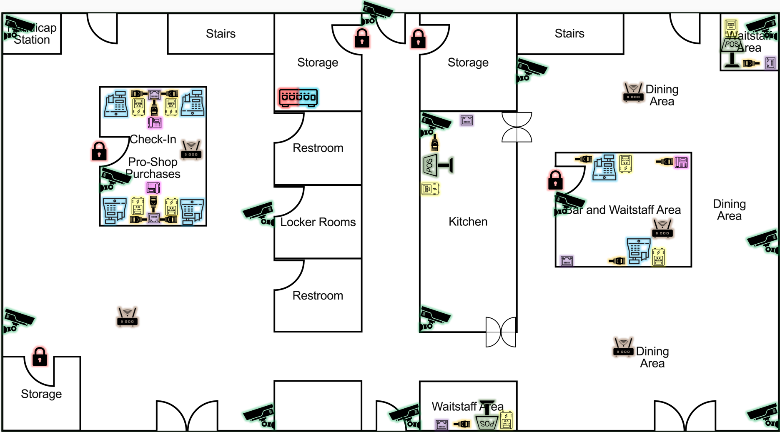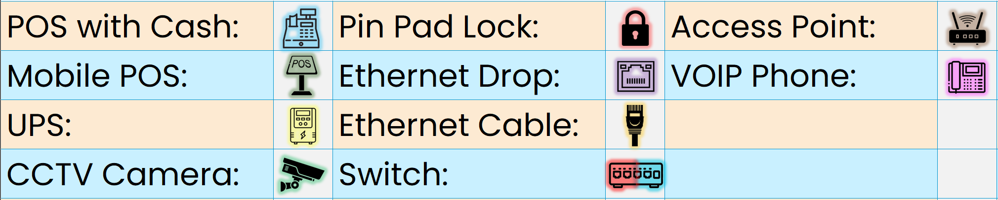

Floor 2

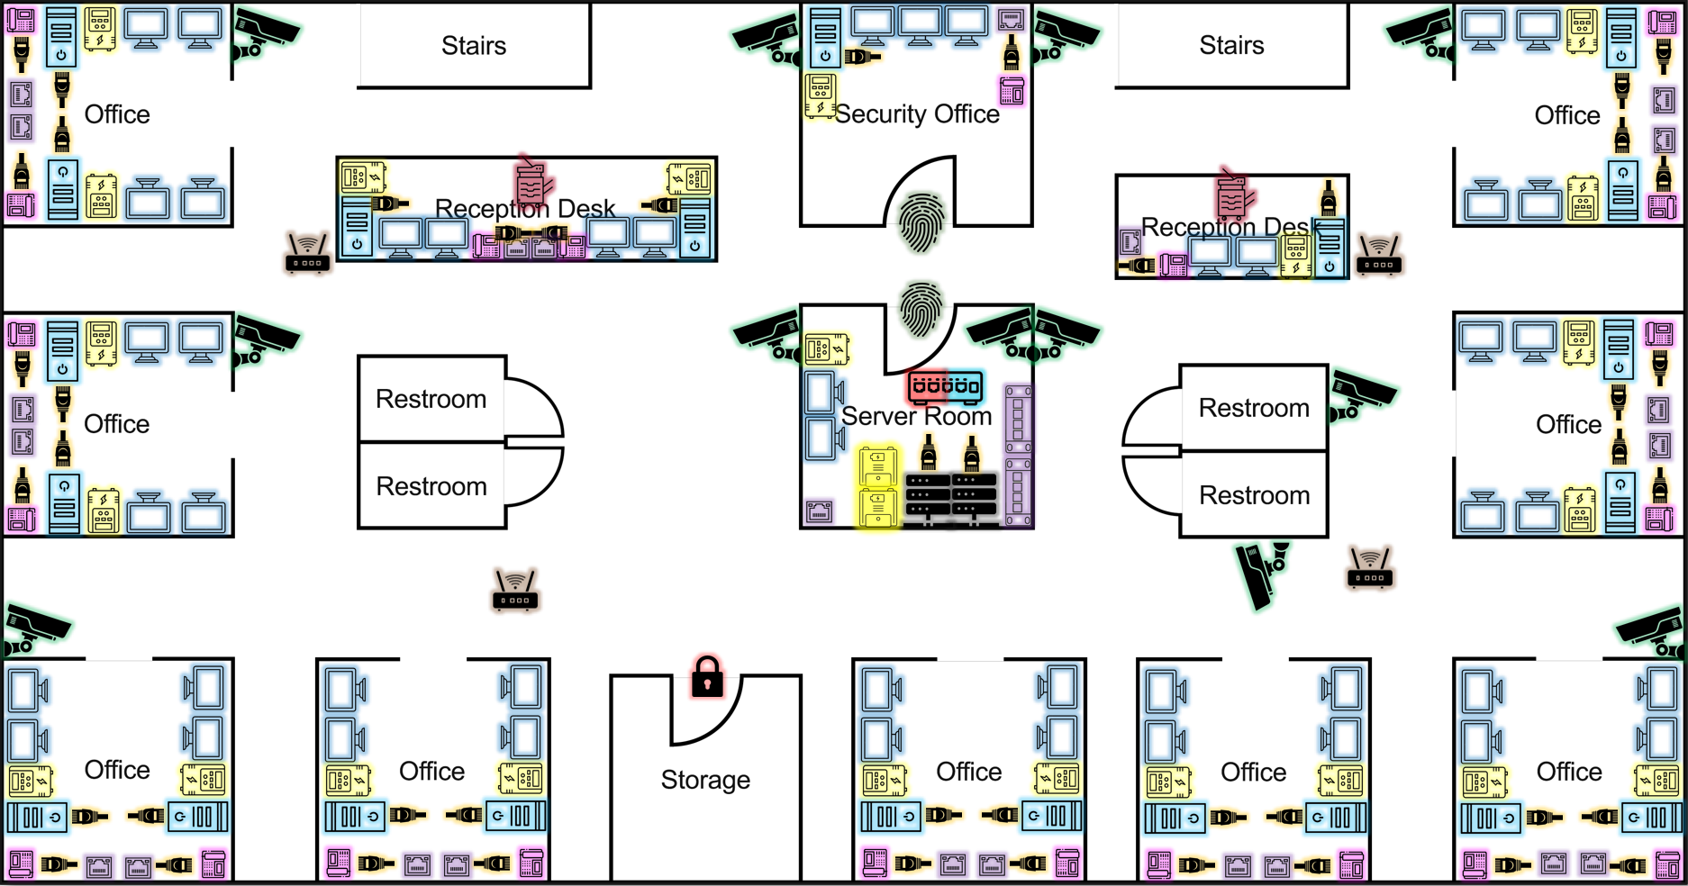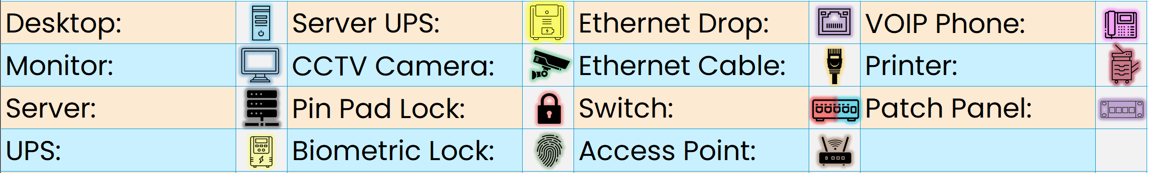

Basement

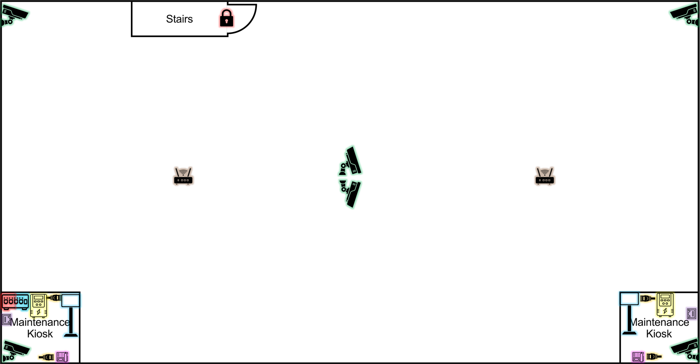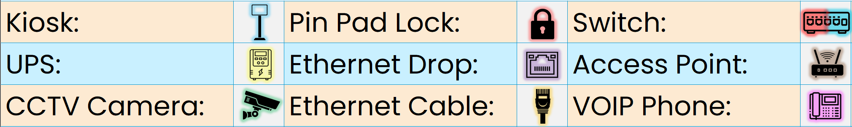

Maintenance Shed

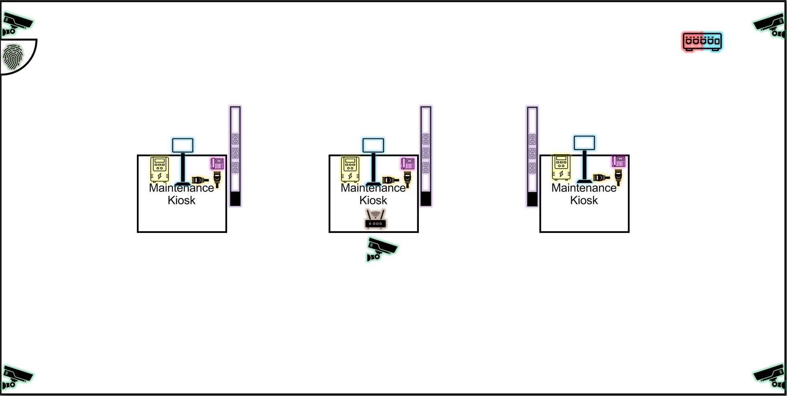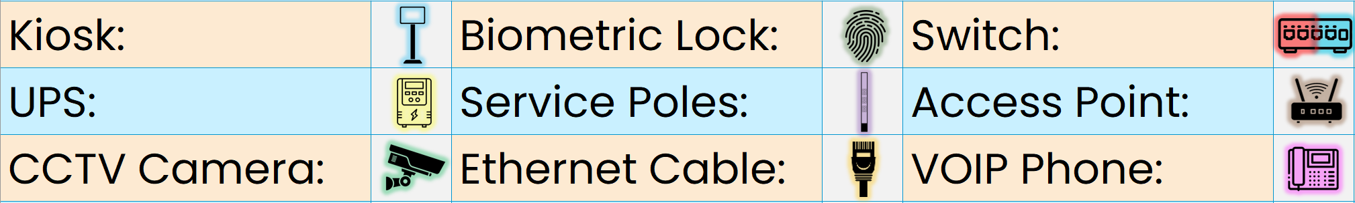

|  |
| --- |
|  |
| Budget |

# Budget

Overall Budget

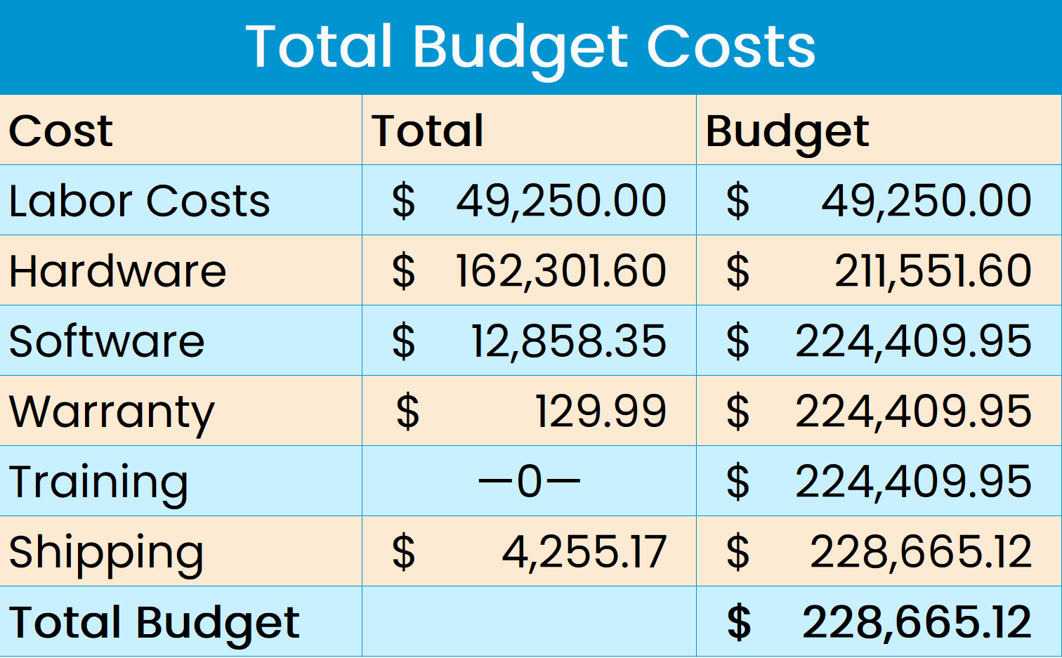

LABOR COSTS

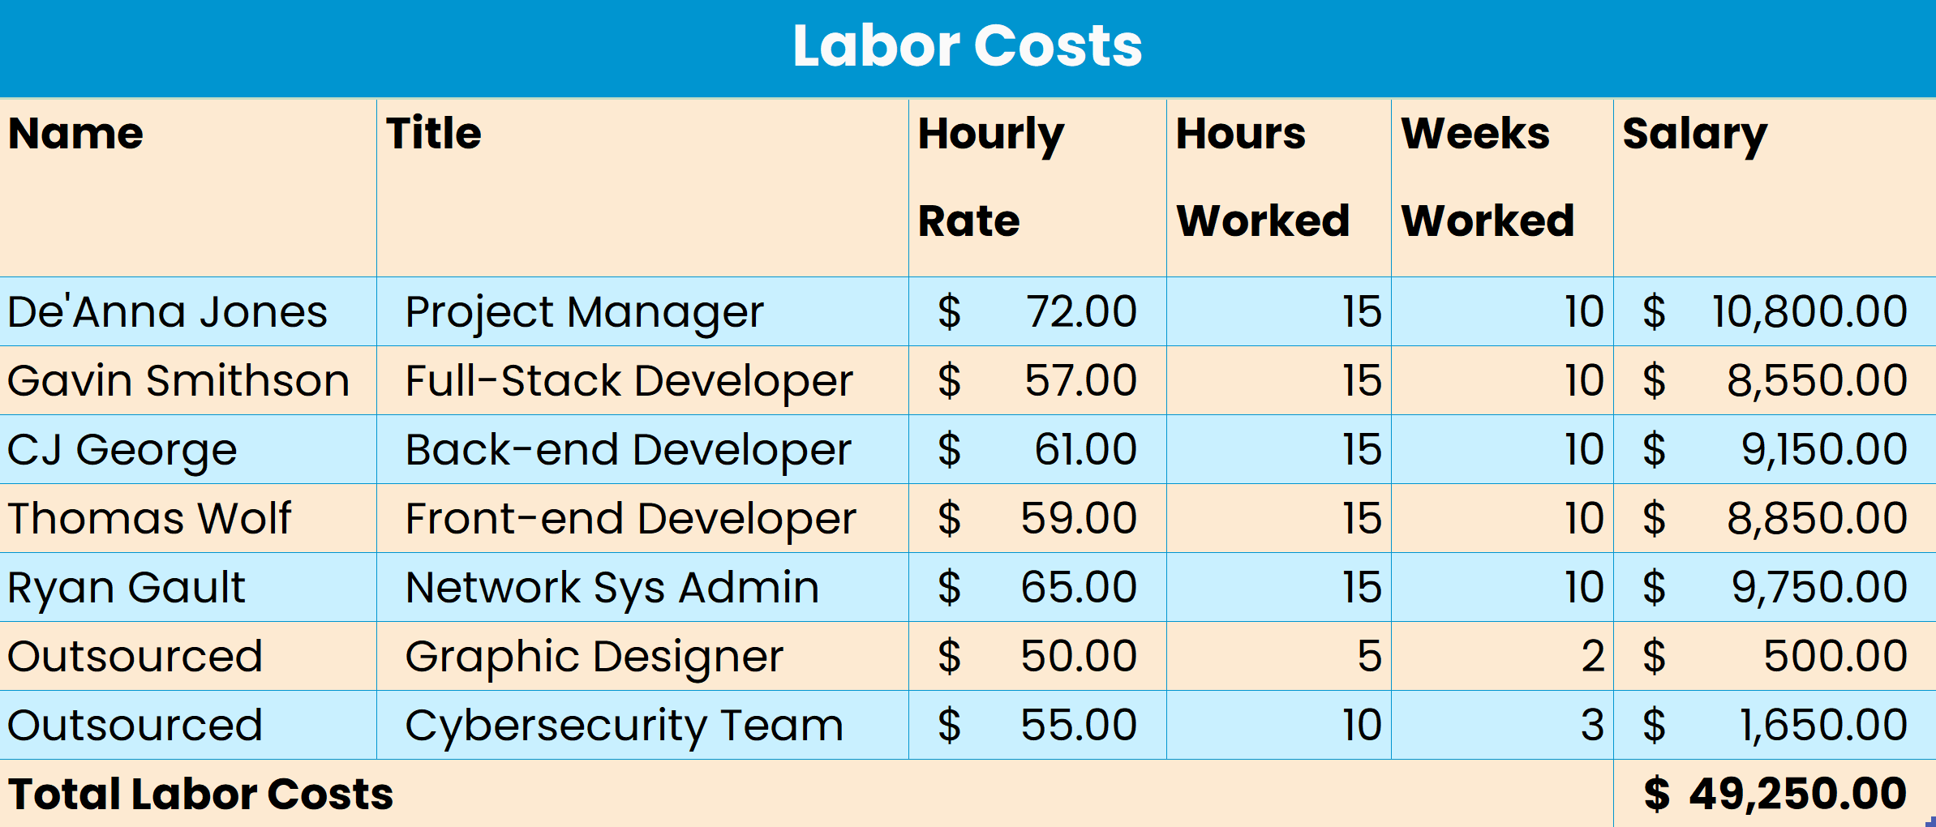

Hardware

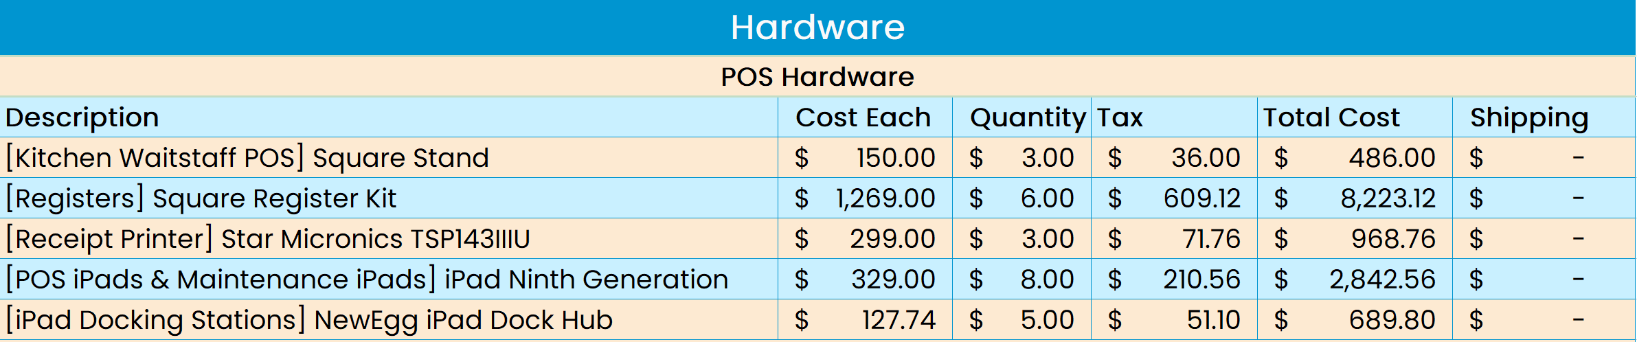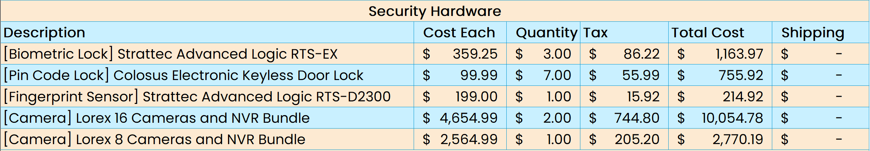

Hardware (cont.)

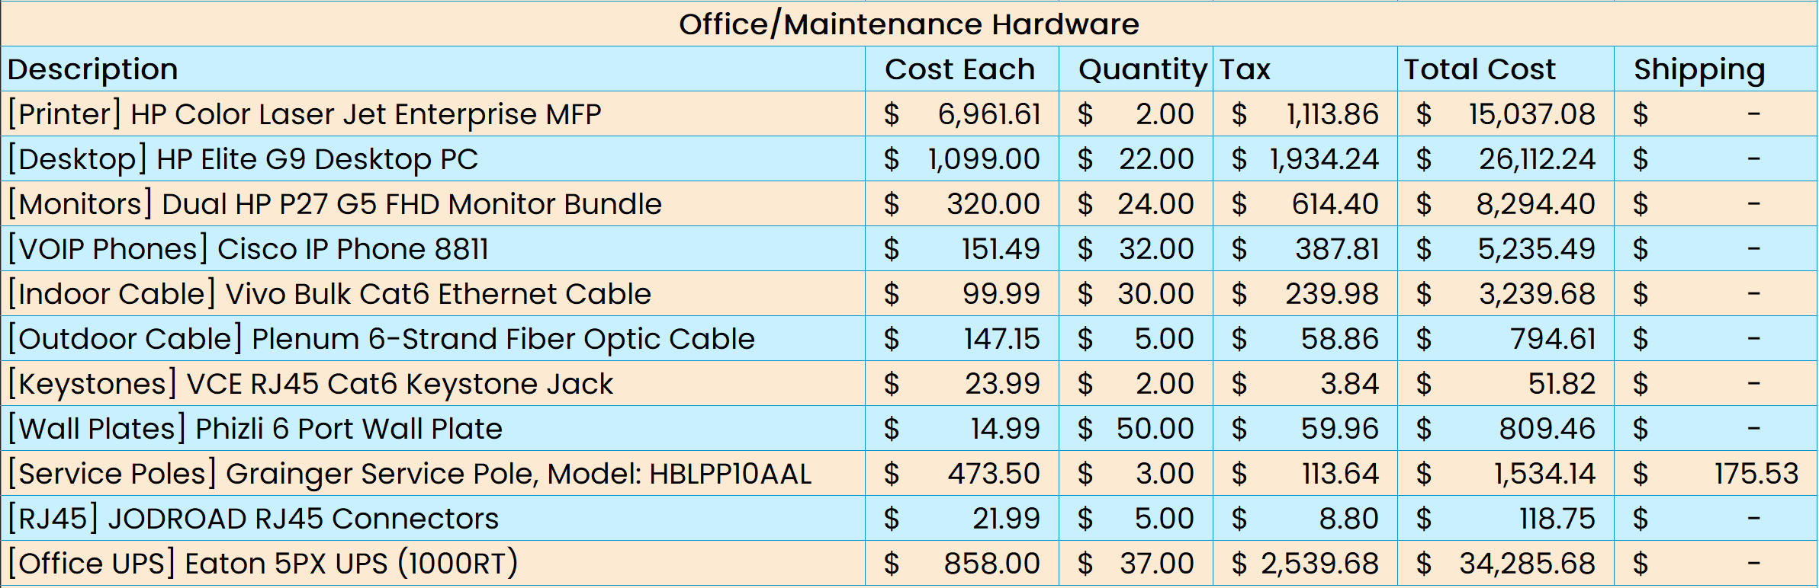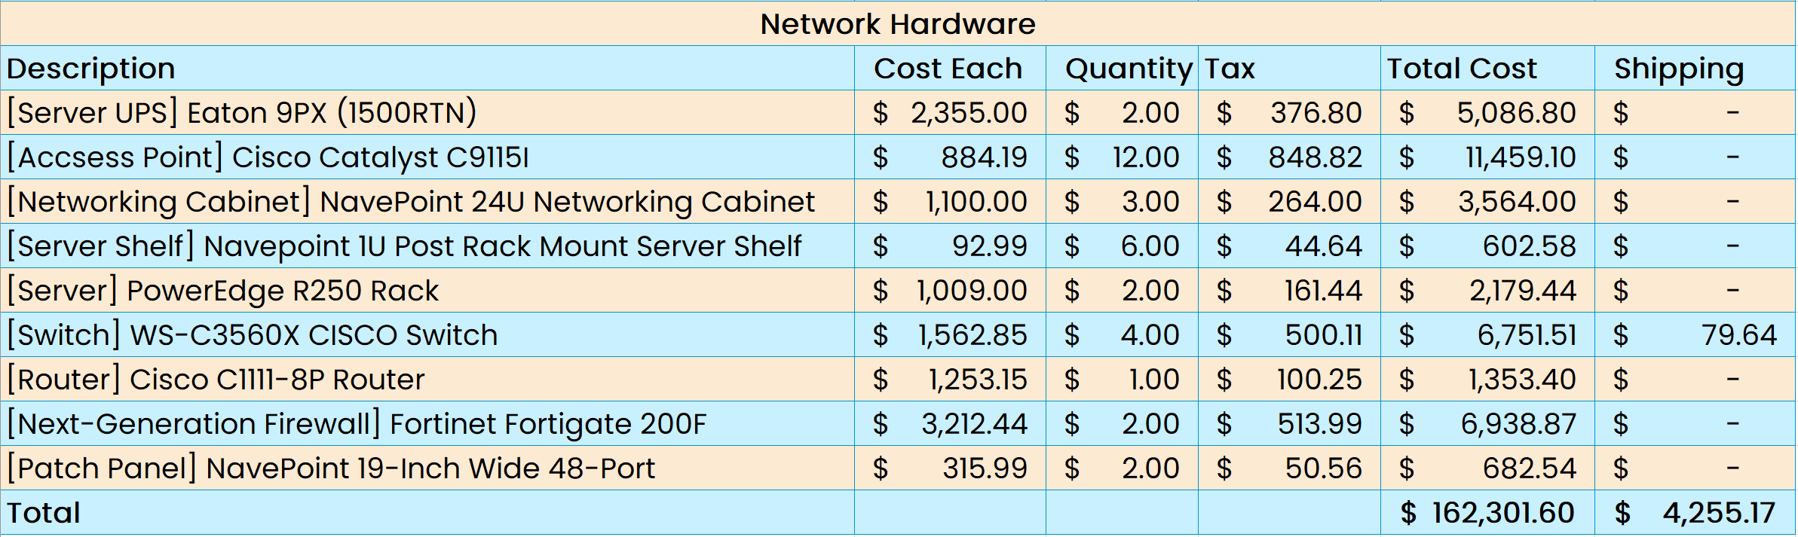

Software

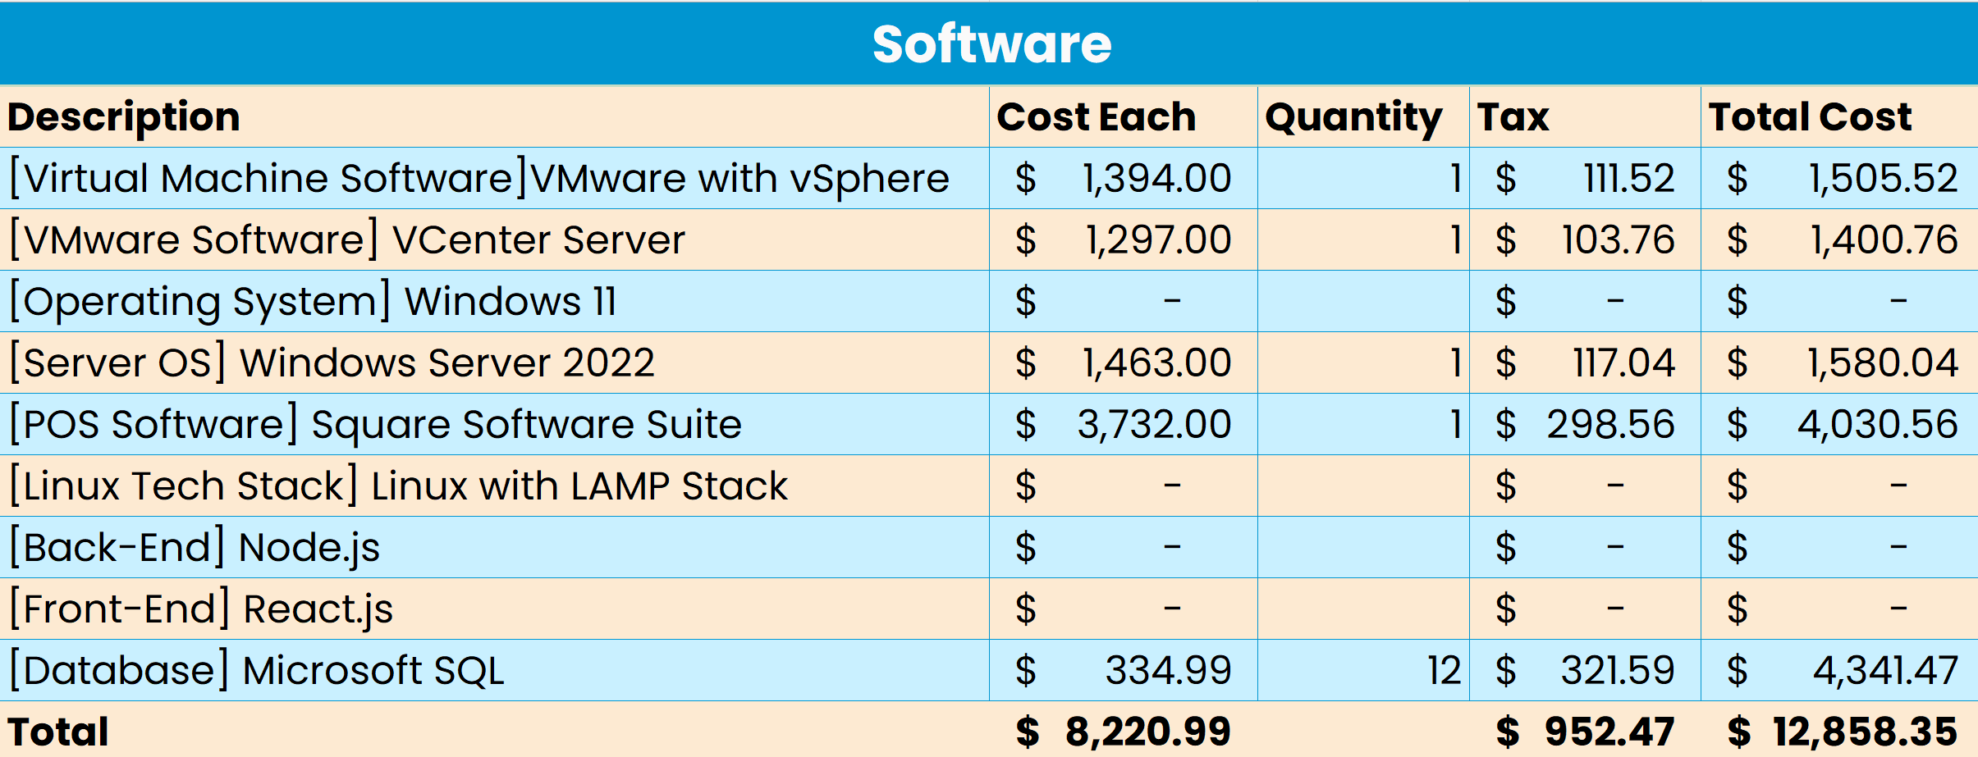

|  |
| --- |
|  |
| Hardware |

# Hardware

Wi-Fi-Access Point

|  |  |
| --- | --- |
| **Cisco Catalyst Wireless Access Point** | |
|  | Specifications |
| - Individual Price: $884.18  - Amount: 6 Wireless Access Points  - Total (pre-tax): $5,305.14  - Limited Lifetime Warranty  - Comes with 802.11ax |
| Cisco Catalyst C9115I: We recommend the Cisco Catalyst C9115I for the wireless access point since Cisco is a trusted company for networking hardware. The device comes equipped with 802.11ax which is the latest network protocol and is considered an IEEE standard. | |

Sever Rack

|  |  |
| --- | --- |
| **NavePoint 24U Mid Depth Networking Cabinet** | |
|  | Specifications |
| - Individual Price: $1,100.00  - Easy cabling setup  - 1,680lb capacity  - Anti-theft Locks  - Compatible with Dell devices |
| We recommend the NavePoint 24U Mid Depth Networking Cabinet. The cabinet’s adjustable rails can hold up to 1000 lbs. The structure allows for proper ventilation with pre-built fan slots to help cool off the equipment. The front door, rear panel, and both side panels have anti-thief locks for maximum security. | |

Server Shelf

|  |  |
| --- | --- |
| **NavePoint 1U Post Rack Mount Server Shelf** | |
|  | Specifications |
| - Individual Price: $92.99  - NavePoint Brand  - Alloy Steel  - Holds 100lbs  - Adjustable for server size  - Alerts to prevent airtime overage  - Desk or rack mount capable |
| We recommend NavePoint 1U Post Rack Mount Server Shelf. NavePoint is a trusted brand which is the same brand as the cabinet itself. These shelves are adjustable to match the cabinet’s depth. Max capacity is 110 pounds with slotted design for venting and cooling. | |

Router

|  |  |
| --- | --- |
| **C1111-8P Integrated Services Router 1100** | |
|  | Specifications |
| - Individual Price: $1,253.15  - Rack-Mountable  - Gigabit is 10x faster  - 3-Protection plan $129.99 |
| We recommend the C1111-8P router as it is compatible with all the other cisco products in your network. This is a reliable device that is capable of 10x better internet speed and is comes equipped with management ports for easy configuration. Cisco is a trusted company when it comes to all things Internet and that is why we recommend this product to your company. | |

Network Switch

|  |  |
| --- | --- |
| **WS-C3560X-24T-S Cisco Switch** | |
|  | Specifications |
| - Individual Price: $1,562.85  - Cisco is a respected company  - 24 full-duplex ports  - Rack mounting capable  - 12-month WIA warranty |
| When it comes to a switch, we recommend the WS-C3560X-24T-S Cisco Switch. With a switch, the main point of one is to connect devices for them to communicate with one another. The main reasoning for this switch is the 24 full-duplex ports which can send and receive data at the same time. | |

Next Generation Fire Wall

|  |  |
| --- | --- |
| **Fortinet FortiGate 200F** | |
|  | Specifications |
| - Individual Price: $3,212.44  - Software-Defined Wide Area  Network: manage and direct traffic across the internet and company sites  - System-on-a-chip acceleration: all  necessary components for a system are on one chip; quicker and more secure than multiple components. |
| For the virtual Next Generation Fire Wall, we recommend Fortinet’s FortiGate 200F. It comes on compact hardware that helps save precious space, has integrated WiFi-6 to offer fast speeds and strong connections, and has continuous risk assessment possibilities for non-stop protection. It also has options for a 3-year warranty ($179.99) and a 4-year warranty ($239.99). | |

Patch Panel

|  |  |
| --- | --- |
| **NavePoint 19-inch Wide 48-Port** | |
|  | Specifications |
| - Individual Price: $315.99  - Can work with any cable plan.  - Numbered ports up to 48 |
| Our Recommendation for patch panel is the NavePoint 19-inch patch panel for the main reason being that it will help the company be able to properly label each port according to where it’s connected by number. It also comes with 48 ports which leaves room for scalability. | |

Server

|  |  |
| --- | --- |
| **Dell PowerEdge R250 Server** | |
| **R250** | Specifications |
| - Individual Price: $1,009.00  - Security integrated into every system  - Full-Stack with VMware |
| Our recommendation for server is the PowerEdge R250 Rack Server from Dell. This server is needed to set up active directory and the mainframe of the network. We personally recommend them based on their 24/7 customer service as well as technicians that can come out and fix any issues. Tech Support Number: 800-999-3355, Customer Support Number: 800-624-9896 | |

Server UPS

|  |  |
| --- | --- |
| **Eaton 9PX1500RT** | |
|  | Specifications |
| - Individual Price: $2,355.00  - 1500VA  - Online/Double Conversion  - 3-Stage Charging  - 3-Year Factory Warranty  - Technical support |
| For powering the server, we recommend the Eaton9PX as the best option in this scenario. Eaton is a reputable brand within its market. Eaton offers excellent customer support and warranties. Another strength is the durability of the products they are known to as industry’s best reliability. | |

Office UPS

|  |  |
| --- | --- |
| **Eaton 5PX1000RT** | |
|  | Specifications |
| - Individual Price: $858.00  - 1000VA  - Line-Active  - 3-Year Factory Warranty  - 1000 W  - Rack/tower |
| For powering the office, we recommend the Eaton5PX as the best option in this scenario. Eaton is a reputable brand within its market. Eaton offers excellent customer support and warranties. | |

Kitchen Waitstaff POS

|  |  |
| --- | --- |
| **Square Stand** | |
|  | Specifications |
| - Individual Price: $150.00  - Features Tap, Card, and Swipe  - Utilizes Square Software Suite  - Built in payments  - Expandable  - Supports Apple Pay |
| The Square stand offers versatility with the ability to utilize the entire square office suite along with housing the power of iOS. Square stands enable waitstaff to carry their iPad to the tables. | |

Registers

|  |  |
| --- | --- |
| **Square Register** | |
|  | Specifications |
| - Individual Price: $1,1269.00  - Attached Cash Register  - Features USB Thermal Receipt  Printer  - Features a detachable customer-  facing display  - Support Appe Pay |
| The Square Register Kit offers a great price and guest experience. The Square Register enables you to have a payment screen for guests to use on the back of the register. | |

Receipt Printer

|  |  |
| --- | --- |
| **Star Micronics TSP143IIIU** | |
|  | Specifications |
| - Individual Price: $299.00  - Compatible with Square Suite  - Thermal Paper  - Replace Rolls are 78$ for 25 rolls  - USB  - Wall mount and vertical mount  included |
| The Star Micronics TSP143IIIU is the Square Receipt Printer. This printer is the best choice for compatibility and reliability within the Point of Sale (POS) system. | |

POS iPads & Maintenance iPads

|  |  |
| --- | --- |
| **iPad Ninth Generation 10.2 Inch** | |
|  | Specifications |
| - Individual Price: $329.00  - Support Apple Pencil  - Touch ID  - Lightning Connector  - 10.2 Inch Display  - Introduced 2021 |
| The ninth generation iPad is a great all-around tool with access to the entire iOS ecosystem. Waitstaff will need these for the Point of Sale (POS) stands, and Maintenance team will use iPads for the kiosks. | |

Ipad Docking Station

|  |  |
| --- | --- |
| **NewEgg iPad Dock Hub** | |
|  | Specifications |
| - Individual Price: $127.74  - Amount: 5  - Shipping included  - Pass through charging  - 11 total ports, room for expandability  - Can have multiple devices connected |
| For iPad docking stations for the maintenance iPad kiosks found in the basement and maintenance shed, we recommend these docking hub stands from NewEgg. They are packed full of ports including 3 USB-C ports and 3 USB-A ports for charging and transferring data. It also has an RJ45 ethernet connector that handles up to 1000 mbps to connect the maintenance iPads to ethernet. | |

Biometric Locks

|  |  |
| --- | --- |
| **Strattec Advance Logic RTS-EX** | |
|  | Specifications |
| - Individual Price: $359.25  - Pin code, Fingerprint, and  Mechanical Key  - Software Included  - Up to 1000 users per lock  - Allows Scheduling of locks  - Weather Resistant |
| We recommend the Strattec Advance Logic RTS-EX. Biometrics are important for ensuring correct individual access to places, so there will be proper identification of individuals. This lock allows for multiple ways of access besides biometric, so there will not extra biometric information in the system. | |

Pin Pad Lock

|  |  |
| --- | --- |
| **Colosus Electronic Keyless Lock** | |
|  | Specifications |
| - Individual Price: $99.99  - No subscription needed  - Pin code, RFID card, remote control,  and physical key  - Batteries included  - Customer Support in English  - Anti-Peeking and Anti-Thief |
| We recommend the Colosus Electronic Keyless lock. This lock is secure with the Anti-peeking and anti-theft precautions for prevention of malicious interactions. Multiple points of access allow for failsafe and backup with the locks. There is no continuous cost since these locks do not need a subscription. If there is a problem, there are call centers based in the United States to help with the problems. | |

Fingerprint Sensor

|  |  |
| --- | --- |
| **Strattec Advance Logic RTS-D2300** | |
|  | Specifications |
| - Individual Price: $199.00  - Software Included  - Register Biometrics  - Recommended for biometric Lock |
| We recommend Strattec Advance Logic RTS-D2300. The registration of the fingerprint is through this device. This device is highly recommended for the biometric lock above. The software is included. | |

Cameras and NVRs

|  |  |
| --- | --- |
| **Lorex Camera and NVR System** | |
|  | Specifications |
| - Individual Price: $4,654.99 pack of  16  - Individual Price: $2,564.99 pack of 8  - Amount: 2 pack of 16  - Amount: 1 pack of 8  - No Subscription  - Night vision  - NVR System |
| We recommend getting two of the sixteen camera bundles and one of the eight camera bundles. This allows full coverage of the property and ensures safety throughout. | |

Printers

|  |  |
| --- | --- |
| **HP Color Laser Jet Enterprise MFP** | |
|  | Specifications |
| - Individual Price: $6,961.61 (shipping  included)  - Optional access to HP’s care  packages for onsite repairs  - Prints 46 pages per minute (ppm)  black and color  - Duty cycle maximum of 200,000  pages a month  - Cost per page (black): 1.3 cents  - Cost per page (color): 2 cents |
| For printers, we recommend two of the HP Color Laser Jet Enterprise MFP. This model offers high print speeds and paper yields, as well as longevity in black and color ink cartridge life. HP also offers shipping included and access to their client services to reduce downtime as much as possible.-- | |

Desktops

|  |  |
| --- | --- |
| **HP Elite Desk Top PC** | |
|  | Specifications |
| - Individual Price: $1,099.00  - Offers multiple drives and  configurable ports.  - Powerful Intel® Core™ i7  Processor  - Protected by HP Wolf Security  - Eco-Friendly  - Windows 11 Pro |
| We recommend this desktop because it is a reliable, secure, and future-proof investment in your IT infrastructure. Its powerful Intel® processor and top of the line HP Wolf Security ensures unbeatable performance and defense which makes it an ideal choice for businesses aiming for growth and resilience in a digital-first world. | |

Monitors

|  |  |
| --- | --- |
| **Dual HP P27 G5 FHD Monitor Bundle** | |
|  | Specifications |
| - Individual Price: $320.00  - 2 27-inch FHD IPS monitors  - 75Hz refresh rate  - 3-sided micro-edge bezel.  - Adjustable tilt stand  - EPEAT® Gold & ENERGY  STAR® rated  - 85% recycled plastics |
| We recommend this Dual HP P27 G5 FHD Monitor Bundle. It will enhance your employees' productivity and comfort. Its combination of high-resolution displays, ergonomic design, and eco-friendly construction makes an ideal choice for modern and sustainable workplaces. | |

VOIP Phones

|  |  |
| --- | --- |
| **Cisco IP Phone 8811** | |
|  | Specifications |
| - Individual Price: $151.49  - Full duplex wideband audio  - High-resolution, widescreen  grayscale display  - Echo cancellation  - Optional wall mount  - One year warranty |
| For VOIP phones, we recommend Cisco’s 8811 model phones. Cisco is a very reliable brand, and their products are covered by a standard one-year warranty. The phones have five programmable buttons, exceptional voice clarity, and optionally mountable. | |

Inside Ethernet Cable

|  |  |
| --- | --- |
| **Vivo Bulk Cat6 Ethernet Cable** | |
|  | Specifications |
| - Individual price: $99.99 For 1,000 ft  - Amount: 30  - 10-Gigabit Ethernet  - Solid CCA  - 4-pair unshielded Twisted pair |
| We recommend Vivo bulk Cat6 Ethernet Cable for the inside installation. These cables will be able to bend properly for indoors installation without breaking or ruining connection. | |

Outside Ethernet Cable

|  |  |
| --- | --- |
| **Plenum 6-Strand Fiber Optic Cable** | |
|  | Specifications |
| - Individual price: $147.15 For 1000ft  - Amount: 5  - Cutoff distance 1,260nm  - Good Protection and Great Stability  - Lifetime Warranty |
| We recommend the Plenum 6-Strand wires. For starters the cables are water blocking which will be good for our local area. Second the cables are designed specifically to be installed underground or above office spaces. | |

Keystone Jack

|  |  |
| --- | --- |
| **VCE RJ45 Cat6 Keystone Jack** | |
|  | Specifications |
| - Individual Price: $23.99 For 25 (.96  cent/per)  - Amount: 2  - Supports up to 1000mbps  - Safe for indoor/outdoors  - Supports Power over Ethernet (PoE)  - 18-month warranty  - Useful for replacing individual  keystones on wall plates |
| For Keystone Jacks, we recommend the VCE RJ45 Cat6 Keystone Jacks. They easily and securely snap into place using plastic retaining clips. They are corrosion resistant with a standard 18-month warranty. | |

Wall Plates

|  |  |
| --- | --- |
| **Phizli 6 Port Wall Plate** | |
|  | Specifications |
| - Individual Price: $14.99  - Installation screws included  - Removable keystones  - Standard size |
| For wall plates, one type we recommend are Phizli’s 6 port wall plate. The keystone jacks are removable and compatible with Cat6. These are particularly useful for areas with high concentrations of devices since the cords can easily be managed into one wall plate. | |

Service Poles

|  |  |
| --- | --- |
| **Grainger Service Pole** | |
|  | Specifications |
| - Individual Price: $473.50  - Pre-wired outlets for power  - 4 outlets, two knockouts  - Simple installation  - Available in different lengths |
| For Service Poles, we recommend the four outlets and two knock-out option from Grainger. The outlets are prewired which keeps installation as simple as possible. These are available in different lengths and can mount on to the ceiling to route wires down to avoid tripping hazards. | |

RJ45 Connectors

|  |  |
| --- | --- |
| **JODROAD RJ45 Connectors** | |
|  | Specifications |
| - Individual Price: $21.99 For 50  - Amount: 5  - Ideal for shielded Cables  - Metal-shield shell  - Prevent electromagnetic interference  (EMI) |
| We recommend JODROAD for cable connectors. These waterproof connectors are highly recommended for thick shielded wires. The metal-shield shells prevent both cross-talking and electromagnetic interference (EMI). | |

|  |
| --- |
|  |
| Software |

# Software

POS Software

|  |  |
| --- | --- |
| **Square Software Suite** | |
|  | Specifications |
| - License (1 year): $ 3,732.00 per year  (Negotiable for each business)  - Omnichannel Payment Processing  - Real-time Analytics  - Inventory Management  - Strong Security  - Integrations with third party apps |
| The square office suite is incredibly powerful and straightforward to use. The Square Office Suite offers restaurant, appointment, and retail specific software for each facet of business. | |

VMware with vSphere

|  |  |
| --- | --- |
| **VmWare with Vsphere Version 7.OU3N** | |
|  | Specifications |
| - License (1 year): $ 1,394.00 per  CPU/year  - Easily scalable for future needs  - Newest version of vSphere 7.OU3N  - Requires 64-Bit capable Server |
| The purpose of using VMW with vSphere is to set up and run virtual machines for the office space. It will also be used to set a firewall for the office space which is crucial to having a secure network. | |

VCenter Server

|  |  |
| --- | --- |
| **VCenter Server** | |
|  | Specifications |
| - Individual Price: $1,297.00  - Simple and Quick Deployment  - Extensibility and Scalability  - Centralized Control and Visibility  - Proactive Optimization  - Native Protection and Recovery  - Plug-in Extensibility  - Proactive Management Tools |
| We recommend VMware vCenter Server for efficient and centralized server management in hybrid clouds. It boosts administrative efficiency, ensures uptime, and easily integrates with public clouds which makes it vital for modern IT. Its scalability and proactive management help businesses meet Service-Level Agreements (SLAs) and reduce costs. | |

Operating System

|  |  |
| --- | --- |
| **Windows 11 Pro** | |
|  | Specifications |
| - Included with Desktop Computers  - Compatibility  - Familiar Interface  - Strong Support  - Microsoft Product Integration |
| Windows is the operating system of choice; Windows is the best choice for an office setting due to the Microsoft Office Suite. Windows 11 is included within the desktop computers of choice which allows us to save on budget. | |

Firewall Software

|  |  |
| --- | --- |
| **FortiOS 7.4** | |
|  | Specifications |
| - Integrated network and security features  - Fortinet Security Fabric architecture built in  - Real-time visibility for network  - Unified management  - Automated threat responses  - Preventive actions with AI and machine learning |
| FortiOS 7.4 is the most up-to-date software for the Fortinet FortiGate series next-generation firewalls. It’s a powerful software with integrated cybersecurity and allows you to manage your network, in real time, from just a few screens, and is optimized to work with a mixture of different devices and setups. | |

Website Software

|  |  |
| --- | --- |
| **Linux with LAMP stack** | |
| lamp-stack-logo » Phoenix Web | Specifications |
| - Open source  - Customizable  - Stability and Uptime  - Security  - Community Support |
| The Linux LAMP stack, consisting of Linux, Apache, MySQL, and PHP, is a capable and open-source software suite which is used for hosting websites along with web applications. Its inclusion will greatly benefit the business. | |

Database Software

|  |  |
| --- | --- |
| **Microsoft SQL Server** | |
|  | Specifications |
| - Individual price: $339.99  - Amount: 12  - Total: $4,079.88  - Allows Multiple Users  - Cost effective for Shifts  - Includes Database Engine Features  and enhancements |
| We recommend Microsoft SQL Device CAL. Microsoft is a trusted brand, and SQL is the preferred language for databases in the industry. Device CAL is the best option for this project, because there will be multiple shifts, individuals, and devices accessing the database. | |

Server 2022 with Active Directory and IIS

|  |  |
| --- | --- |
| **Windows Server 2022 With Active Directory IIS** | |
|  | Specifications |
| - Pricing: $1,463.00  - Advanced multi-layer security  - Improved tools for hybrid server  management  - Can support 25 to 50 devices  - Windows is a reputable company  - Easy to use install wizard |
| The purpose of Server 2022 with active directory is to set up a server and customize the server using active directory and IIS. This is important for running an office network. | |

Back-End Software

|  |  |
| --- | --- |
| **Node.js** | |
|  | Specifications |
| - Open Source  - Industry Standard  - Scalable Network Application  - Asynchronous  - Event-driven  - Low Latency |
| We recommend node, an open-source programming language. This is industry standard for back-end development. A scalable network is produced from its asynchronous event-driven structure. | |

Front-End Software

|  |  |
| --- | --- |
| **React.js** | |
|  | Specifications |
| - Open Source  - Reactive websites  - Industry Standard  - Library with tools for websites |
| We recommend react. This open-source software allows website to be reactive to the end-user’s interactions. Reacts dynamic interfaces react are industry standard which optimizes business. | |

Primary ISP

|  |  |
| --- | --- |
| **HTC** | |
|  | Specifications |
| - Individual Price: $74.90/month  - One Year Cost: $898.89/year  - Primary ISP  - Both Internet and Phone  - Installation and equipment included  - 750 MBPS |
| HTC is our recommendation for the primary Internet Service Provider (ISP). HTC reliably serves local businesses across the Grand Strand. There is a bundle deal for both internet and phones which includes equipment and installation prices. The speeds are starting at 750mbps | |

Secondary ISP

|  |  |
| --- | --- |
| **Spectrum Business** | |
|  | Specifications |
| - Individual Price: $79.98/month  - One Year Cost: $959.76/year  - Secondary ISP  - Both Internet and Phone  - 600 MBPS |
| Spectrum Business is our recommendation for the secondary Internet Service Provider (ISP). Spectrum is in familiar in the Grand Strand area. They offer a bundle deal for both internet and phone with a bonus of a free unlimited phone line when one purchases the bundle. Spectrum offers an all-in-one app for meeting and messages. | |

Cloud Provider

|  |  |
| --- | --- |
| **Wasabi Hot Cloud Storage** | |
|  | Specifications |
| - Monthly Price: $139.80 (20  terabytes)  - One Year Cost: $1,677.60  - Cloud Storage  - S3 Object Lock  - No charge for egress or API requests  - Increased RTO/RPO |
| Wasabi Hot Cloud Storage is recommended for cloud storage. Wasabi specializes in cloud storage, so they prioritize functional and cost. There are no charges for egress and API when retrieving the backups form them. The backups are secured with the S3 Object Lock where backups are lock from changes to keep integrity. With an increase of Recovery Time Objective and Recovery Point Objective, Wasabi is highly recommended for this project. | |

|  |
| --- |
|  |
| Security Polices |

# Security Polices

Acceptable Use Policy

Acceptable Use Policy

**Last Update Status:** *Updated October 2022*

**Free Use Disclaimer:** *This policy was created by or for the SANS Institute for the Internet community. All or parts of this policy can be freely used for your organization. There is no prior approval required. If you would like to contribute a new policy or updated version of this policy, please send email to* [*policy-resources@sans.org*](mailto:policy-resources@sans.org)*.*

1. **Overview**

Infosec Team’s intentions for publishing an Acceptable Use Policy are not to impose restrictions that are contrary to <Company Name>’s established culture of openness, trust and integrity. <Company Name> is committed to protecting <Company Name>'s employees, partners and the company from illegal or damaging actions by individuals, either knowingly or unknowingly.

Internet/Intranet/Extranet-related systems, including but not limited to computer equipment, mobile devices, software, operating systems, storage media, network accounts providing electronic mail, WWW browsing, and FTP, are the property of <Company Name>. These systems are to be used for business purposes in serving the interests of the company, and of our clients and customers during normal operations. Please review Human Resources policies for further details.

Effective security is a team effort involving the participation and support of every <Company Name> employee and affiliate who deals with information and/or information systems. It is the responsibility of every computer user to know these guidelines, and to conduct their activities accordingly.

1. **Purpose**

The purpose of this policy is to outline the acceptable use of computer equipment and other electronic devices at <Company Name>. These rules are in place to protect the employee and <Company Name>. Inappropriate use exposes <Company Name> to cyber risks including virus attacks including ransomware, compromise of network systems and services, data breach, and legal issues.

1. **Scope**

This policy applies to the use of information, electronic and computing devices, and network resources to conduct <Company Name> business or interact with internal networks and business systems, whether owned or leased by <Company Name>, the employee, or a third party. All employees, contractors, consultants, temporary, and other workers at <Company Name> and its subsidiaries are responsible for exercising good judgment regarding appropriate use of information, electronic devices, and network resources in accordance with <Company Name> policies and standards, and local laws and regulation. Exceptions to this policy are documented in section 5.2

This policy applies to employees, contractors, consultants, temporaries, and other workers at <Company Name>, including all personnel affiliated with third parties. This policy applies to all equipment that is owned or leased by <Company Name>.

1. **Policy**
   1. **General Use and Ownership** 
      1. <Company Name> proprietary information stored on electronic and computing devices whether owned or leased by <Company Name>, the employee or a third party, remains the sole property of <Company Name>. You must ensure through legal or technical means that proprietary information is protected in accordance with the *Data Protection Standard.*
      2. You have a responsibility to promptly report the theft, loss, or unauthorized disclosure of <Company Name> proprietary information.
      3. You may access, use or share <Company Name> proprietary information only to the extent it is authorized and necessary to fulfill your assigned job duties.
      4. Employees are responsible for exercising good judgment regarding the reasonableness of personal use. Individual departments are responsible for creating guidelines concerning personal use of Internet/Intranet/Extranet systems. In the absence of such policies, employees should be guided by departmental policies on personal use, and if there is any uncertainty, employees should consult their supervisor or manager.
      5. For security and network maintenance purposes, authorized individuals within <Company Name> may monitor equipment, systems, and network traffic at any time, per Infosec's *Audit Policy*.
      6. <Company Name> reserves the right to audit networks and systems on a periodic basis to ensure compliance with this policy.
   2. **Security and Proprietary Information**
      1. All mobile and computing devices that connect to the internal network must comply with the *Minimum Access Policy*.
      2. System level and user level passwords must comply with the *Password Policy*. Providing access to another individual, either deliberately or through failure to secure its access, is prohibited.
      3. All computing devices must be secured with a password-protected lock screen with the automatic activation feature set to 10 minutes or less. You must lock the screen or log off when the device is unattended.
      4. Postings by employees from a <Company Name> email address to newsgroups or other online platforms, should contain a disclaimer stating that the opinions expressed are strictly their own and not necessarily those of <Company Name>, unless posting is during business duties.
      5. Employees must use extreme caution when opening email attachments received from unknown senders, which may contain malware.
   3. **Unacceptable Use**

The following activities are, in general, prohibited. Employees may be exempted from these restrictions during their legitimate job responsibilities (e.g., systems administration staff may have a need to disable the network access of a host if that host is disrupting production services).Under no circumstances is an employee of <Company Name> authorized to engage in any activity that is illegal under local, state, federal or international law while utilizing <Company Name>-owned resources.

The lists below are by no means exhaustive but attempt to provide a framework for activities which fall into the category of unacceptable use.

* + 1. **System and Network Activities**

The following activities are strictly prohibited, with no exceptions:

1. Violations of the rights of any person or company protected by copyright, trade secret, patent or other intellectual property, or similar laws or regulations, including, but not limited to, the installation or distribution of "pirated" or other software products that are not appropriately licensed for use by <Company Name>.
2. Unauthorized copying of copyrighted material including, but not limited to, digitization and distribution of photographs from magazines, books or other copyrighted sources, copyrighted music, and the installation of any copyrighted software for which <Company Name> or the end user does not have an active license is strictly prohibited.
3. Accessing data, a server, or an account for any purpose other than conducting <Company Name> business, even if you have authorized access, is prohibited.
4. Exporting software, technical information, encryption software or technology, in violation of international or regional export control laws, is illegal. The appropriate management should be consulted prior to export of any material that is in question.
5. Introduction of malicious programs into the network or server (e.g., viruses, worms, trojan horses, ransomware, etc.).
6. Revealing your account password/passphrase to others or allowing use of your account by others. This includes family and other household members when work is being done at home.
7. Using a <Company Name> computing asset to actively engage in procuring or transmitting material that is in violation of sexual harassment or hostile workplace laws in the user's local jurisdiction.
8. Making fraudulent offers of products, items, or services originating from any <Company Name> account.
9. Making statements about warranty, expressly or implied, unless it is a part of normal job duties.
10. Effecting security breaches or disruptions of network communication. Security breaches include, but are not limited to, accessing data of which the employee is not an intended recipient or logging into a server or account that the employee is not expressly authorized to access, unless these duties are within the scope of regular duties. For purposes of this section, "disruption" includes, but is not limited to, network sniffing, ping floods, packet spoofing, denial of service, brute-forcing accounts, and forged routing information for malicious purposes.
11. Port scanning or security scanning is expressly prohibited unless prior notification to the Infosec Team is made.
12. Executing any form of network monitoring which will intercept data not intended for the employee's host, unless this activity is a part of the employee's normal job/duty.
13. Circumventing user authentication or security of any host, network, or account.
14. Introducing honeypots, honeynets, or similar technology on the <Company Name> network.
15. Interfering with or denying service to any user other than the employee's host (for example, denial of service attack).
16. Using any program/script/command, or sending messages of any kind, with the intent to interfere with, or disable, a user's terminal session, via any means, locally or via the Internet/Intranet/Extranet.
17. Providing information about, or lists of, <Company Name> employees to parties outside <Company Name>.
    * 1. **Email and Communication Activities**

When using company resources to access and use the Internet, users must realize theyrepresent the company. Whenever employees state an affiliation to the company, they must also clearly indicate that "the opinions expressed are my own and not necessarily those of the company". Questions may be addressed to the IT Department

1. Sending unsolicited email messages, including the sending of "junk mail" or other advertising material to individuals who did not specifically request such material (email spam).
2. Any form of harassment via email, telephone, text, or paging, whether through language, frequency, or size of messages.
3. Unauthorized use, or forging, of email header information.
4. Solicitation of email for any other email address, other than that of the poster's account, with the intent to harass or to collect replies.
5. Creating or forwarding "chain letters", "Ponzi" or other "pyramid" schemes of any type.
6. Use of unsolicited email originating from within <Company Name>'s networks of other Internet/Intranet/Extranet service providers on behalf of, or to advertise, any service hosted by <Company Name> or connected via <Company Name>'s network.
7. Posting the same or similar non-business-related messages to large numbers of Usenet newsgroups (newsgroup spam).
   * 1. **Blogging and Social Media**
8. Blogging or posting to social media platforms by employees, whether using <Company Name>’s property and systems or personal computer systems, is also subject to the terms and restrictions set forth in this Policy. Limited and occasional use of <Company Name>’s systems to engage in blogging or other online posting is acceptable, provided that it is done in a professional and responsible manner, does not otherwise violate <Company Name>’s policy, is not detrimental to <Company Name>’s best interests, and does not interfere with an employee's regular work duties. Blogging or other online posting from <Company Name>’s systems is also subject to monitoring.
9. <Company Name>’s Confidential Information policy also applies to blogging. As such, Employees are prohibited from revealing any <Company> confidential or proprietary information, trade secrets or any other material covered by <Company>’s Confidential Information policy when engaged in blogging.
10. Employees shall not engage in any blogging that may harm or tarnish the image, reputation and/or goodwill of <Company Name> and/or any of its employees. Employees are also prohibited from making any discriminatory, disparaging, defamatory or harassing comments when blogging or otherwise engaging in any conduct prohibited by <Company Name>’s *Non-Discrimination and Anti-Harassment* policy.
11. Employees may also not attribute personal statements, opinions or beliefs to <Company Name> when engaged in blogging. If an employee is expressing his or her beliefs and/or opinions in blogs, the employee may not, expressly, or implicitly, represent themselves as an employee or representative of <Company Name>. Employees assume any and all risk associated with blogging.
12. Apart from following all laws pertaining to the handling and disclosure of copyrighted or export-controlled materials, <Company Name>’s trademarks, logos and any other <Company Name> intellectual property may also not be used in connection with any blogging or social media activity
13. **Policy Compliance**
    1. Compliance Measurement

The Infosec Team will verify compliance to this policy through various methods, including but not limited to, business tool reports, internal and external audits, and feedback to the policy owner.

* 1. Exceptions

Any exception to the policy must be approved by the Infosec team in advance.

* 1. Non-Compliance

An employee found to have violated this policy may be subject to disciplinary action, up to and including termination of employment.

1. **Related Standards, Policies and Processes**

* Data Classification Policy
* Data Protection Standard
* Social Media Policy
* Minimum Access Policy
* Password Policy

1. **Definitions and Terms**

The following definition and terms can be found in the SANS Glossary located at:

https://www.sans.org/security-resources/glossary-of-terms/

* Blogging
* Honeypot
* Honeynet
* Proprietary Information
* Spam
* Ransomware

1. **Revision History**

|  |  |  |
| --- | --- | --- |
| Date of Change | Responsible | Summary of Change |
| June 2014 | SANS Policy Team | Updated and converted to new format. |
| Oct 2022 | SANS Policy Team | Updated and converted to new format. |

Active Directory User Naming Conventions

**Active Directory User Naming Conventions**

**Things to consider**

* Legacy applications or computer systems with 8-character limit
* Security
* Single Sign on with other systems

Some legacy applications only allow 8 characters for the username. If you have programs like this, then you may want to limit your Active Directory accounts to 8 characters as well. Most programs let you map the username to a windows name which could be different.

The problem is this creates a different logon name your users will need to remember. We want to make things as easy for the users as possible. Some of the commonly used naming conventions creates easy to guess logon names, there is a security concern with this.

This makes it easy for spammers and hackers to guess the logon name and email address. The last thing to consider is your applications that use single sign on, will the naming scheme you choose be compatible with SSO.

**Exceptions Policy**

* Duplicate names
* Last name change
* Odd or horrible logon names

There will always be problems so you will need to be flexible with your users. For large environments, you could run into duplicate accounts with some of these methods. You will want to have the user’s complete name including the middle; you can use the . First three characters of the first name and first three of last name: You combine the first three characters of the first name and the first three of the last name.

Example:

Joe Smith logon name would be joesmi, if duplicates just add the middle initial joeasmi.

This method has the advantage of creating short easy to remember logon names. It would also keep the logon name under 8 characters. I don’t see any major drawbacks to this method, except that it might create some duplicate names.

4. Three random letters and three numbers: This one was not commonly used but I could see some advantages to using it. It would work well in a very large environment. You would also avoid duplicate names and renaming accounts if a user’s last name changed.

The only drawback to this is the email address; I don’t think the users would want an email address that is random characters, but you could always give them a different email address.

This also may help with spam and security. If spammers get a list of usernames, they will not be able to guess their email address.

Example: aed234

What you could do to make it a little easier for users to remember is use the first three characters of their first name and three random numbers.

Example: For Joe Smith the logon name would be joe234

|  |  |  |  |
| --- | --- | --- | --- |
| Signature |  | Date |  |
| Title |  |  |  |

Bluetooth Baseline Requirements Policy

**Bluetooth Baseline Requirements Policy**

**Last Update Status:** *Updated October 2022*

**Free Use Disclaimer:** *This policy was created by or for the SANS Institute for the Internet community. All or parts of this policy can be freely used for your organization. There is no prior approval required. If you would like to contribute a new policy or updated version of this policy, please send email to* [*policy-resources@sans.org*](mailto:policy-resources@sans.org)*.*

**Things to Consider:** *Please consult the Things to Consider FAQ for additional guidelines and suggestions for personalizing the SANS policies for your organization.*

middle name if you run into duplicate accounts.

There have been a few times where I’ve still run into duplicate accounts even after using the middle initial. When this occurs, we just add a number to the end of the account. For any method that uses the full last name you will probably run into users that get married and will need their logon name changed.

In these types of circumstances, extra work will be required which include renaming the Active Directory account, and home directories. The email address will also need to be either renamed or have a new alias added. You may also end up with some bad logon names that the users request to be changed, this is rare, but it does happen.

**Naming Conventions**

1. Complete first name plus last name: This is by far the most commonly used naming convention I found other people using. You take the users complete first name and combine it with complete last name. A hyphen or period may also be added.

Example: For Joe smith the logon name would be joe.smith, if there are duplicates just add the middle initial joe.a.smith.

This method has the advantage of creating easy to remember logon names and it works well for small and large organizations. The one drawback to this method is it can create long names that are over 8 characters.

2. Initial of first name and complete last name: You take the user’s first initial and combine it with their complete last name. This works well for large and small organizations, and it keeps the logon name shorter. In large organizations you will have some duplicates. This method can also create some odd logon names.

The funniest combination I’ve seen was with a user Todd Estes, the logon name was testes. It didn’t take long for the user to call and request the name be changed. You must be flexible and make your end users happy

Example: For Joe Smith the logon name would be jmith, if there are duplicates use the middle initial jasmith.

1. **Overview**

Insecure Bluetooth connections can introduce a number of potential serious security issues. Hence, there is a need for a minimum standard for connecting Bluetooth enable devices.

1. **Purpose**

The purpose of this policy is to provide a minimum baseline standard for connecting Bluetooth enabled devices to the <Company Name> network or <Company Name> owned devices. The intent of the minimum standard is to ensure sufficient protection Personally Identifiable Information (PII) and confidential <Company Name> data.

1. **Scope**

This policy applies to any Bluetooth enabled device that is connected to <Company Name> network or owned devices.

1. **Policy**
   1. **Version**

No Bluetooth Device shall be deployed on <Company Name> equipment that does not meet a minimum of Bluetooth v2.1 specifications without written authorization from the Infosec Team. Any Bluetooth equipment purchased prior to this policy must comply with all parts of this policy except the Bluetooth version specifications.

* 1. **Pins and Pairing**

When pairing your Bluetooth unit to your Bluetooth enabled equipment (i.e. phone, laptop, etc.), ensure that you are not in a public area where you PIN can be compromised.

If your Bluetooth enabled equipment asks for you to enter your pin after you have initially paired it, you must refuse the pairing request and report it to Infosec, through your Help Desk, immediately.

* 1. **Device Security Settings**
* All Bluetooth devices shall employ ‘security mode 3’ which encrypts traffic in both directions, between your Bluetooth Device and its paired equipment.
* Use a minimum PIN length of 8. A longer PIN provides more security.
* Switch the Bluetooth device to use the hidden mode (non-discoverable)
* Only activate Bluetooth only when it is needed.
* Ensure device firmware is up-to-date.
  1. **Security Audits**

The Infosec Team may perform random audits to ensure compliancy with this policy. In the process of performing such audits, Infosec Team members shall not eavesdrop on any phone conversation.

* 1. **Unauthorized Use**

The following is a list of unauthorized uses of <Company Name>-owned Bluetooth devices:

* Eavesdropping, device ID spoofing, DoS attacks, or any form of attacking other Bluetooth enabled devices.
* Using <Company Name>-owned Bluetooth equipment on non-<Company Name>-owned Bluetooth enabled devices.
* Unauthorized modification of Bluetooth devices for any purpose.
  1. **User Responsibilities**
* It is the Bluetooth user's responsibility to comply with this policy.
* Bluetooth mode must be turned off when not in use.
* PII and/or <Company Name> Confidential or Sensitive data must not be transmitted or stored on Bluetooth enabled devices.
* Bluetooth users must only access <Company Name> information systems using approved Bluetooth device hardware, software, solutions, and connections.
* Bluetooth device hardware, software, solutions, and connections that do not meet the standards of this policy shall not be authorized for deployment.
* Bluetooth users must act appropriately to protect information, network access, passwords, cryptographic keys, and Bluetooth equipment.
* Bluetooth users are required to report any misuse, loss, or theft of Bluetooth devices or systems immediately to Infosec.

1. **Policy Compliance**
   1. Compliance Measurement

The Infosec Team will verify compliance to this policy through various methods, including but not limited to, periodic walk-thrus, video monitoring, business tool reports, internal and external audits, and feedback to the policy owner.

* 1. Exceptions

Any exception to the policy must be approved by the Infosec Team in advance.

* 1. Non-Compliance

An employee found to have violated this policy may be subject to disciplinary action, up to and including termination of employment.

1. **Related Standards, Policies and Processes**

None.

1. **Definitions and Terms**

None.

1. **Revision History**

|  |  |  |
| --- | --- | --- |
| Date of Change | Responsible | Summary of Change |
| June 2014 | SANS Policy Team | Updated and converted to new format. |
| October 2022 | SANS Policy Team | Converted to new format. |

Data Backup Plan

**Data Backup Policy**

**Purpose and Scope**

* The purpose of this policy is as follows:
  + To safeguard the information assets of <Company Name>
  + To prevent the loss of data in the case of an accidental deletion or corruption of data, system failure, or disaster.
  + To permit timely restoration of information and business processes, should such events occur.
  + To manage and secure backup and restoration processes and the media employed in the process.
* This policy applies to all servers in the Information Technology (IT) Data and Telephone Centers, including the Network Attached Storage (NAS)
* The retention periods of information contained within system level backups are designed for recoverability and provide a point-in-time snapshot of information as it existed during the time period defined by system backup policies.
  + Backup retention periods are in contrast to retention periods defined by legal or business requirements.
  + System backups are not meant for the following purposes:
    - Archiving data for future reference.
    - Maintaining a versioned history of data.

**Policy**

* Systems will be backed up according to the schedule below:
  + Data stored on the server will be regularly backed up as follows:
    - Incremental backup daily (Mon.-Fri.) and data located on-site.
    - Full backup weekly (Sat.) and data located off-site.
  + Exchange Mailbox will be regularly backed up as follows:
    - Full backup daily (Mon.-Fri.) and data located on-site.
    - Full backup weekly (Sat.) and data located off-site.
  + Windows Servers (not in DMZ) will be regularly backed up as follows:
    - Incremental backup daily (Mon.-Fri.) and data stored on-site.
    - Full backup weekly (Sat.) and data located off-site.
  + The Virtual Machine Server will have its VM data drive regularly backed up as follows:
    - Image backups of virtual machines will be taken on Tuesday and Thursday. These backup files will be stored on-site.
    - Weekly file and folder full backup will be taken on Sunday. These backup files will be stored off-site.
* Backup tapes will be transported and stored as described below:
  + Currently all backups will be written to reusable media with capacity of 400 GB uncompressed (800 GB compressed) and a transfer rate of 60 MB/Sec (native).
  + Media will be clearly labeled and stored in a secure area that is accessible only to IT staff or employees of the contracted secure off-site media vaulting vendor used by IT.
  + During transport or changes of media, media will not be left unattended.
  + Daily backups will be stored on-site in a physically secured fire-proof safe located in a building separate from the Data Center.
    - Daily backups will be maintained for one week.
  + Weekly backups will be stored in a physically secured, off-site media vaulting location maintained by a third party.
    - Weekly backups will be maintained for a period of three weeks.
    - After the period of three weeks has elapsed, the media will be returned to IT and will be either re-used or destroyed.
* Media will be retired and disposed of as described below:
  + Prior to retirement and disposal, IT will ensure that:
    - The media no longer contains active backup images
    - The media’s current or former contents cannot be read or recovered by an unauthorized party.
  + With all backup media, IT will ensure the physical destruction of media prior to disposal.
* Backups will be verified periodically.
  + On a daily basis, logged information generated from each backup job will be reviewed for the following purposes**:**
    - To check for and correct errors.
    - To monitor the duration of the backup job.
    - To optimize backup performance where possible.
  + IT will identify problems and take corrective action to reduce any risks associated with failed backups.
  + Random test restores will be done once a week in order to verify that backups have been successful
  + IT will maintain records demonstrating the review of logs and test restores so as to demonstrate compliance with this policy for auditing purposes.
* Data Recovery
  + In the event of a catastrophic system failure, off-site backed up data will be made available to users within 3 working days if the destroyed equipment has been replaced by that time.
  + In the event of a non-catastrophic system failure or user error, on-site backed up data will be made available to users within 1 working day.
* Restoration Requests
  + In the event of accidental deletion or corruption of information, requests for restoration of information will be made to Ron Wood.

**Responsibilities**

* Backups and Date Recovery <Person Responsible >
* Telephone System Backups <Person Responsible>
* Verification <Person Responsible>
* Disaster Recovery Policy

Disaster Recovery Plan Policy

**Free Use Disclaimer:** *This policy was created by or for the SANS Institute for the Internet community. All or parts of this policy can be freely used for your organization. There is no prior approval required. If you would like to contribute a new policy or updated version of this policy, please send email to* [*policy-resources@sans.org*](mailto:policy-resources@sans.org)*.*

**Last Update Status:** *Updated June 2014*

**1.Overview**

Since disasters happen so rarely, management often ignores the disaster recovery planning process. It is important to realize that having a contingency plan in the event of a disaster gives <Company Name> a competitive advantage. This policy requires management to financially support and diligently attend to disaster contingency planning efforts. Disasters are not limited to adverse weather conditions. Any event that could likely cause an extended delay of service should be considered. The Disaster Recovery Plan is often part of the Business Continuity Plan.

**2.Purpose**

This policy defines the requirement for a baseline disaster recovery plan to be developed and implemented by <Company Name> that will describe the process to recover IT Systems, Applications and Data from any type of disaster that causes a major outage.

**3.Scope**

This policy is directed to the IT Management Staff who is accountable to ensure the plan is developed, tested and kept up-to-date. This policy is solely to state the requirement to have a disaster recovery plan, it does not provide requirement around what goes into the plan or sub-plans.

**4.Policy**

4.1 Contingency Plans

The following contingency plans must be created:

* Computer Emergency Response Plan:Who is to be contacted, when, and how? What immediate actions must be taken in the event of certain occurrences?
* Succession Plan:Describe the flow of responsibility when normal staff is unavailable to perform their duties.
* Data Study:Detail the data stored on the systems, its criticality, and its confidentiality.
* Criticality of Service List:List all the services provided and their order of importance.
* It also explains the order of recovery in both short-term and long-term timeframes.
* Data Backup and Restoration Plan:Detail which data is backed up, the media to which it is saved, where that media is stored, and how often the backup is done. It should also describe how that data could be recovered.
* Equipment Replacement Plan:Describe what equipment is required to begin to provide services, list the order in which it is necessary, and note where to purchase the equipment.
* Mass Media Management:Who is in charge of giving information to the mass media?
* Also provide some guidelines on what data is appropriate to be provided.

After creating the plans, it is important to practice them to the extent possible. Management should set aside time to test implementation of the disaster recovery plan. Table top exercises should be conducted annually. During these tests, issues that may cause the plan to fail can be discovered and corrected in an environment that has few consequences.

The plan, at a minimum, should be reviewed an updated on an annual basis.

**5.Policy Compliance**

* 1. Compliance Measurement

The Infosec team will verify compliance to this policy through various methods, including but not limited to, periodic walk-thrus, video monitoring, business tool reports, internal and external audits, and feedback to the policy owner.

* 1. Exceptions

Any exception to the policy must be approved by the Infosec Team in advance.

* 1. Non-Compliance

An employee found to have violated this policy may be subject to disciplinary action, up to and including termination of employment.

1. **Related Standards, Policies and Processes**

None.

1. **Definitions and Terms**

The following definition and terms can be found in the SANS Glossary located at:

https://www.sans.org/security-resources/glossary-of-terms/

* Disaster

1. **Revision History**

|  |  |  |
| --- | --- | --- |
| Date of Change | Responsible | Summary of Change |
| June 2014 | SANS Policy Team | Updated and converted to new format. |
|  |  |  |

Password Protection Policy

**Password Protection Policy**

**Last Update Status:** *Updated October 2022*

**Free Use Disclaimer:** *This policy was created by or for the SANS Institute for the Internet community. All or parts of this policy can be freely used for your organization. There is no prior approval required. If you would like to contribute a new policy or updated version of this policy, please send email to* [*policy-resources@sans.org*](mailto:policy-resources@sans.org)*.*

**1.Overview**

Passwords are a critical aspect of computer security. A weak or compromised password can result in unauthorized access to our most sensitive data and/or exploitation of our resources. All staff, including contractors and vendors with access to <Company Name> systems, are responsible for taking the appropriate steps, as outlined below, to select and secure their passwords.

**2.Purpose**

The purpose of this policy is to establish a standard for the secure use and protection of all work related passwords.

**3.Scope**

The scope of this policy includes all personnel who have or are responsible for an account (or any form of access that supports or requires a password) on any system that resides at any <Company Name> facility, has access to the <Company Name> network, or stores any non-public <Company Name> information.

**4.Policy**

* 1. **Password Creation and Use**

4.1.1 All user-level and system-level passwords must conform to the *Password Construction Guidelines*.

4.1.2 Users must use a separate, unique password for each of their work related accounts. Users may not use any work related passwords for their own, personal accounts.

4.1.3 Staff are allowed to use authorized, approved password managers to securely store and manage all their work related passwords.

4.1.4 User accounts that have system-level privileges granted through group memberships or programs such as sudo must have a unique password from all other accounts held by that user to access system-level privileges. In addition, it is highly recommended that some form of multi-factor authentication is used for any privileged accounts

* 1. **Password Change**
     1. Passwords should be changed only when there is reason to believe a password has been compromised or fails to meet our Password Creation Requirements.. We do not recommend the use or setting of regular password expiration.
  2. **Password Protection**
     1. Passwords must not be shared with anyone, including supervisors and coworkers. All passwords are to be treated as sensitive, Confidential <Company Name> information. Corporate Information Security recognizes that legacy applications do not support proxy systems in place. Please refer to the technical reference for additional details.
     2. Passwords must not be inserted into email messages or other forms of electronic communication, nor revealed over the phone to anyone.
     3. Passwords may be stored only in password managers authorized by the organization.
     4. Do not use the "Remember Password" feature of applications (for example, web browsers).
     5. Any individual suspecting that their password may have been compromised must report the incident and change all relevant passwords.
  3. **Application Development**

Application developers must ensure that their programs contain the following security precautions:

* + 1. Applications must support authentication of individual users, not groups.
    2. Applications must not store passwords in clear text or in any easily reversible form.
    3. Applications must not transmit passwords in clear text over the network.
    4. Applications must provide for some sort of role management, such that one user can take over the functions of another without having to know the other's password.
  1. **Multi-Factor Authentication**
     1. Multi-factor authentication is highly encouraged and should be used whenever possible, not only for work related accounts but personal accounts also

1. **Policy Compliance**
   1. Compliance Measurement

The Infosec team will verify compliance to this policy through various methods, including but not limited to, business tool reports, internal and external audits, and feedback to the policy owner.

* 1. Exceptions

Any exception to the policy must be approved by the Infosec team in advance.

* 1. Non-Compliance

An employee found to have violated this policy may be subject to disciplinary action, up to and including termination of employment.

1. **Related Standards, Policies and Processes**

• Password Construction Guidelines

1. **Revision History**

|  |  |  |
| --- | --- | --- |
| **Date of Change** | **Responsible** | **Summary of Change** |
| June 2014 | SANS Policy Team | Updated and converted to new format. |
| October, 2017 | SANS Policy Team | Updated to confirm with new NIST SP800-63.3 standards. |
| October 2022 | SANS Policy Team | Updated and converted to new format. |

Software Installation Policy

**Software Installation Policy**

**Last Update Status:** *October 2022*

**Free Use Disclaimer:** *This policy was created by or for the SANS Institute for the Internet community. All or parts of this policy can be freely used for your organization. There is no prior approval required. If you would like to contribute a new policy or updated version of this policy, please send email to* [*policy-resources@sans.org*](mailto:policy-resources@sans.org)*.*

1. **Overview**

Allowing employees to install software on company computing devices opens the organization up to unnecessary exposure. Conflicting file versions or DLLs which can prevent programs from running, the introduction of malware from infected installation software, unlicensed software which could be discovered during audit, and programs which can be used to hack the organization’s network are examples of the problems that can be introduced when employees install software on company equipment.

1. **Purpose**

The purpose of this policy is to outline the requirements around installation software on <Company Owned> computing devices. To minimize the risk of loss of program functionality, the exposure of sensitive information contained within <Company Name’s> computing network, the risk of introducing malware, and the legal exposure of running unlicensed software

1. **Scope**

This policy applies to all <Company Name> employees, contractors, vendors and agents with a <Company Name>-owned mobile devices. This policy covers all computers, servers, smartphones, tablets and other computing devices operating within <Company Name>.

1. **Policy**
   1. Employees may not install software on <Company Name’s> computing devices operated within the <Company Name> network.
   2. Software requests must first be approved by the requester’s manager and then be made to the Information Technology department or Help Desk in writing or via email.
   3. Software must be selected from an approved software list, maintained by the Information Technology department, unless no selection on the list meets the requester’s need.
   4. The Information Technology Department will obtain and track the licenses, test new software for conflict and compatibility, and perform the installation.
2. **Policy Compliance**
   1. Compliance Measurement

The Infosec team will verify compliance to this policy through various methods, including but not limited to, business tool reports, internal and external audits, and feedback to the policy owner.

* 1. Exceptions

Any exception to the policy must be approved by the Infosec team in advance.

* 1. Non-Compliance

An employee found to have violated this policy may be subject to disciplinary action, up to and including termination of employment.

1. **Related Standards, Policies and Processes**

None.

1. **Definitions and Terms**

None.

1. **Revision History**

|  |  |  |
| --- | --- | --- |
| Date of Change | Responsible | Summary of Change |
| June 2014 | SANS Policy Team | Updated and converted to new format. |
| October 2022 | SANS Policy Team | Converted to new format. |

# Installation Guide

|  |
| --- |
|  |
| Installation Guide |

ERD (Entity Relationship Diagram)

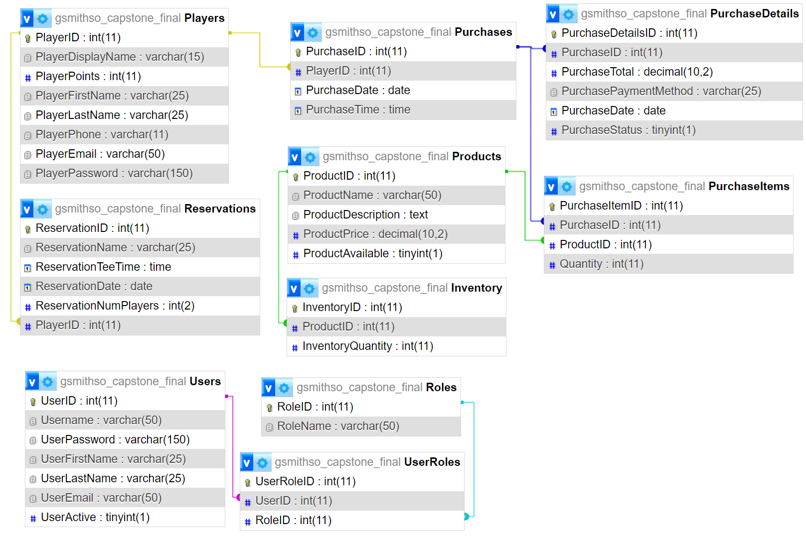

Website - Front End



Home Page HTML Code

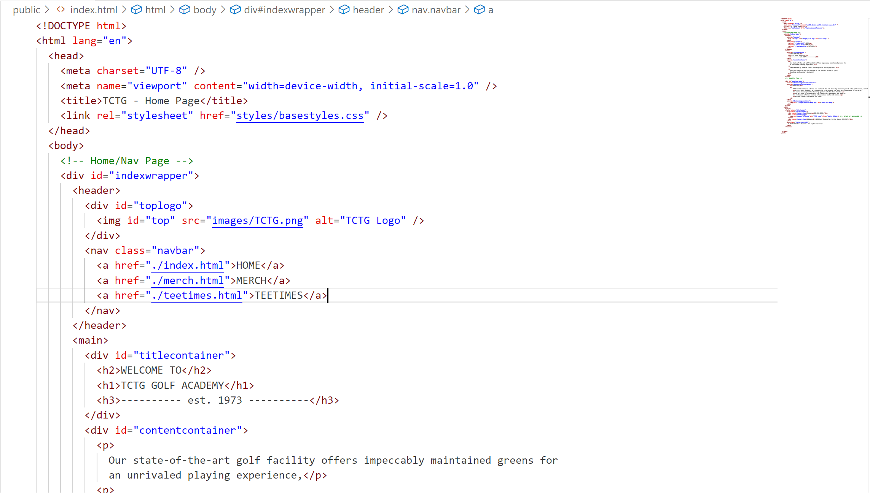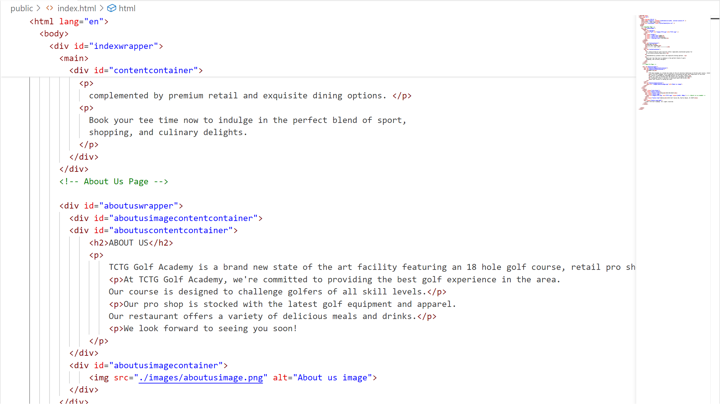

Website - Front End

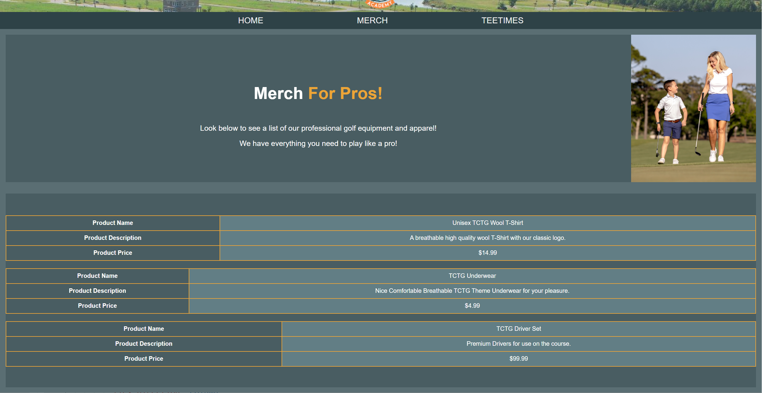

Merchandise HTML Code

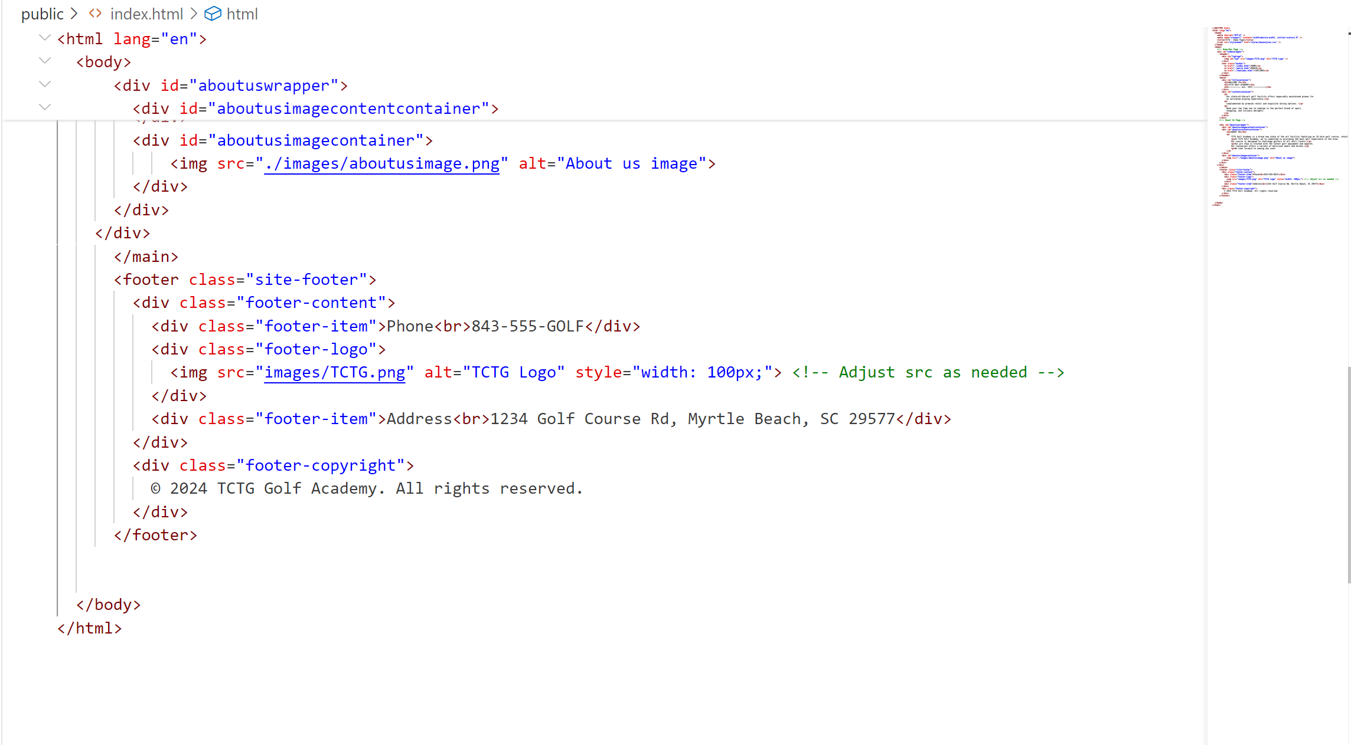

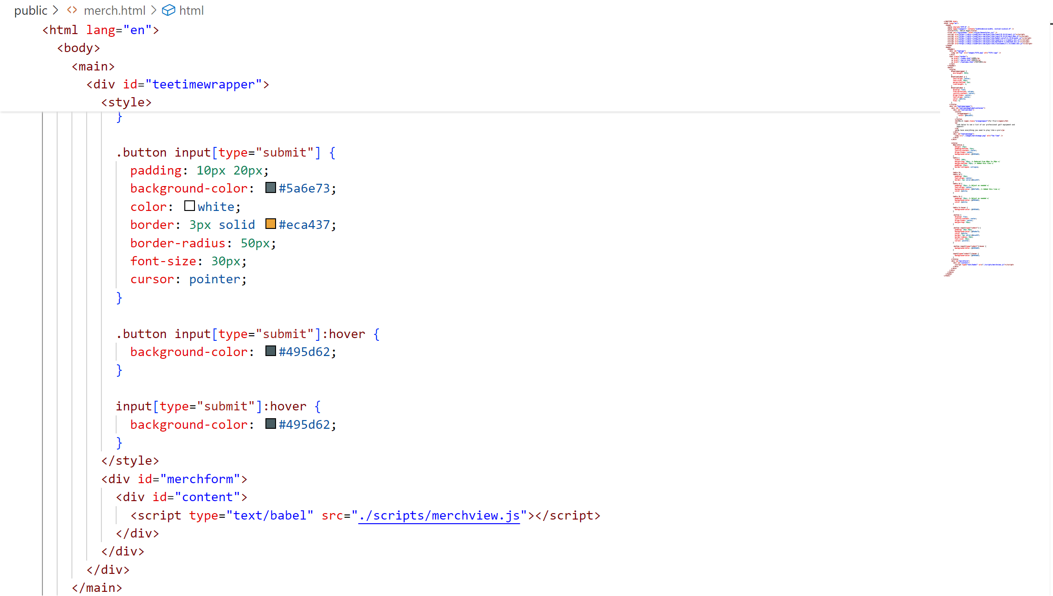

Merchandise Java Script Code

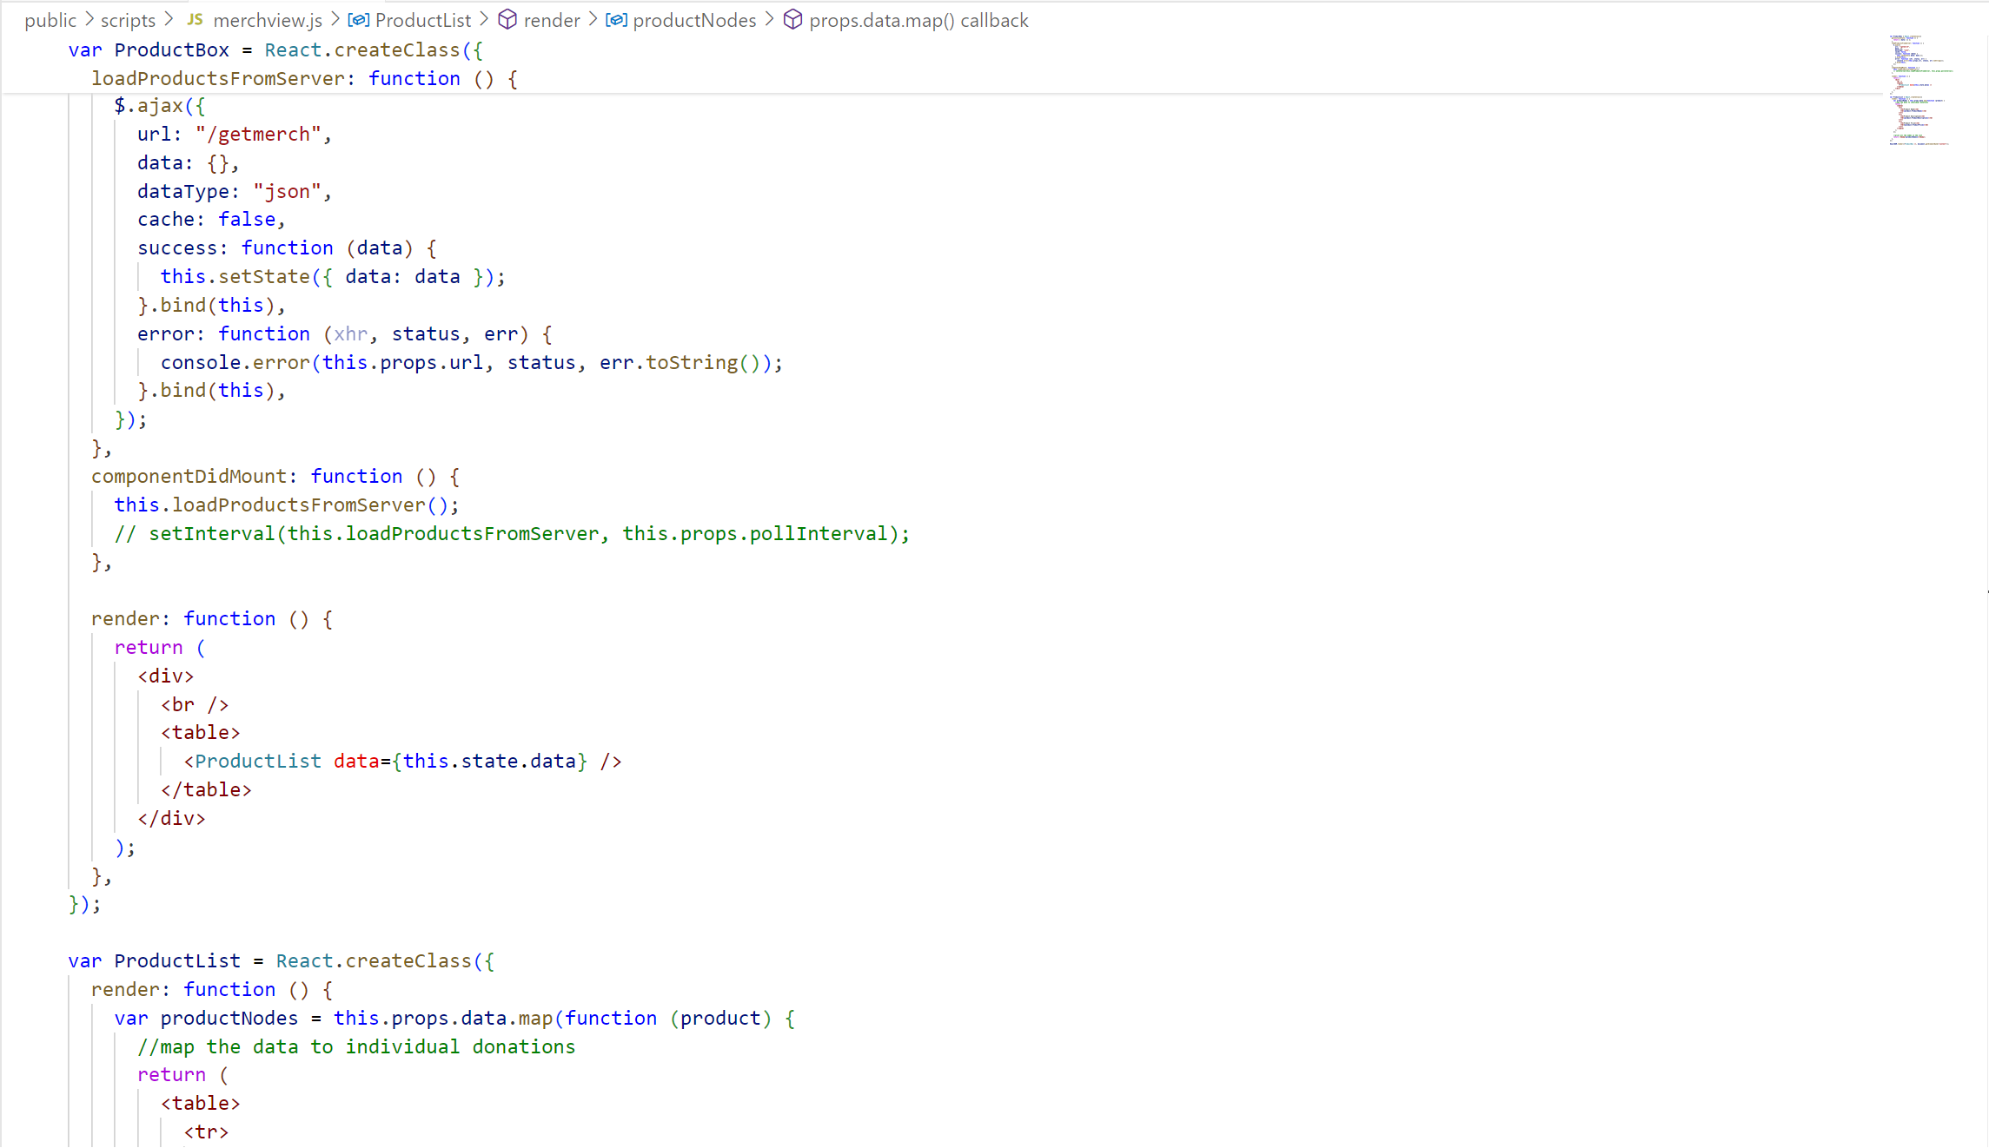

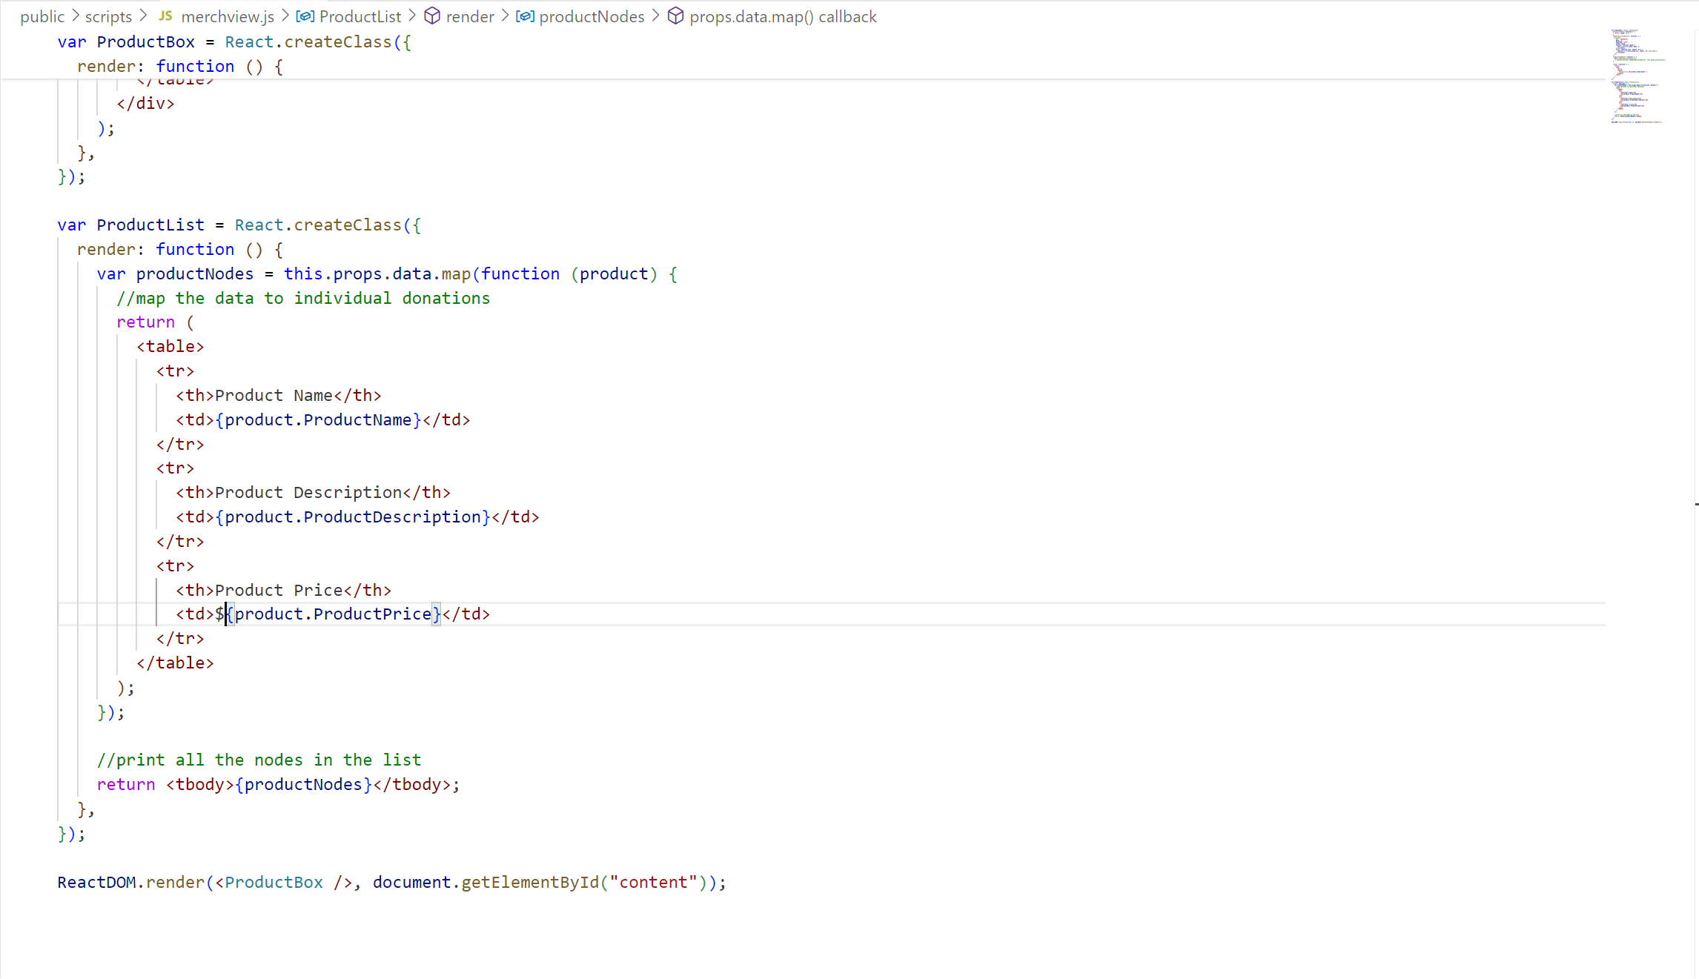

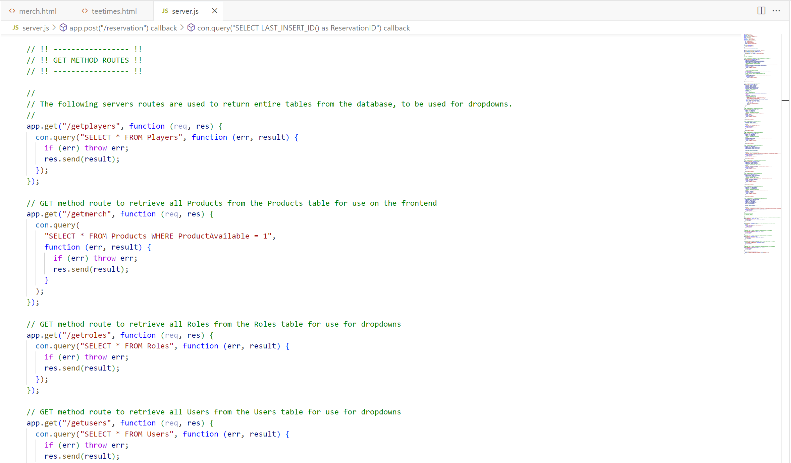

Website - Front End

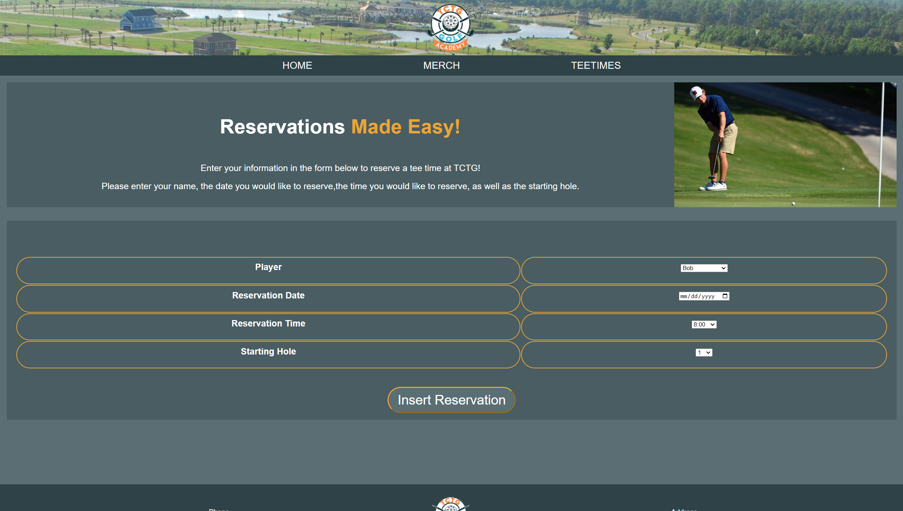

Reservation HTML Code

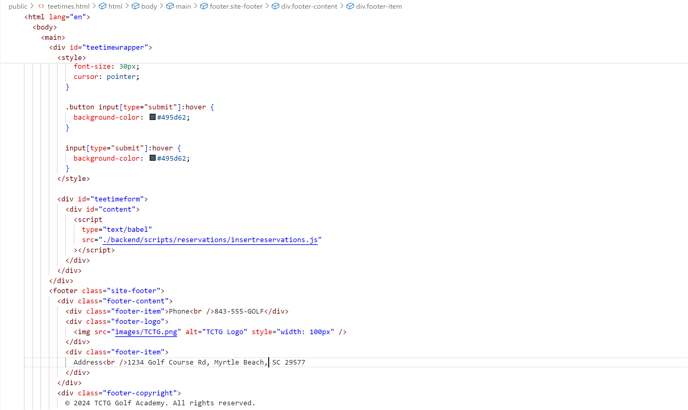

Reservation Java Script Code

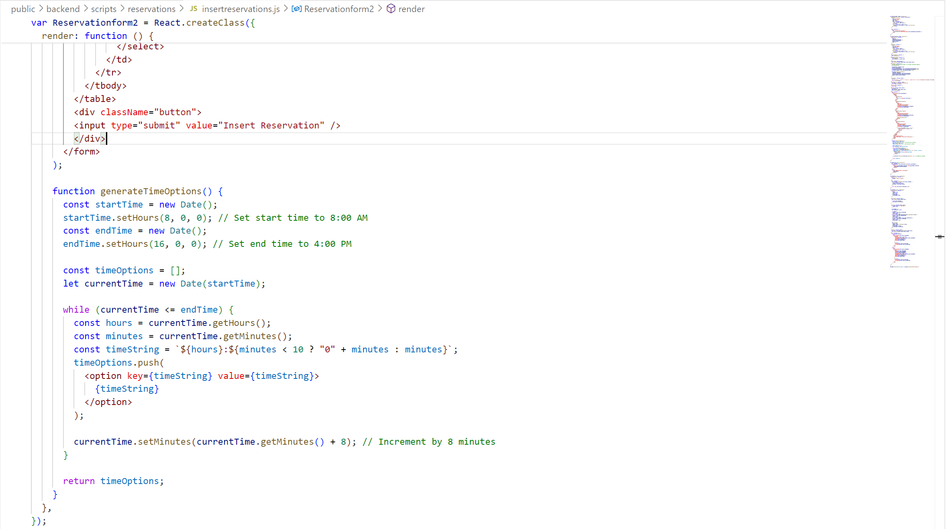

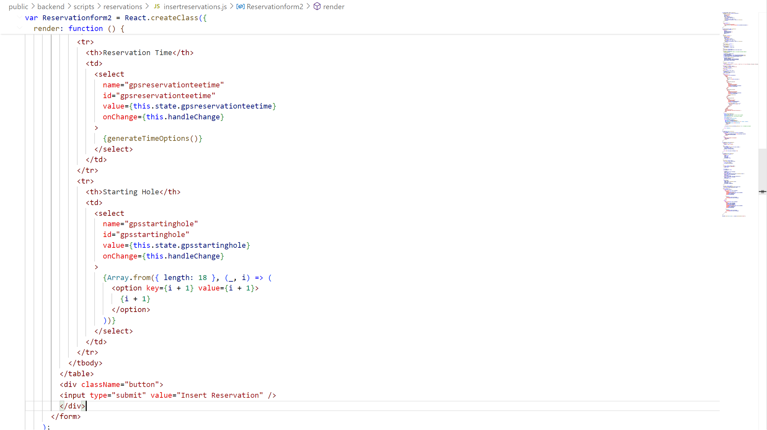

Website – Back End Update Product

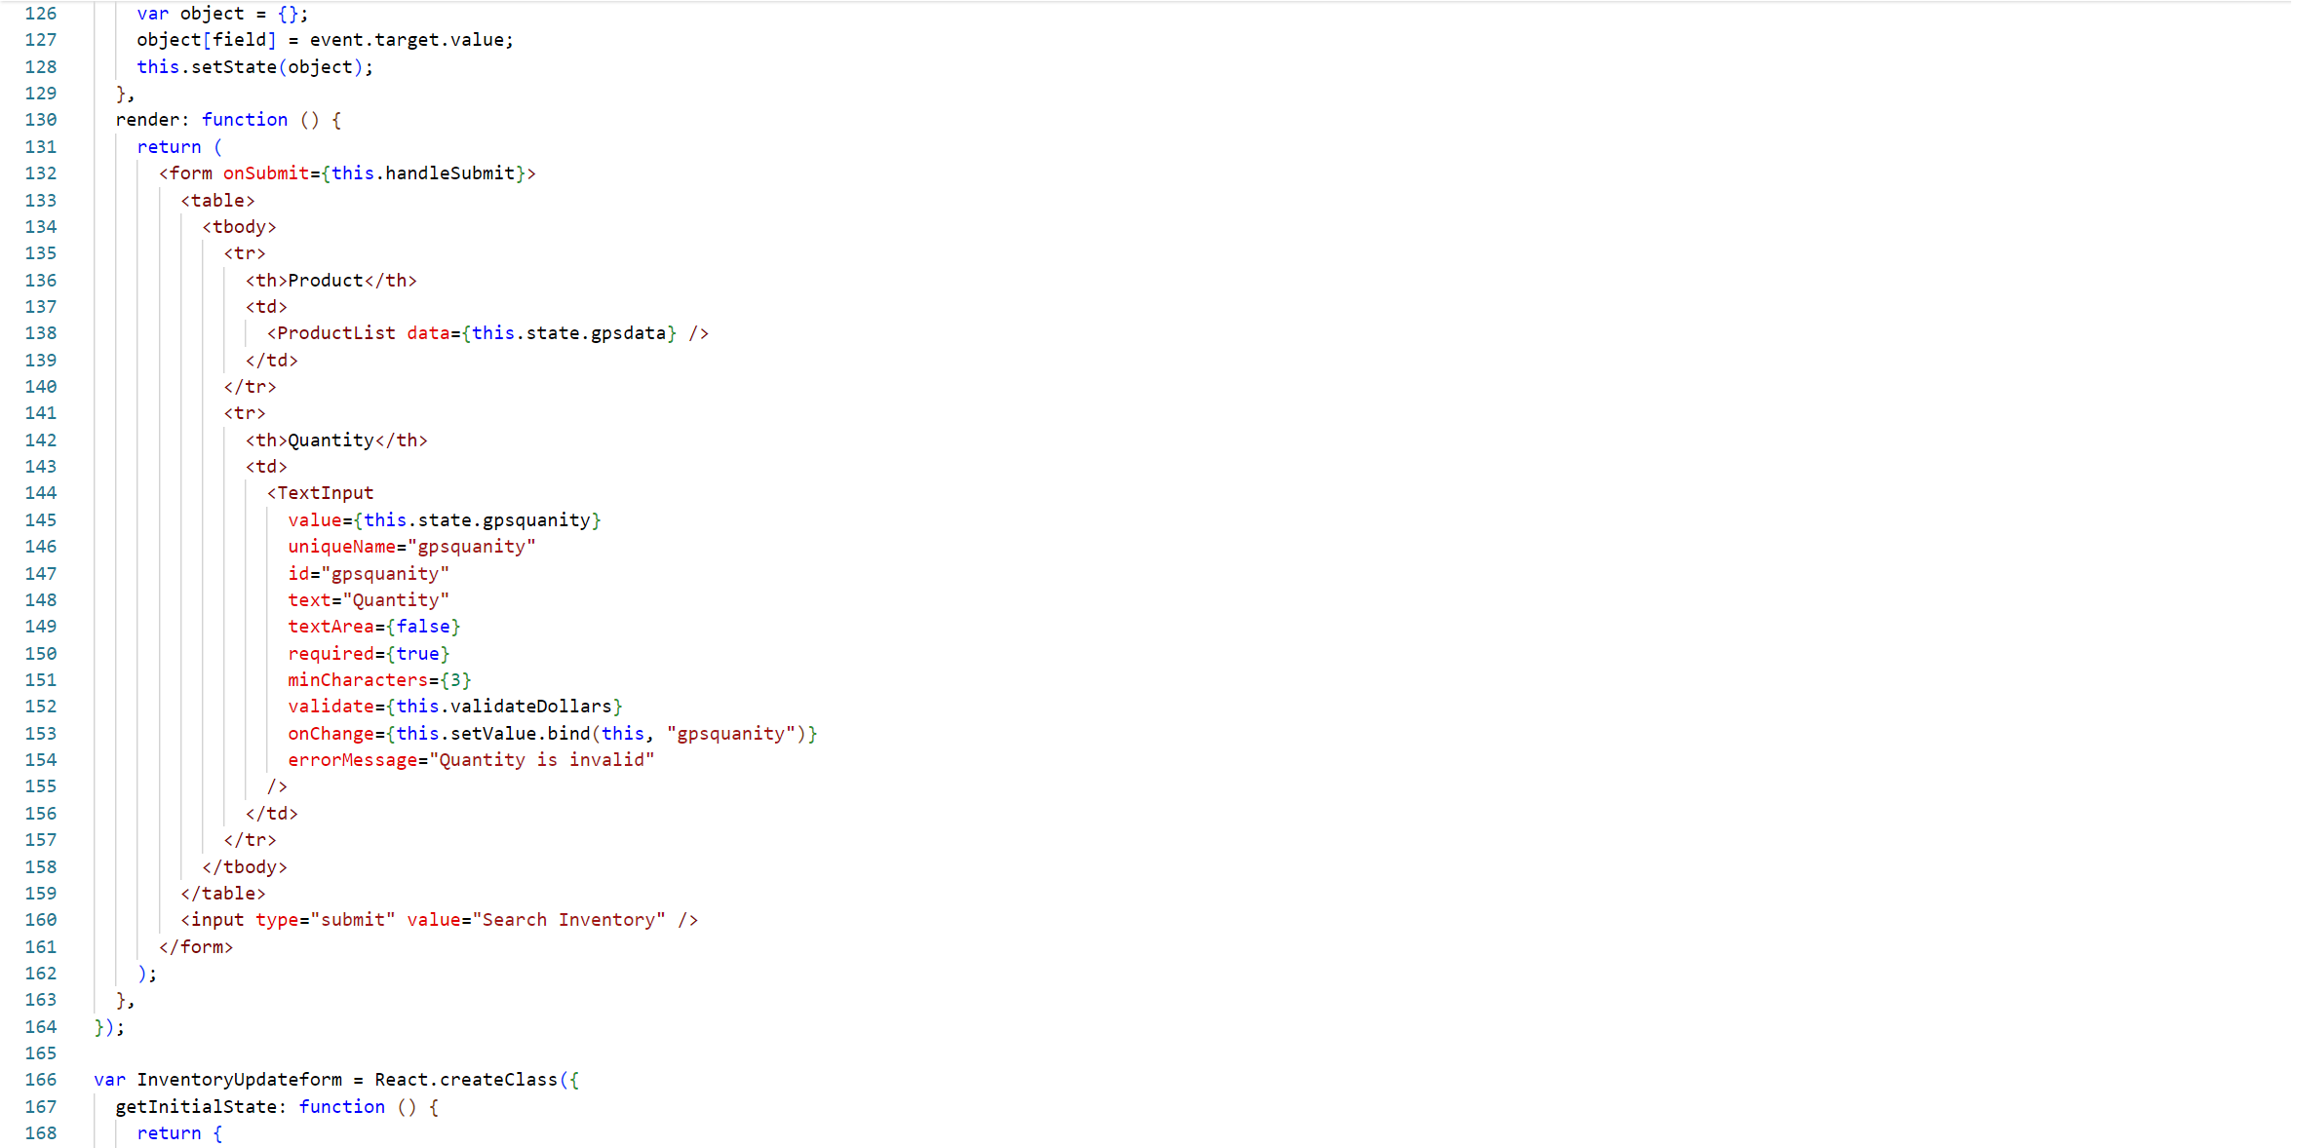

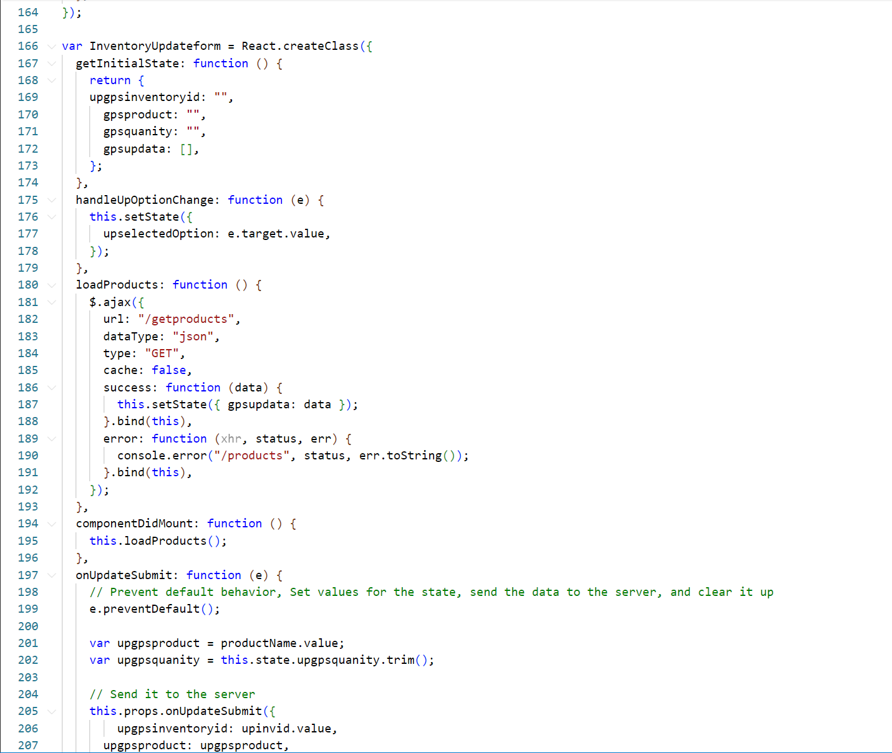

Packet Tracker Demonstration

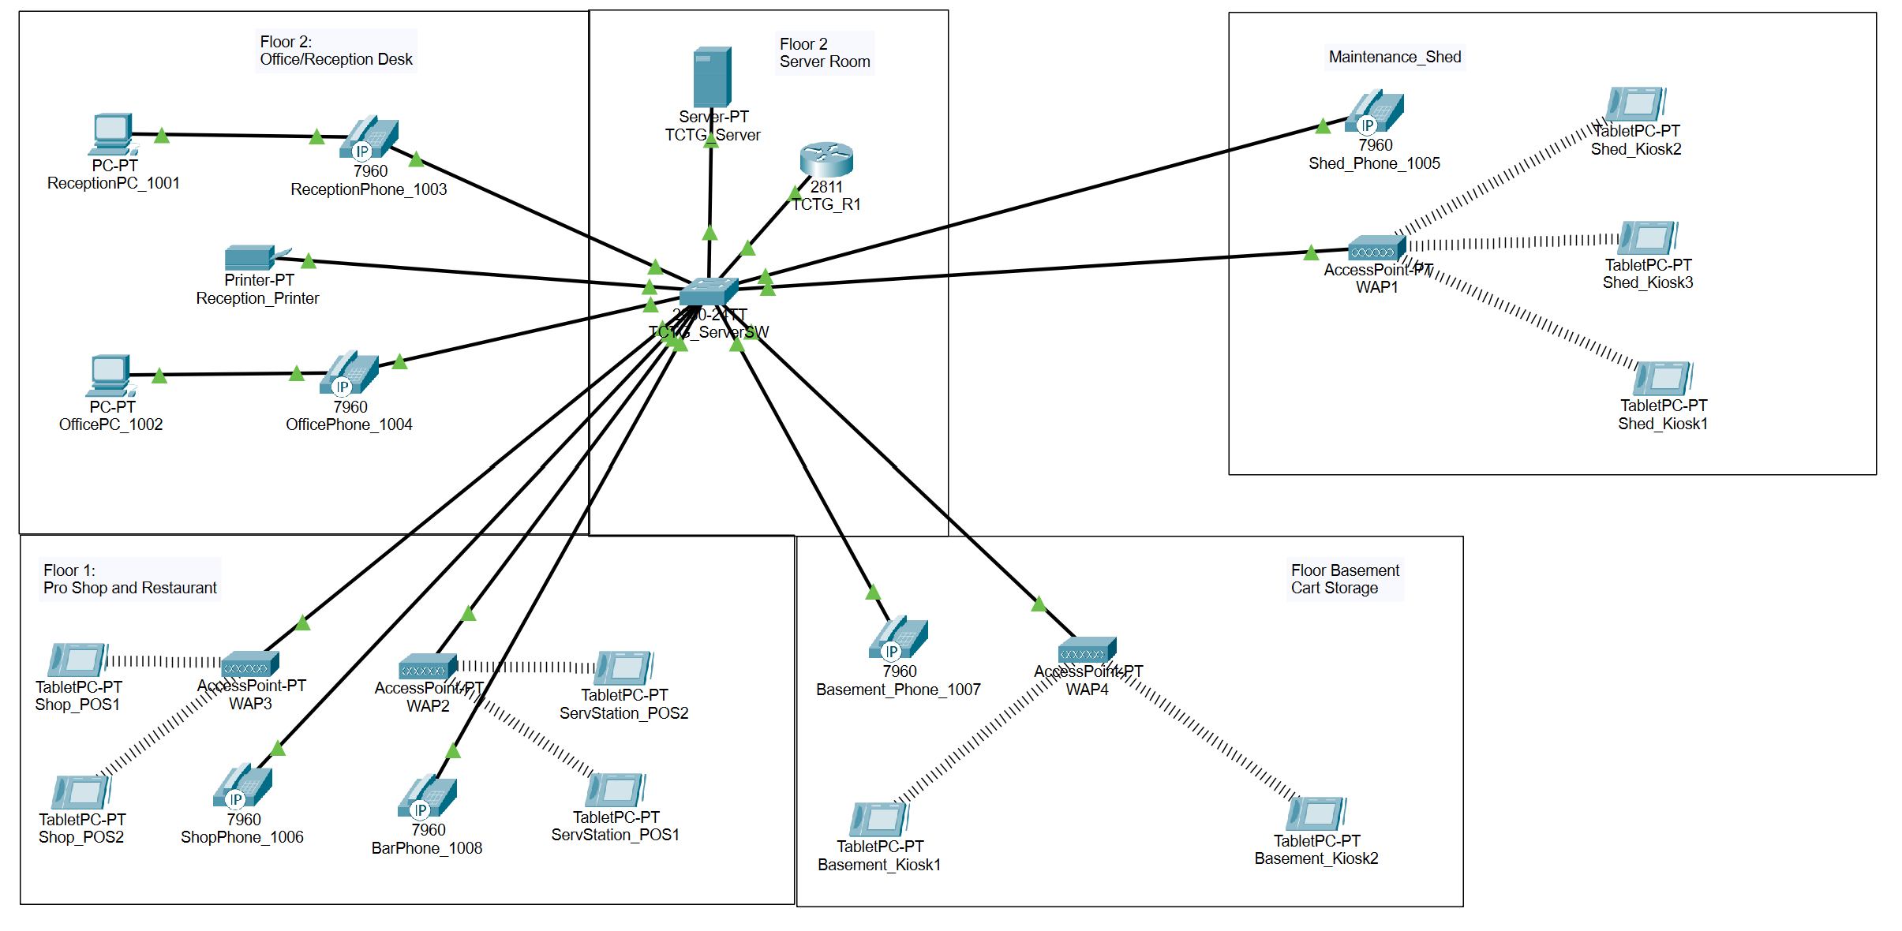

Network Installation

Part I. Install Windows Server:

Step 1. Go to the Virtual Machines tab and click on Create / Register VM.

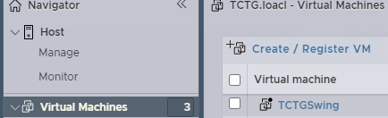

Step 2. On page 1 make sure *Create a new virtual machine* is selected then click next.

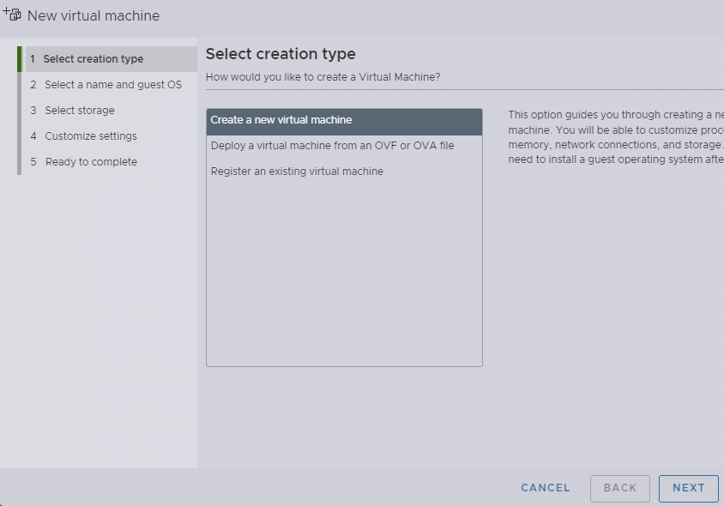

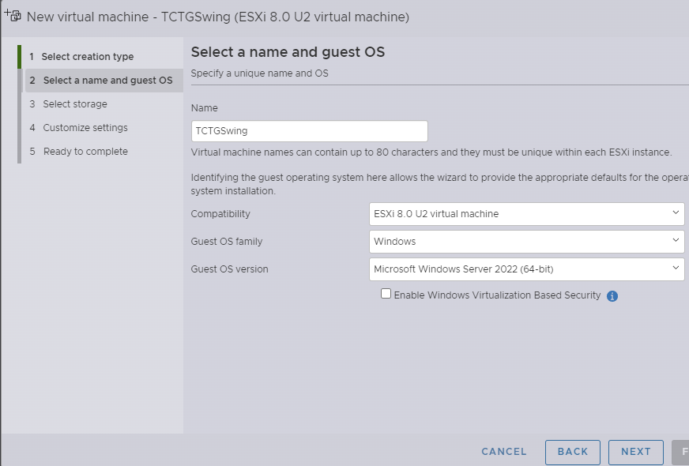Step 3. On page 2 type in a name in the text box then select the correct OS family and OS version then click next.

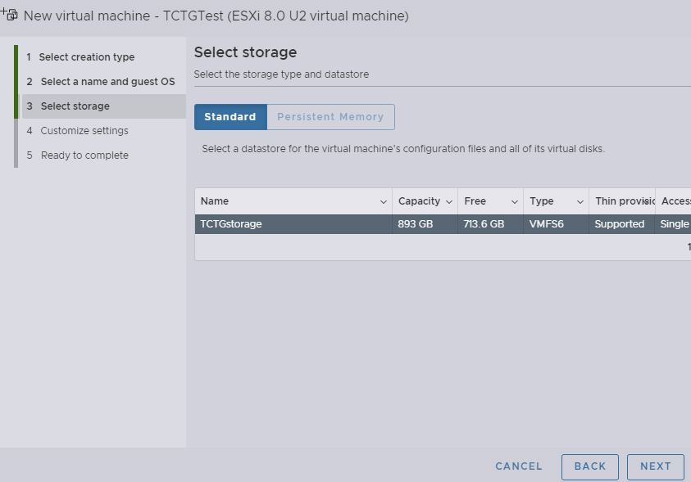Step 4. On page 3 make sure you have the proper storage selected and that its set to standard then click next.

Step 5. On page 4 leave all the settings as default and click next.

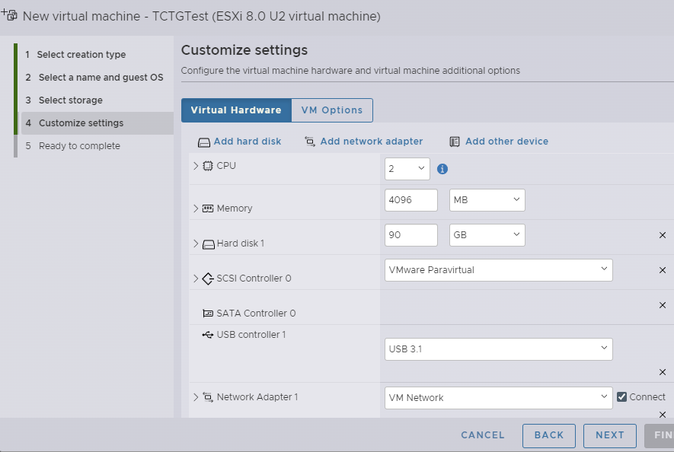

Step 6. On page 6 review all of your settings then click finish.

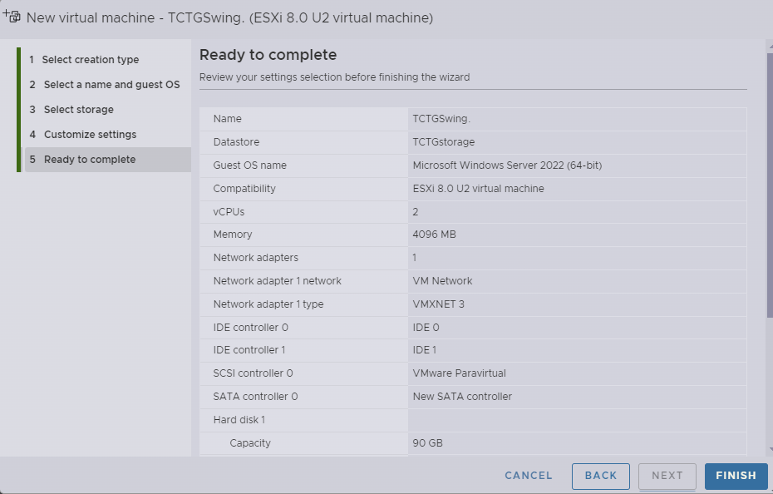

Part II Install Active Directory and IIS:

Step 1. Open Server Manager.

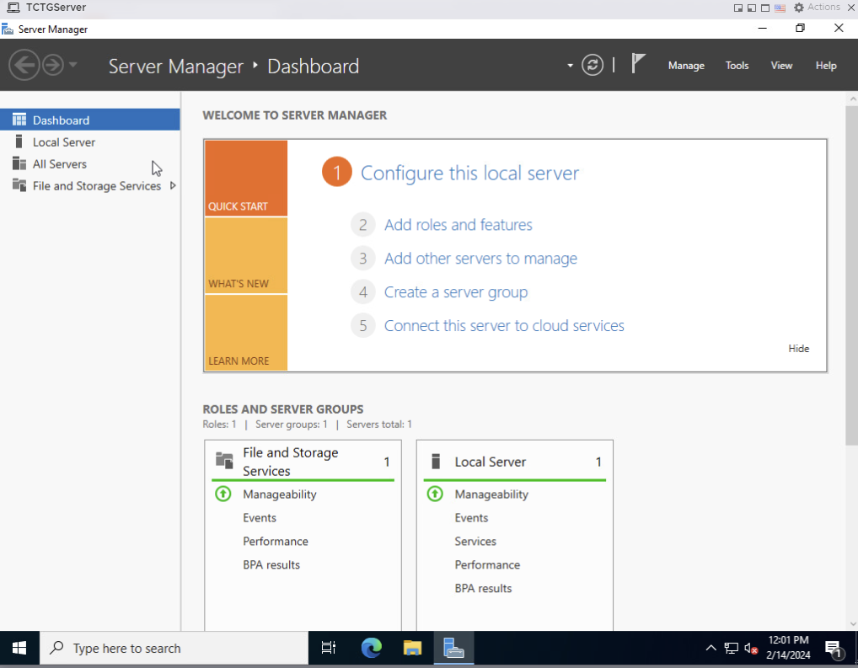

Step 2. Click Manage then Add Roles and Features.

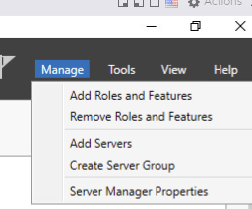

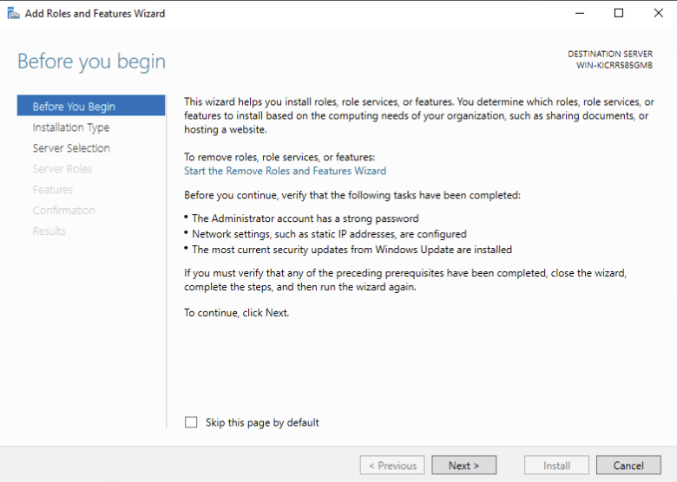Step 3. Click Next.

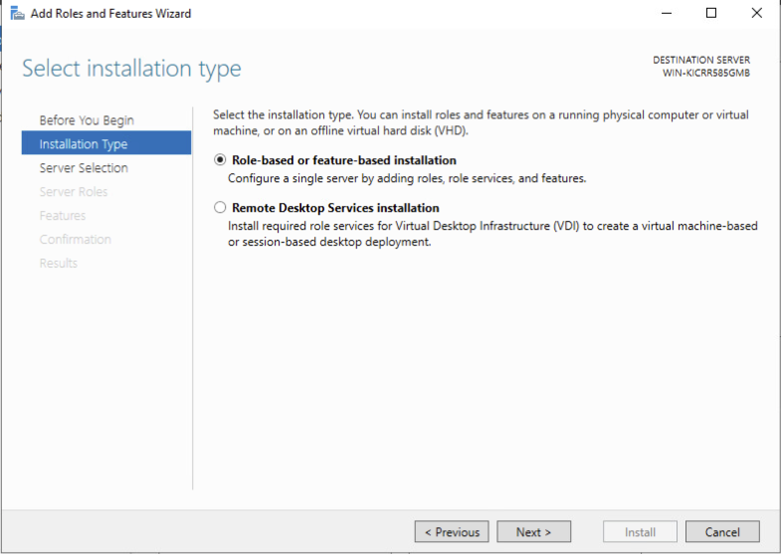Step 4. Make sure you have (Role-Based Installation) Selected then click Next.

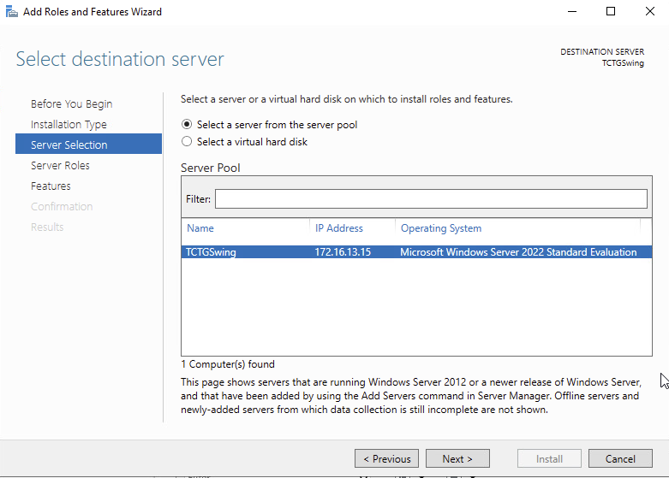Step 5. Make sure you have (select a server from the server pool) chosen then make sure the server you want to use is also selected then click Next.

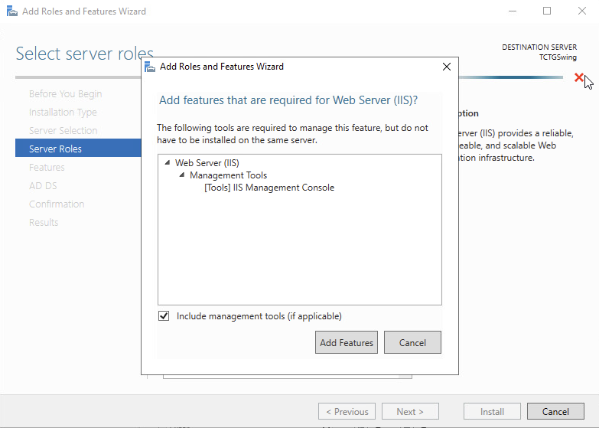Step 6. Check the boxes for Active Directory Domain Services a popup wizard will open click Add Features. Repeat the process for Web Server (IIS) the click Next.

Step 7. Don’t add anything from the Features tab and click Next.

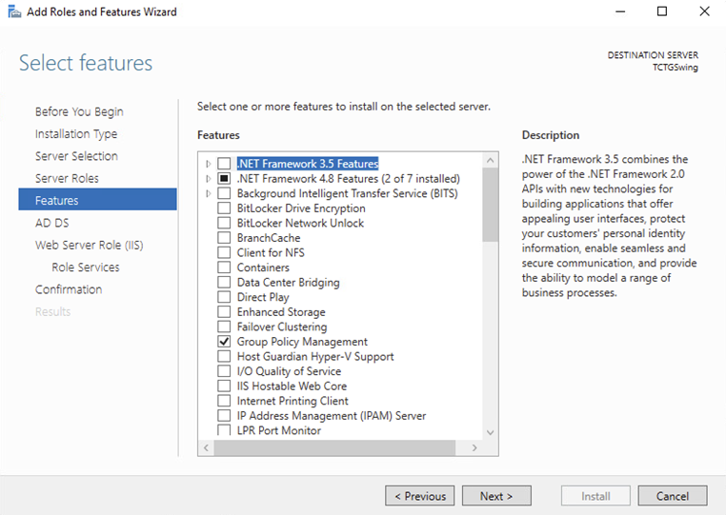

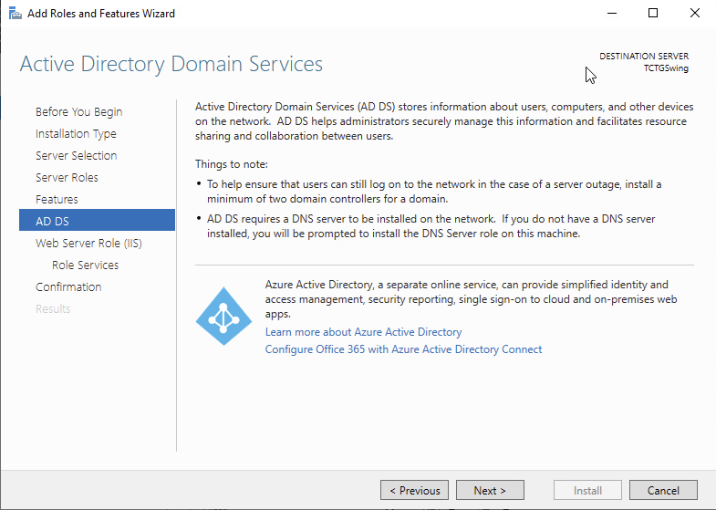Step 8. Click Next for the AD DS tab.

Step 9. Click Next for the Web Server (IIS) tab.

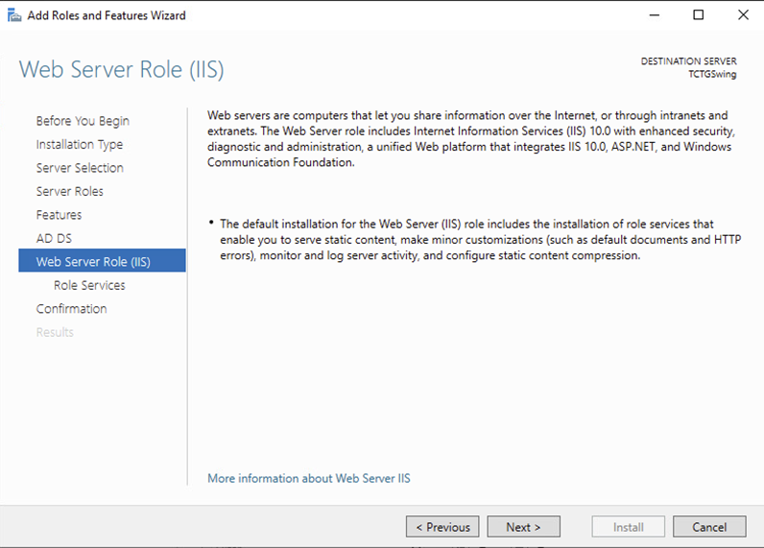

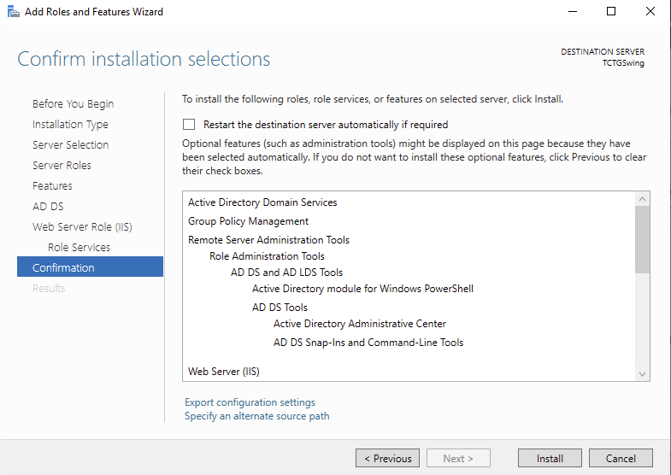Step 12. Click Install for the Conformation tab.

Step 13. Once the instillation is finished click close.

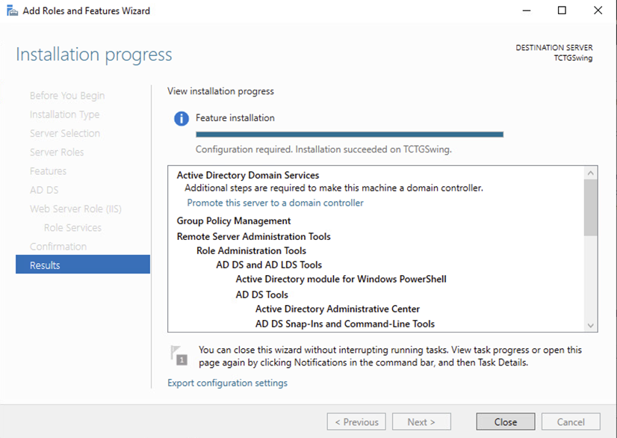

Part III Post Deployment:

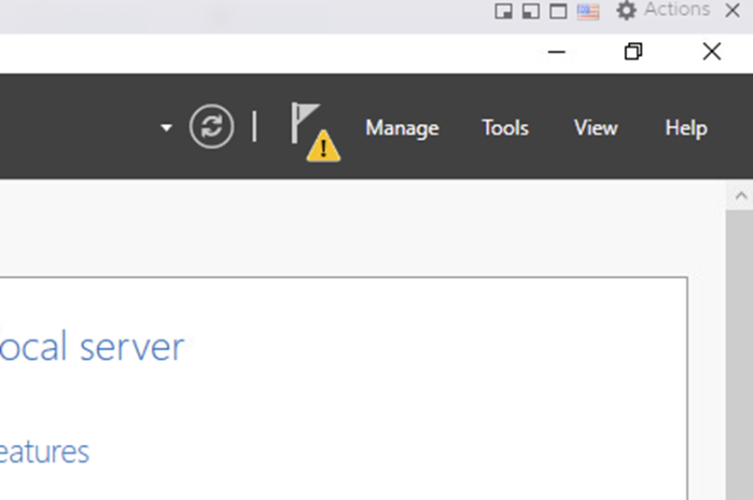Step 1. Click the flag with the yellow triangle at the top of the screen.

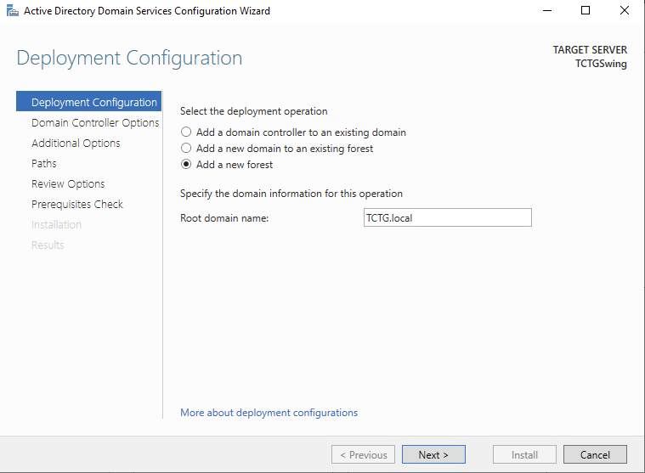Step 2. Click promote this server to a domain controller

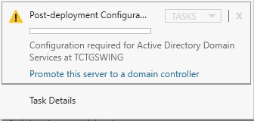Step 3. The ADDS config wizard opens select the add a new forest button then add a root domain name after that click next.

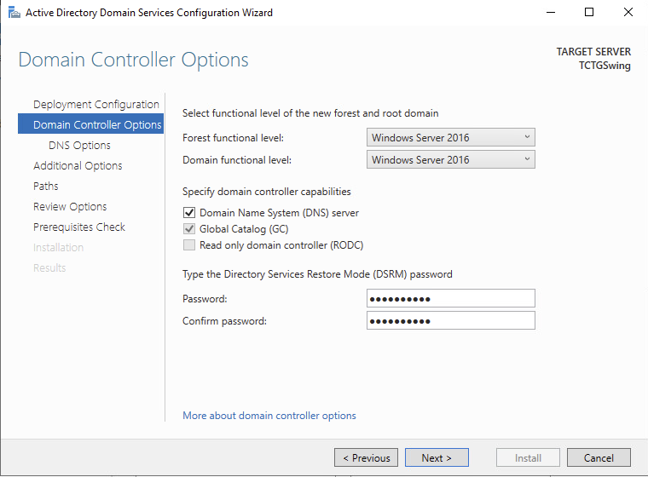Step 4. Set a password for directory Services Restore Mode then click next

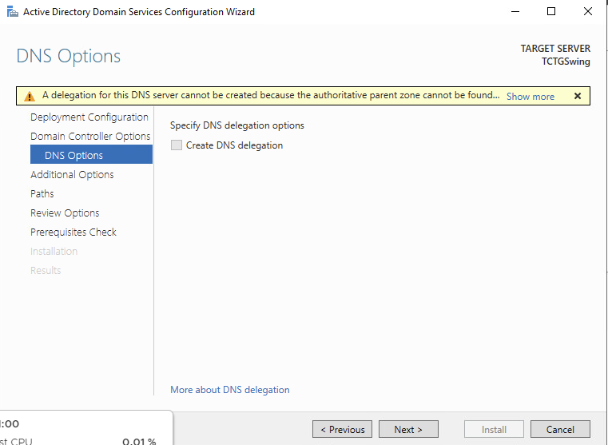Step 5. The DNS Options tab click next.

Step 6. Add a NetBIOS name (Optional but recommended) click next.

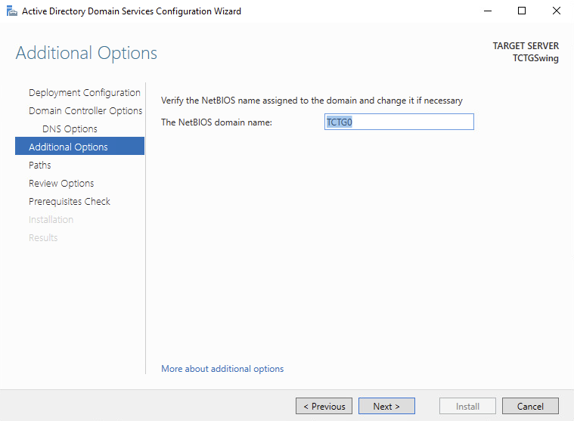

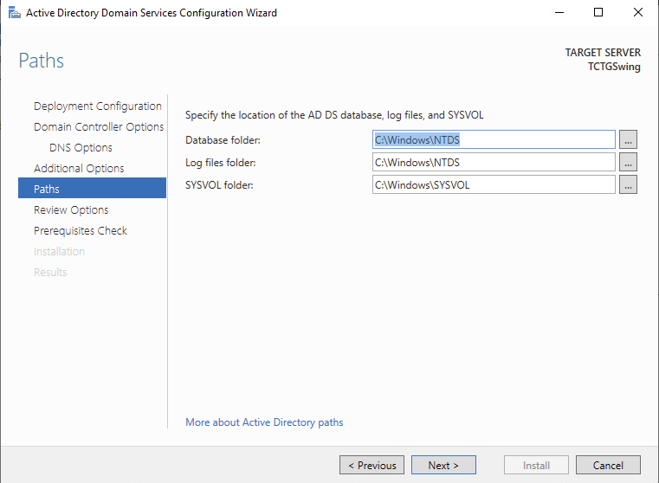Step 7. Click Next n the Paths tab.

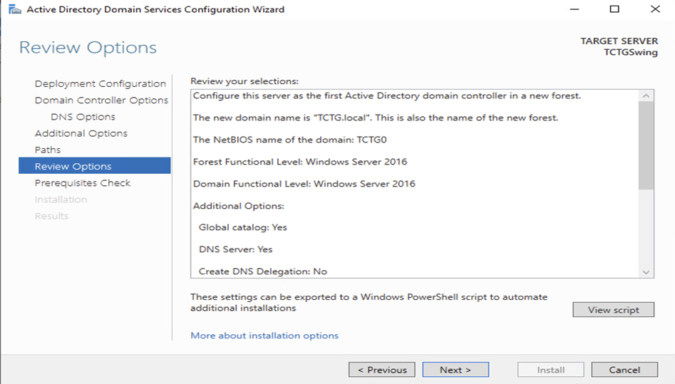Step 8. Review your selections then click next.

Step 9. Let the prerequisites check run if any changes need to be made fix them then click install. After install is complete let the machine restart.

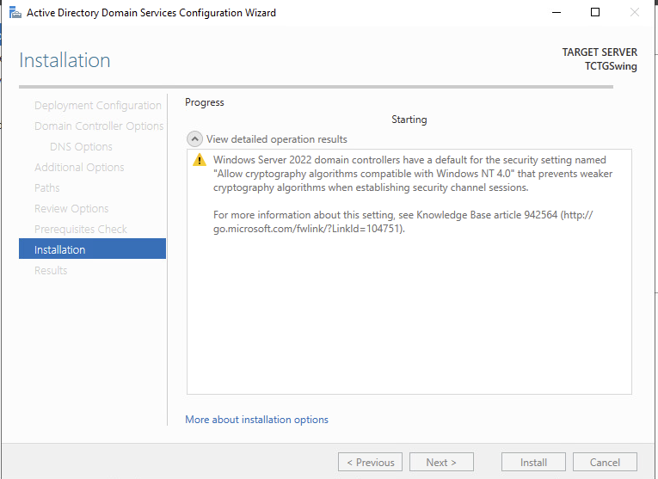Part IV DNS:

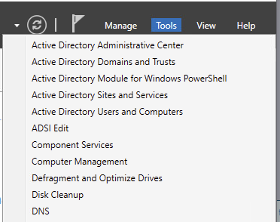Step 1. Go to Tools and click DNS in the drop-down menu.

Step 2. Click on your server’s name then click on forward lookup zone.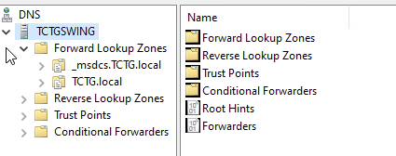

Step 3. Click the drop-down arrow on your Domain name.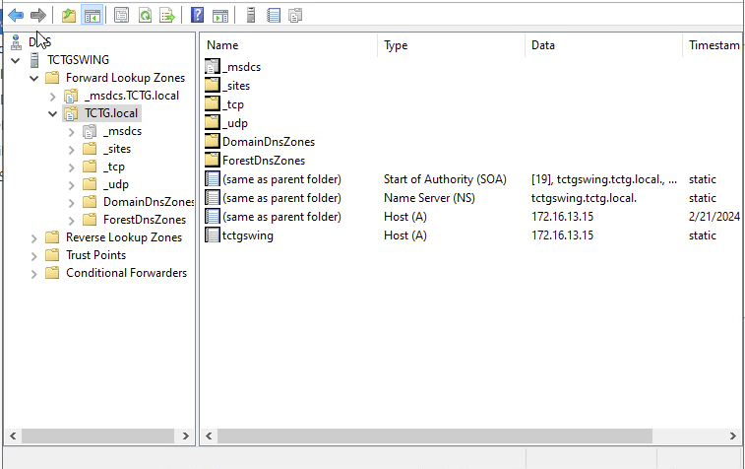

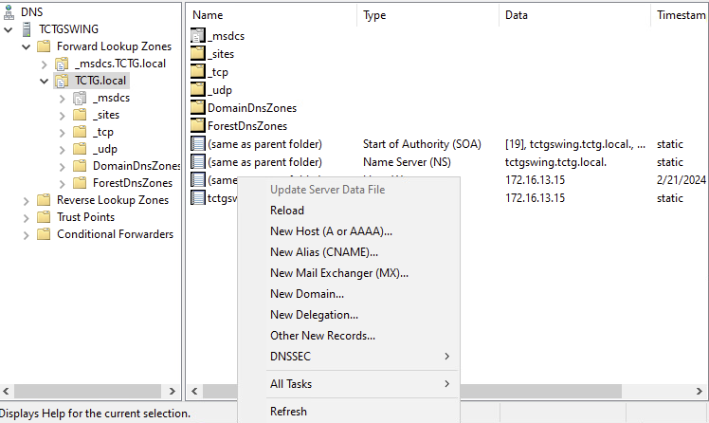Step 4. Right click the white space on the right side of the window and select New Host (A or AAAA)…

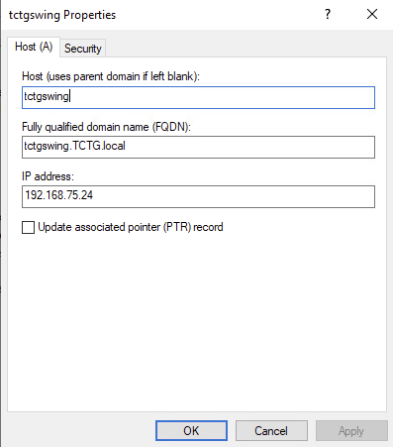Step 5. Add the name of your ESX host and the IP address of the DNS server in the respective text boxes. Then click add host.

Part V vCenter:

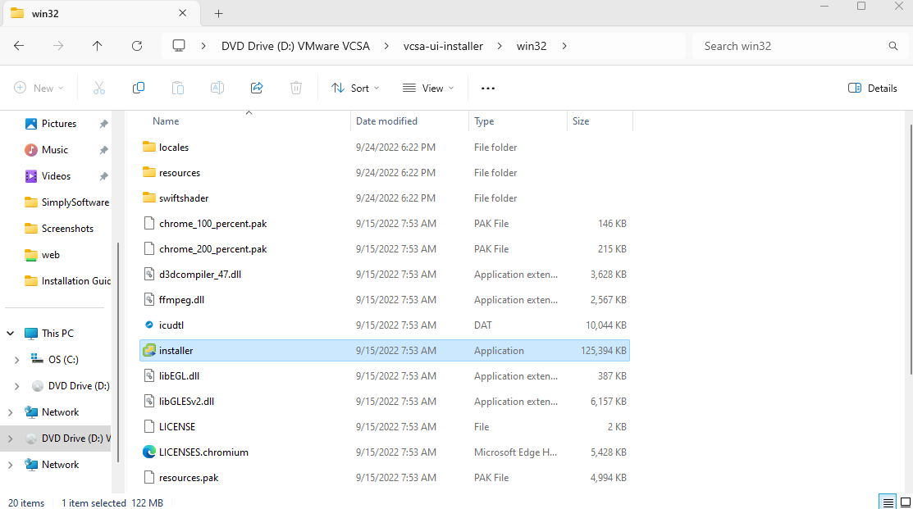Step 1. Mount the file then click run the file as an admin

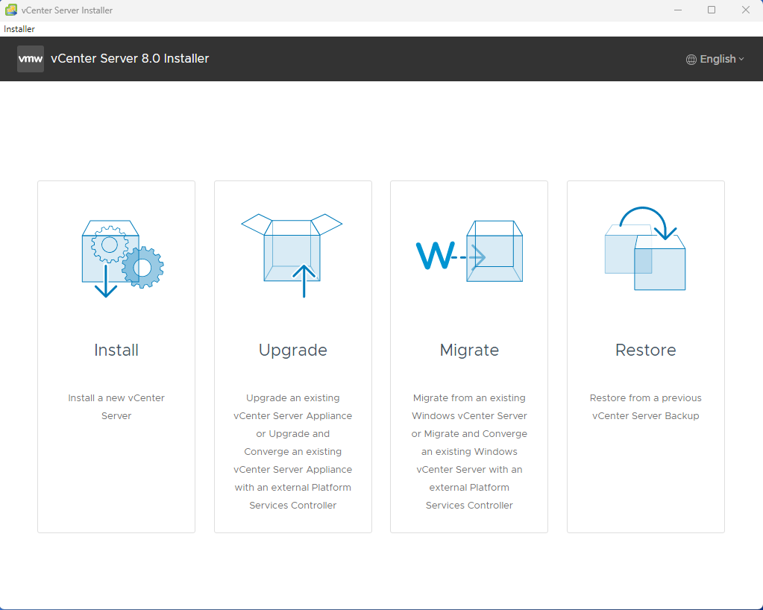Step 2. The wizard opens click on the install button.

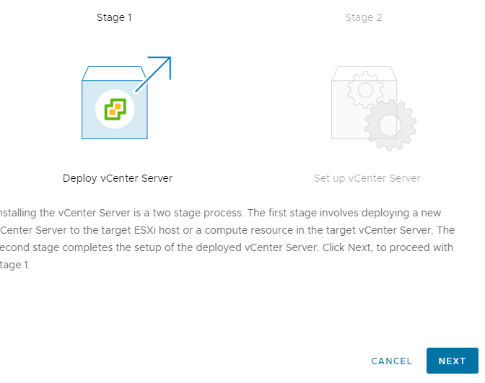Step 3. For the introduction page click next.

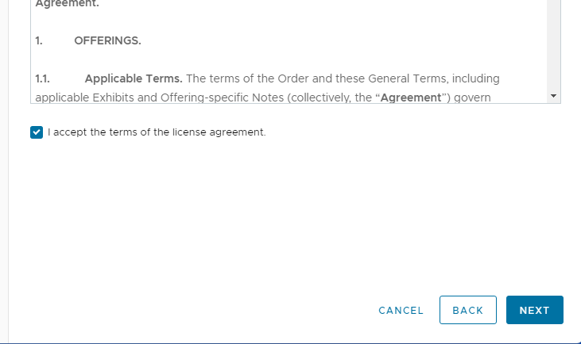Step 4. Check the I accept box then click next for the license agreement page.

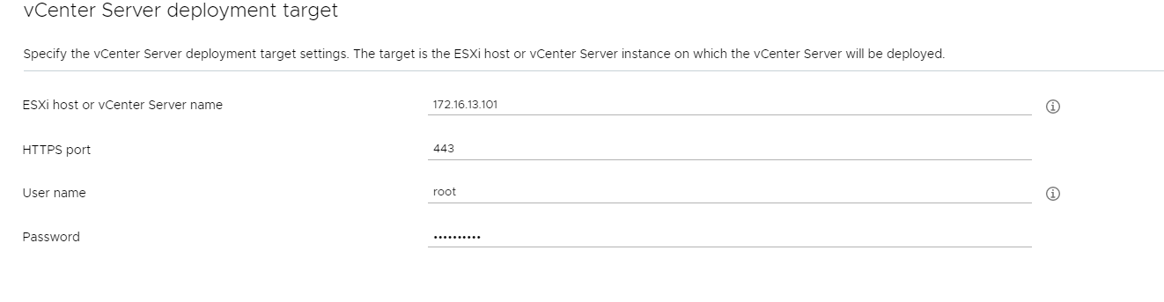Step 5. On page 3 of the wizard enter you ESXi server ip address and your login information for it too. Then click next

Step 6. The Certificate Warning pops up click Yes.

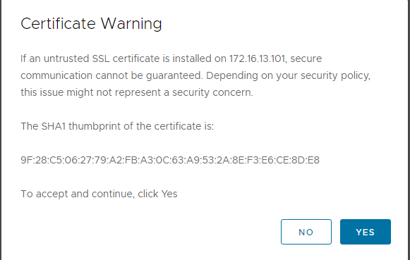

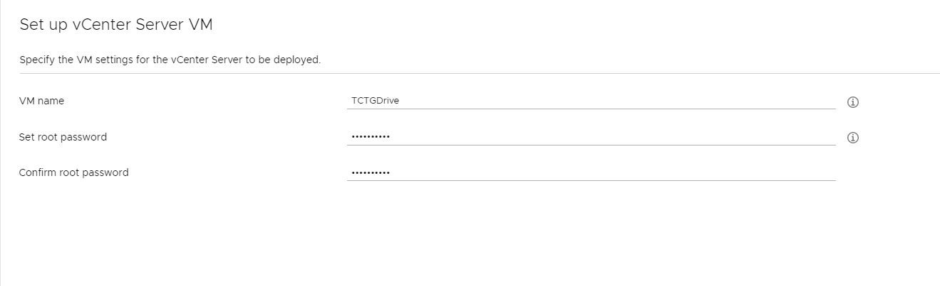Step 7. In the page 4 window you need to enter a name and password

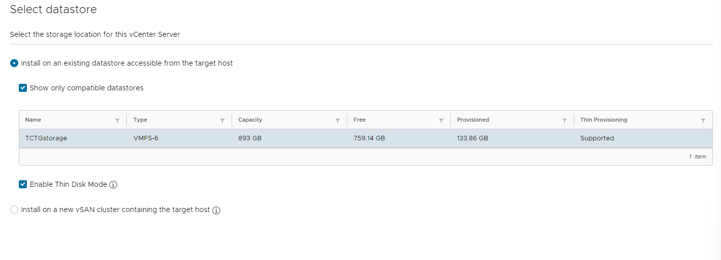Step 8. Click the check box to enable thin disk mode

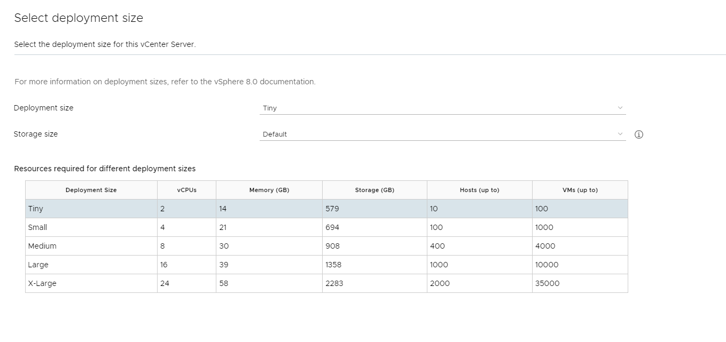Step 9. Leave everything as default click next

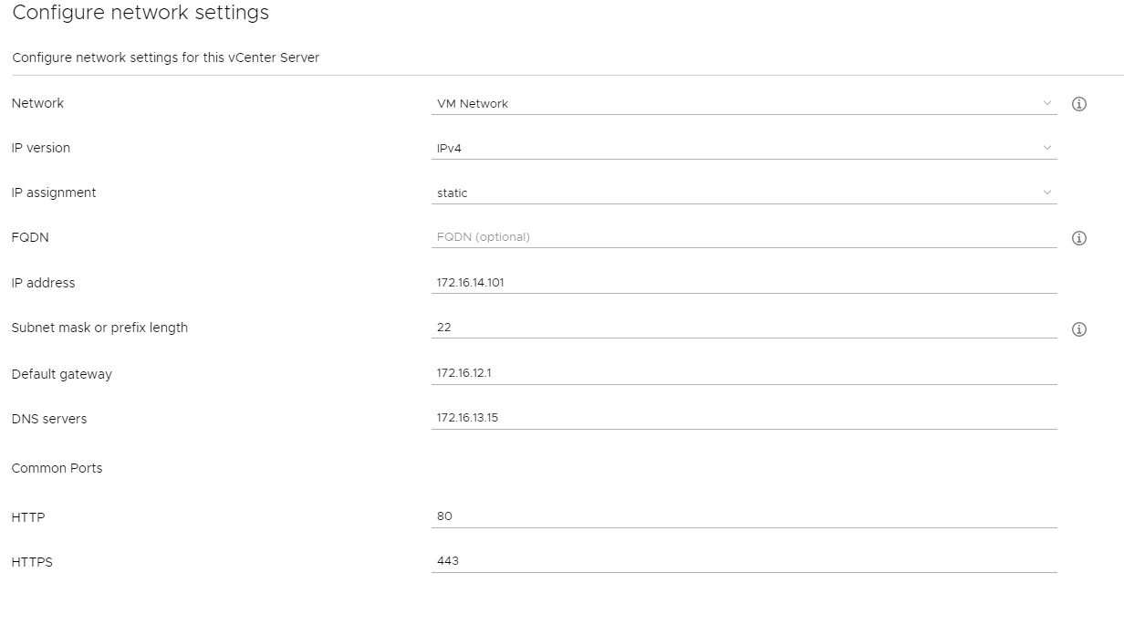Step 10. Add the ip address of your vCenter, subnet mask, default gateway, and DNS server then click next.

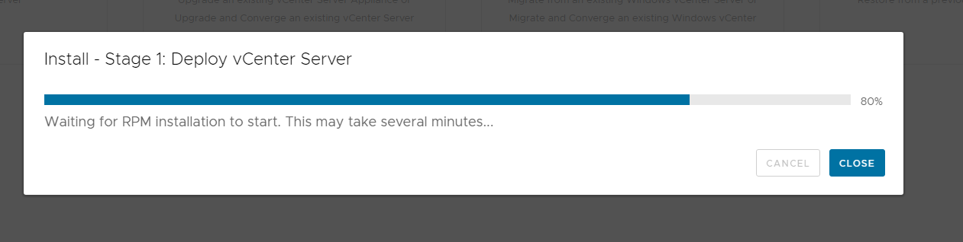Step 11. Click finish then let download complete.

Step 12. Once download is complete click continue Stage 1 complete

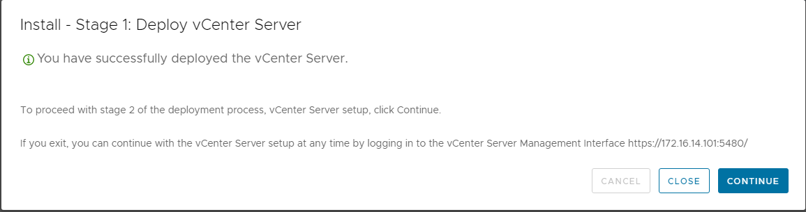

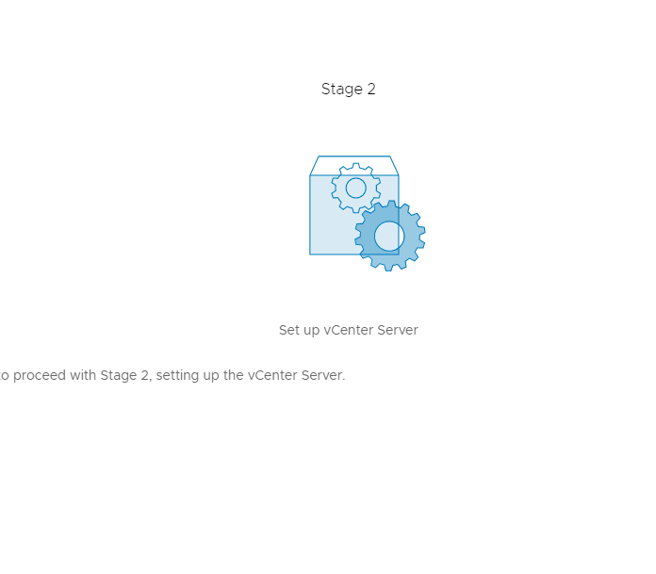Step 13. Click next to begin Stage 2

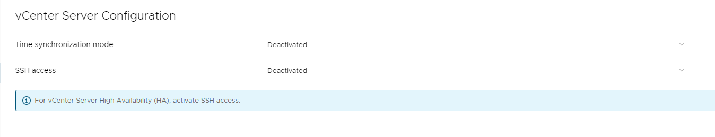Step 14. Leave default options then click next

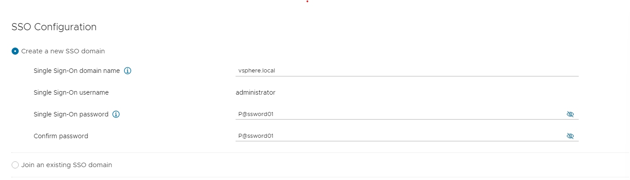Step 15. Enter a single sign on domain name and a password

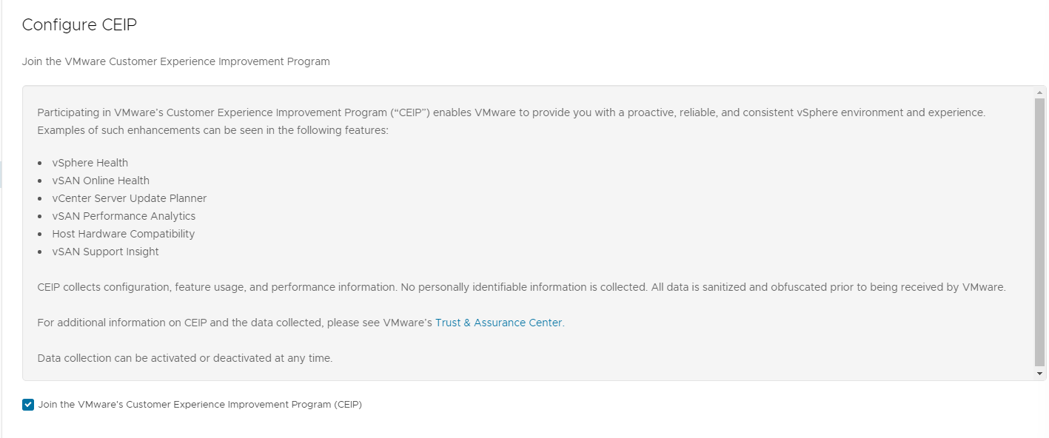Step 16. Leave as default and click next.

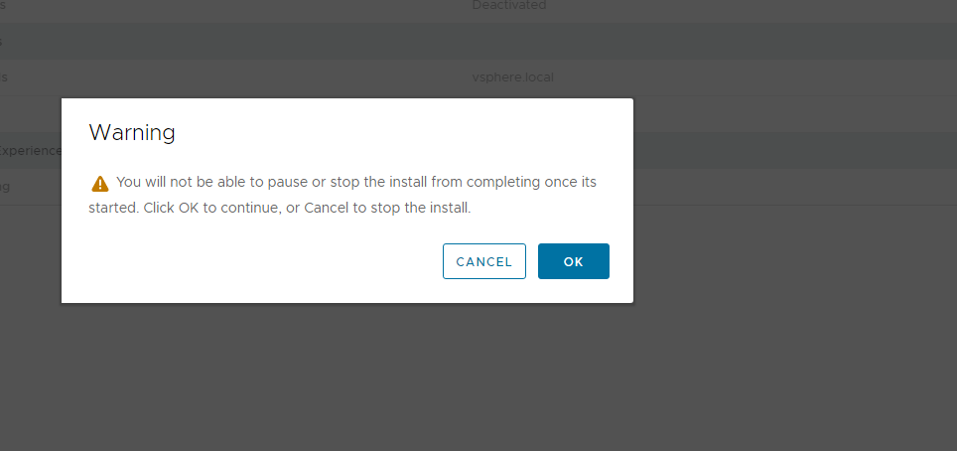Step 17. Click finish on the review page then click ok on the warning popup.

|  |
| --- |
|  |
| Works Cited |

# Work Cited

Work Cited

“Acceptable Use Policy”, *San’s Institute*, <https://view.officeapps.live.com/op/view.aspx?src=https%3A%2F%2Fassets.contentstack.io%2Fv3%2Fassets%2Fblt36c2e63521272fdc%2Fblt1862b165519ffa1b%2F636f1a30bdef432fb152d0f8%2FAcceptable_Use_Policy.docx&wdOrigin=BROWSELINK> . Accessed 27 Feb. 2024

“All-in-One Small Business Solutions”. *Spectrum*, <https://www.spectrum.com/business/lp/ultra-connect-mob>. Accessed 8 Feb. 2024.

“Bluetooth Baseline Requirements Policy”, *San’s Institute*, <https://view.officeapps.live.com/op/view.aspx?src=https%3A%2F%2Fassets.contentstack.io%2Fv3%2Fassets%2Fblt36c2e63521272fdc%2Fblte97979ea44ea5185%2F636db413421feb097ddb6d32%2FBluetooth_Baseline_Requirements_Policy.docx&wdOrigin=BROWSELINK> Accessed 27 Feb. 2024

“C1111-8P Router”, *Amazon*, [Amazon.com: Cisco C1111-8P Integrated Services Router 1100 with 8-Gigabit Ethernet (GbE) Dual Ports, WAN, 1-Year Limited Hardware Warranty (C1111-8P) : Electronics](https://www.amazon.com/Cisco-Integrated-Services-Router-C1111-8P/dp/B079XZWNS3/ref=sr_1_1?crid=1MPXCKQC6B1DR&dib=eyJ2IjoiMSJ9.aEGB-JbvetOsmpjAlnrIZUzblZo4Ha5kdTmsUopN0qcXLUqppQYU27-zgeoRa89XKUzPJOCIxfYs3-989qKMmRY--D0eN0muoND1jvkqwYb1eT8FwmsA2HWExolaUeDdSAtAs5Mwgti-Tboolhuj44fVAT_qZ3WmWXw9fDnrzEOUITx0EA9O3pMaUeIubTr2rRF8X4hYo0BFWC72M3cAj9l17AShTzzy8KFVVgmT7MpFIA_sFpd8zTU-Ueu5SDpF_rYoxEdQm2zzFl4Hq4HLe1m0hImt4HvCWjyslNCJg7c.H9BTj8yUleB6VKHInu6Nv-UWIIqbHFy76CiMjJ_miW8&dib_tag=se&keywords=cisco+router&qid=1710188168&refinements=p_123%3A365432%7C460128%2Cp_n_feature_seventeen_browse-bin%3A24003469011&rnid=24003305011&s=pc&sprefix=cisco+router+%2Celectronics%2C65&sr=1-1). Accessed 11 March 2024.

“Cat 6 Ethernet Wall Plate 6 Port,Ethernet Wall Plate Female-Female Removable Compatible with Cat7/6/6e/5/5e Ethernet Devices -Blue”. *Amazon*, <https://a.co/d/e0Ehmh2>. Accessed 8 Feb. 2024.

“Cisco Catalyst C9115I”, *Cisco*, [Cisco Catalyst C9115I 802.11ax 5.38 Gbits Wireless Access Point 2.40 GHz 5 GHz MIMO Technology 1 x Network RJ 45 2.5 Gigabit Ethernet Bluetooth 5 - Office Depot](https://www.officedepot.com/a/products/7074083/Cisco-Catalyst-C9115I-80211ax-538-Gbits/?cm_mmc=PLA-_-Bing-_-Networking_Cables-_-7074083&mediacampaignid=71700000099751180_370758097&gclid=62479d1fd6141f51d74cf8a0c1b4e703&gclsrc=3p.ds&msclkid=62479d1fd6141f51d74cf8a0c1b4e703&utm_source=bing&utm_medium=cpc&utm_campaign=pla_cor_core_electronics_ssc_unid_prch-l3_non-match_non-pm&utm_term=4577473070474780&utm_content=Electronics). Accessed 5 Feb. 2024.

“Cisco IP Phone 8811”. *Cisco*, <https://www.cisco.com/c/en/us/products/collaboration-endpoints/ip-phone-8811/index.html>. Accessed 8 Feb. 2024.

“Cisco IP Phone 8811 - VoIP Phone - SIP, RTCP, RTP, SRTP, SDP - 5 Lines – Charcoal”. *Amazon*, <https://a.co/d/c00bVHf>. Accessed 8 Feb. 2024.

“Colosus Electronic Keyless Door Lock”, *Amazon*, [Amazon.com: Electronic Keyless Door Lock, Keyless Entry with Touchscreen, Key Fobs, Remote Control, Keys for Home, Office or Commercial, Silver NDL319 : Electronics](https://www.amazon.com/COLOSUS-Keyless-Electronic-Security-Touchscreen/dp/B07ND5BW1X/ref=sr_1_1_sspa?crid=1KAZZSK6DDOYG&keywords=card%2BLOCK&qid=1707403508&sprefix=card%2Block%2Caps%2C110&sr=8-1-spons&sp_csd=d2lkZ2V0TmFtZT1zcF9hdGY&th=1). Accessed 11 Feb. 2024.

“Data Backup Policy” Wofford College

<https://www.formsbirds.com/download-data-backup-policy>. Accessed 4 March. 2024.

“Dell Customer Support”, *Dell*, [Contact Technical Support | Dell US](https://www.dell.com/support/incidents-online/en-us/contactus/Dynamic). Accessed 10 March. 2024.

“Design Services Specialist IV in South Carolina”, *Salary,* [www.salary.com/tools/salary-calculator/design-services-specialist-iv-hourly/sc](http://www.salary.com/tools/salary-calculator/design-services-specialist-iv-hourly/sc) . Accessed 5 Feb. 2024.

“Disaster Recovery Plan Policy” <https://view.officeapps.live.com/op/view.aspx?src=https%3A%2F%2Fassets.contentstack.io%2Fv3%2Fassets%2Fblt36c2e63521272fdc%2Fbltf4cc470769782b68%2F5e9ddba5f80b6c64dd7cb496%2Fdisaster_recovery_plan_policy.docx&wdOrigin=BROWSELINK>. Accessed 27 Feb. 2024.

“Dual HP P27 G5 FHD Monitor Bundle”, *HP*, [www.hp.com/us-en/shop/pdp/dual-hp-p27-g5-fhd-monitor-bundle-dual-p27-g5-kit#specialOffers](http://www.hp.com/us-en/shop/pdp/dual-hp-p27-g5-fhd-monitor-bundle-dual-p27-g5-kit#specialOffers). Accessed 8 Feb. 2024.

“Eaton 5PX UPS”, *Eaton*,[www.eaton.com/in/en-us/catalog/backup-power-ups-surge-it-power-distribution/eaton-5px-ups.html](http://www.eaton.com/in/en-us/catalog/backup-power-ups-surge-it-power-distribution/eaton-5px-ups.html) . Accessed 5 Feb. 2024.

“Eaton 9PX”, *Eaton*, <https://www.eaton.com/us/en-us/skuPage.9PX1500RT.html#share> . Accessed 12 Feb. 2024.

“Entry Level Front End Web Developer Salary in Myrtle Beach, SC.”, *ZipRecruiter*, [www.ziprecruiter.com/Salaries/Entry-Level-Front-End-Web-Developer-Salary-in-Myrtle-Beach,SC](http://www.ziprecruiter.com/Salaries/Entry-Level-Front-End-Web-Developer-Salary-in-Myrtle-Beach,SC) Accessed 5 Feb. 2024.

“FortiGate / FortiOS”, *Fortinet Document Library*, <https://docs.fortinet.com/product/fortigate/7.4>. Accessed 11 March 2024.

“Fortinet FortiGate Fortinet FortiGate 200F | 27 Gbps Firewall Throughput | 3 Gbps Threat Protection”, *Amazon*, <https://a.co/d/5yBJ8Cl>. Accessed 16 Feb 2024.

“How Much Do Senior Cyber Security Analyst Jobs Pay per Hour?”*, ZipRecruiter*, [www.ziprecruiter.com/Salaries/Senior-Cyber-Security-Analyst-Salary-per-Hour](http://www.ziprecruiter.com/Salaries/Senior-Cyber-Security-Analyst-Salary-per-Hour) . Accessed 5 Feb 2024.

*“*HP Elite SFF 800 G9 Desktop PC Wolf pro Security Edition”, *HP*, [www.hp.com/us-en/shop/pdp/hp-elite-sff-800-g9-desktop-pc-wolf-pro-security-edition](http://www.hp.com/us-en/shop/pdp/hp-elite-sff-800-g9-desktop-pc-wolf-pro-security-edition). Accessed 8 Feb. 2024.

“HP Ink, Toner and Paper Finder”, *HP*, <https://www.hp.com/us-en/shop/mdp/ink-toner/hp-color-laserjet-enterprise-mfp-m681dh>. Accessed 29 Feb 2024.

“iPad Learn More Page”, *Apple*, <https://www.apple.com/ipad-10.2/> . Accessed 12 Feb 2024

“JODROAD Shielded RJ45 Cat6 Cat 6A Connectors - Pass Through Connector Gold Plated 3 Prong 8P8C Modular Plugs for FTP/STP Stranded Ethernet Cable & Solid Wire - 50 Pcs/Jar”, *Amazon*, <https://a.co/d/fTCAovP>. Accessed 5 Feb 2024.

“Lorex NC4K4MV-1616BB-2 4K 16-Channel 4TB Wired NVR System with Nocturnal 4 Smart IP Bullet (16X LNB9383/Black) Cameras Featuring Motorized Varifocal Lens, Vandal Resistant and 30FPS Recording”, *Amazon*, [www.amazon.com/dp/B0BKLTHJ4G?_encoding=UTF8&ref_=cm_sw_r_cp_ud_dp_BPPDQ1DX701XPA9GA3Z2_1&th=1](http://www.amazon.com/dp/B0BKLTHJ4G?_encoding=UTF8&ref_=cm_sw_r_cp_ud_dp_BPPDQ1DX701XPA9GA3Z2_1&th=1). Accessed 5 Feb 2024.

“Microsoft SQL Server -1 Device CAL (w/ Software Assurance)”, *trustedtechteam*, [Microsoft SQL Server – 1 Device CAL (w/ Software Assurance) (trustedtechteam.com)](https://www.trustedtechteam.com/collections/microsoft-sql-server/products/microsoft-sql-server-1-device-cal-software-assurance) Accessed 11 Feb 2024.

“NavePoint 19-Inch Wide 48 Port Patch Panel”, *NavePoint*, [NavePoint 19-inch wide 48 Port CAT6A Unshielded Patch Panel, 1U, Black](https://navepoint.com/navepoint-19-inch-wide-48-port-cat6a-unshielded-patch-panel-1u-black/?utm_id=430013960&identifiers=pla-4575617660664102&Campaign=(ROI)%20Shopping%20-%20All%20Products&CampaignId=430013960&AdGroup=Accessories&AdGroupId=1152289841562798&AdId=72018263297341&Network=o&msclkid=1b9fcaa61cbd18a697a5af6965512af4&utm_source=bing&utm_medium=cpc&utm_campaign=(ROI)%20Shopping%20-%20All%20Products&utm_term=4575617660664102&utm_content=Accessories). Accessed 16 Feb 2024.

“Network Engineer Salary in South Carolina”*, Indeed*, [www.indeed.com/career/network-engineer/salaries/SC](http://www.indeed.com/career/network-engineer/salaries/SC) . Accessed 5 Feb 2024.

"New HP Color LaserJet Enterprise Flow MFP M776z Color Laser MFP”, *A Matter of Fax*, <https://www.amatteroffax.com/E010-914-02.html?gad_source=1&gclid=Cj0KCQiAn-2tBhDVARIsAGmStVlwQxbs_edZadYB78x0r_HOWQHjpZpqUFD66urnEVxwmRQuEIs22s4aAiziEALw_wcB>. Accessed Feb 5 2024.

“Next-Generation Firewall (NGFW)”, *Fortinet*, <https://www.fortinet.com/products/next-generation-firewall>. Accessed 16 Feb 2024.

“Node.js”, *Node*, <https://nodejs.org/en> . Accessed 11 Feb 2024.

“Password Protection Policy” <https://view.officeapps.live.com/op/view.aspx?src=https%3A%2F%2Fassets.contentstack.io%2Fv3%2Fassets%2Fblt36c2e63521272fdc%2Fblt8777ea257087b4b1%2F636f1a31dbf6c23129b81fa7%2FPassword_Protection_Policy.docx&wdOrigin=BROWSELINK> Accessed 27 Feb 2024.

“Plenum 6-Strand Fiber Optic Cable”, *CableWholesale,* [1000ft Black Plenum 6 Strand Outdoor Fiber Optic Cable,9/125 (cablewholesale.com)](https://www.cablewholesale.com/products/fiber-optic/bulk-fiber-9-125/product-11e3-006nh.php?gad_source=4&gclid=Cj0KCQiAz8GuBhCxARIsAOpzk8wAT5BXGlIeN5wL9CfKhiVZH4HmnWxXYHtmg9oVuYdHN0U--ly5ukwaAu-dEALw_wcB). Accessed 10 March 2024.

“PowerEdge R250 Server”, *Dell,* [PowerEdge R250 Rack Server | Dell USA](https://www.dell.com/en-us/shop/cty/pdp/spd/poweredge-r250/pe_r250_tm_vi_vp_sb?tfcid=39138382&&gacd=9650523-1132-5761040-266691960-0&dgc=ST&gad_source=4&gclid=EAIaIQobChMIm9rJj5XAhAMVSTHUAR2Uog8BEAQYASABEgImAPD_BwE&gclsrc=aw.ds). Accessed 22 Feb 2024.

“Product Quick Guide”, *HodgesMarine*, [hodgesmarine.com/amfile/file/download/file/28169/product/6216/](https://www.hodgesmarine.com/amfile/file/download/file/28169/product/6216/). Accessed 10 March 2024.

“RackSolutions Rack Model 151 Server Rack”, *RackSolutions*, [RackSolutions 18U-42U Server Rack Cabinet Enclosures](https://www.racksolutions.com/rack-mount-enclosure.html?config=171-412&gad_source=1&gclid=EAIaIQobChMI1PqPqJjAhAMVdjbUAR3lCArYEAQYAiABEgKBnPD_BwE). Accessed 22 Feb 2024.

“React.js”, *React*, <https://react.dev/>. Accessed 11 Feb 2024.

“Receipt Rolls for TSP-100", S*tar Micronics,* [*https://starmicronics.com/product/trf80-d83-c17/*](https://starmicronics.com/product/trf80-d83-c17/) *.* Accessed 26 Feb 2024.

“Salary: Full Stack Web Developer Salary”*, ZipRecruiter*, [www.ziprecruiter.com/Salaries/FULL-Stack-WEB-Developer-Salary](http://www.ziprecruiter.com/Salaries/FULL-Stack-WEB-Developer-Salary) . Accessed 5 Feb 2024.

"Salary: Senior Back End Developer in South Carolina.", *ZipRecruiter*, [www.ziprecruiter.com/Salaries/Senior-Back-End-Developer-Salary--in-South-Carolina](http://www.ziprecruiter.com/Salaries/Senior-Back-End-Developer-Salary--in-South-Carolina) . Accessed 5 Feb 2024.

“Salary: Senior Project Manager”. *ZipRecruiter*, [www.ziprecruiter.com/Salaries/Senior-Project-Manager-Salary](http://www.ziprecruiter.com/Salaries/Senior-Project-Manager-Salary) . Accessed 5 Feb 2024.

“Service Pole: 2 Channels, 4 Outlets, (6) 5-20R, 0, 2 Knockouts, 10 ft 2 in, Clear, Aluminum”. *Grainger*, <https://www.grainger.com/product/HUBBELL-WIRING-DEVICE-KELLEMS-Service-Pole-2-Channels-1MXR4?searchQuery=HBLPP10AAL&searchBar=true&tier=Tier+6>. Accessed 8 Feb 2024.

“Square Home Page”, *Square*, <https://squareup.com/us/en> . Accessed 12 Feb. 2024.

“Smart Business Bundle”. *HTC*, <https://www.htcinc.net/smart-business-bundle/>. Accessed 8 Feb 2024.

“Software Installation Policy” <https://view.officeapps.live.com/op/view.aspx?src=https%3A%2F%2Fassets.contentstack.io%2Fv3%2Fassets%2Fblt36c2e63521272fdc%2Fblt9680a0bd38a0e3a6%2F636f12dfbdef432fb152d0f4%2FSoftware_Installation_Policy.docx&wdOrigin=BROWSELINK> Accessed 27 Feb 2024.

“Strattec Advance Logic RTS-D2300” *Gokeyless*, [STRATTEC Advanced Logic RTS-D2300 Optical Scanner For RTS Biometric Locks | GoKeyless](https://www.gokeyless.com/product/strattec-advanced-logic-rts-d2300-optical-scanner/) Accessed 11 Feb 2024.

“Strattec Advance Logic RTS-EX”, *Gokeyless*, [STRATTEC Advanced Logic RTS-EX PIN and Biometric Lock Works with Exit Devices | GoKeyless](https://www.gokeyless.com/product/strattec-advanced-logic-rts-ex-pin-biometric-lock-works-exit-devices/). Accessed 11 Feb 2024.

“USB C Hub Stand…”, *NewEgg*, https://www.newegg.com/p/0Y3-0676-000A9. Accessed 16 Feb 2024.

“User Account Nomenclature (User naming conventions)”. *Active Directory Pro* <https://activedirectorypro.com/active-directory-user-naming-convention/> . Accessed 27 Feb 2024.

“Vivo bulk Cat6 Ethernet Cable”, *Amazon*, [Amazon.com: VIVO 500ft Bulk Cat6, CCA Ethernet Cable, 23 AWG, UTP Pull Box, Cat-6 Wire, Indoor, Network Installations, Gray, CABLE-V006 : Electronics](https://www.amazon.com/VIVO-Ethernet-Cable-500ft-CABLE-V006/dp/B00AWPYG4O/ref=sr_1_4?crid=7LXUMHQZVYFP&keywords=indoor%2Bcat6%2Bshielded%2Bethernet%2Bcable&qid=1707525935&refinements=p_36%3A1253505011&rnid=386442011&s=electronics&sprefix=%2Caps%2C77&sr=1-4&th=1). Accessed 11 Feb 2024.

“VMware vSphere Licensing Costs”, *A Comprehensive Guide. Redress Compliance*, <https://redresscompliance.com/vmware-vsphere-licensing-costs-a-comprehensive-guide/> Accessed 11 Feb 2024.

“Wasabi Hot Cloud Storage”, *Wasabi*, [Cloud Storage Pricing: Wasabi vs Azure, Google & AWS S3 Pricing](https://wasabi.com/cloud-storage-pricing/?utm_term=cloud%20storage%20pricing&utm_campaign=Primary+-+Cloud+Storage+-+USA&utm_source=bing&utm_medium=ppc&hsa_acc=5541186137&hsa_cam=844122677&hsa_grp=1179777672637383&hsa_ad=&hsa_src=o&hsa_tgt=kwd-73736335784241:loc-190&hsa_kw=cloud%20storage%20pricing&hsa_mt=e&hsa_net=adwords&hsa_ver=3&msclkid=b4747e284b791cd12f6e1bee63fe5f80) Accessed 11 Feb 2024.

“Windows Server 2022 Standard CAL 16 Core License Pack + 5 CALS”, *Microsoft*, https://www.microsoft.com/en-us/d/windows-server-2022-standard-cal/dg7gmgf0d6m5/0003?activetab=pivot:overviewtab. Accessed 10 Feb 2024.

“WS-3560X-24T-S Cisco Switch”, *Cisco*, [WS-C3560X-24T-S Cisco (wiautomation.com)](https://us.wiautomation.com/cisco/industrial-communication/other/wsc3560x24ts?msclkid=6d8b4b803dd91e7cd6112e454eded84e&utm_source=bing&utm_medium=cpc&utm_campaign=US%20-%20Shopping%20-%20Full&utm_term=4588880503569688&utm_content=Full). Accessed 11 Feb 2024.

|  |  |  |
| --- | --- | --- |
|  | | |
|  | (843) 555-1212 | Receiver |
|  | djones69@hgtc.edu | Envelope |
|  | flaresparks.intelligence | World |
|  | 2050 US-501, Conway, SC 29526 | Home |